






Operate basic security equipment
D1.HSS.CL4.03
Trainer Guide

Operate basic security equipment

D1.HSS.CL4.03

Trainer Guide




Project Base
William Angliss Institute of TAFE
555 La Trobe Street
Melbourne 3000 Victoria
Telephone: | (03) 9606 2111
Facsimile: | (03) 9670 1330
Acknowledgements
Project Director: | Wayne Crosbie
Chief Writer: | Alan Hickman
Subject Writer: | Alan Hickman
Project Manager/Editor: | Alan Maguire
DTP/Production: | Daniel Chee, Mai Vu, Kaly Quach

The Association of Southeast Asian Nations (ASEAN) was established on 8 August 1967. The Member States of the Association are Brunei Darussalam, Cambodia, Indonesia, Lao PDR, Malaysia, Myanmar, Philippines, Singapore, Thailand and Viet Nam.
The ASEAN Secretariat is based in Jakarta, Indonesia.
General Information on ASEAN appears online at the ASEAN Website: www.asean.org.
All text is produced by William Angliss Institute of TAFE for the ASEAN Project on “Toolbox Development for Front Office, Food and Beverage Services and Food Production Divisions”.
This publication is supported by the Australian Government’s aid program through the ASEAN-Australia Development Cooperation Program Phase II (AADCP II).
Copyright: Association of Southeast Asian Nations (ASEAN) 2013.
All rights reserved.
Disclaimer
Every effort has been made to ensure that this publication is free from errors or omissions. However, you should conduct your own enquiries and seek professional advice before relying on any fact, statement or matter contained in this book. The ASEAN Secretariat and William Angliss Institute of TAFE are not responsible for any injury, loss or damage as a result of material included or omitted from this course. Information in this module is current at the time of publication. Time of publication is indicated in the date stamp at the bottom of each page.
Some images appearing in this resource have been purchased from stock photography suppliers Shutterstock and iStockphoto and other third party copyright owners and as such are non-transferable and non-exclusive. Clip arts, font images and illustrations used are from the Microsoft Office Clip Art and Media Library. Some images have been provided by and are the property of William Angliss Institute.
Additional images have been sourced from Flickr and SXC and are used under Creative Commons licence: http://creativecommons.org/licenses/by/2.0/deed.en
File name: TG_Operate_basic_security_equipment_refined.docx





Table of contents
Competency Based Training (CBT) and assessment – An introduction for trainers 1
Competency standard 11
Notes and PowerPoint slides 19
Recommended training equipment 145
Instructions for Trainers for using PowerPoint – Presenter View 147
Appendix – ASEAN acronyms 149

Competency Based Training (CBT) and assessment – An introduction for trainers

Competency
Competency refers to the ability to perform particular tasks and duties to the standard of performance expected in the workplace.
Competency requires the application of specified knowledge, skills and attitudes relevant to effective participation, consistently over time and in the workplace environment.
The essential skills and knowledge are either identified separately or combined.
Knowledge identifies what a person needs to know to perform the work in an informed and effective manner.
Skills describe the application of knowledge to situations where understanding is converted into a workplace outcome.
Attitude describes the founding reasons behind the need for certain knowledge or why skills are performed in a specified manner.
Competency covers all aspects of workplace performance and involves:
- Performing individual tasks
- Managing a range of different tasks
- Responding to contingencies or breakdowns
- Dealing with the responsibilities of the workplace
- Working with others.

Unit of Competency
Like with any training qualification or program, a range of subject topics are identified that focus on the ability in a certain work area, responsibility or function.
Each manual focuses on a specific unit of competency that applies in the hospitality workplace.
In this manual a unit of competency is identified as a ‘unit’.
Each unit of competency identifies a discrete workplace requirement and includes:
- Knowledge and skills that underpin competency
- Language, literacy and numeracy
- Occupational health and safety requirements.
Each unit of competency must be adhered to in training and assessment to ensure consistency of outcomes.

Element of Competency
An element of competency describes the essential outcomes within a unit of competency.
The elements of competency are the basic building blocks of the unit of competency. They describe in terms of outcomes the significant functions and tasks that make up the competency.
In this manual elements of competency are identified as an ‘element’.

Performance criteria
Performance criteria indicate the standard of performance that is required to demonstrate achievement within an element of competency. The standards reflect identified industry skill needs.
Performance criteria will be made up of certain specified skills, knowledge and attitudes.

Learning
For the purpose of this manual learning incorporates two key activities:
- Training
- Assessment.
Both of these activities will be discussed in detail in this introduction.
Today training and assessment can be delivered in a variety of ways. It may be provided to participants:
- On-the-job – in the workplace
- Off-the-job – at an educational institution or dedicated training environment
- As a combination of these two options.
No longer is it necessary for learners to be absent from the workplace for long periods of time in order to obtain recognised and accredited qualifications.

Learning Approaches
This manual will identify two avenues to facilitate learning:
Competency Based Training (CBT)
This is the strategy of developing a participant’s competency.
Educational institutions utilise a range of training strategies to ensure that participants are able to gain the knowledge and skills required for successful:
- Completion of the training program or qualification
- Implementation in the workplace.
The strategies selected should be chosen based on suitability and the learning styles of participants.

Competency Based Assessment (CBA)
This is the strategy of assessing competency of a participant.
Educational institutions utilise a range of assessment strategies to ensure that participants are assessed in a manner that demonstrates validity, fairness, reliability, flexibility and fairness of assessment processes.

Flexibility in Learning
It is important to note that flexibility in training and assessment strategies is required to meet the needs of participants who may have learning difficulties. The strategies used will vary, taking into account the needs of individual participants with learning difficulties. However they will be applied in a manner which does not discriminate against the participant or the participant body as a whole.
Catering for Participant Diversity
Participants have diverse backgrounds, needs and interests. When planning training and assessment activities to cater for individual differences, trainers and assessors should:
- Consider individuals’ experiences, learning styles and interests
- Develop questions and activities that are aimed at different levels of ability
- Modify the expectations for some participants
- Provide opportunities for a variety of forms of participation, such as individual, pair and small group activities
- Assess participants based on individual progress and outcomes.
The diversity among participants also provides a good reason for building up a learning community in which participants support each other’s learning.
Participant Centred Learning
This involves taking into account structuring training and assessment that:
- Builds on strengths – Training environments need to demonstrate the many positive features of local participants (such as the attribution of academic success to effort, and the social nature of achievement motivation) and of their trainers (such as a strong emphasis on subject disciplines and moral responsibility). These strengths and uniqueness of local participants and trainers should be acknowledged and treasured
- Acknowledges prior knowledge and experience – The learning activities should be planned with participants’ prior knowledge and experience in mind
- Understands learning objectives – Each learning activity should have clear learning objectives and participants should be informed of them at the outset. Trainers should also be clear about the purpose of assignments and explain their significance to participants
- Teaches for understanding – The pedagogies chosen should aim at enabling participants to act and think flexibly with what they know
- Teaches for independent learning – Generic skills and reflection should be nurtured through learning activities in appropriate contexts of the curriculum. Participants should be encouraged to take responsibility for their own learning
- Enhances motivation – Learning is most effective when participants are motivated. Various strategies should be used to arouse the interest of participants
- Makes effective use of resources – A variety of teaching resources can be employed as tools for learning
- Maximises engagement – In conducting learning activities, it is important for the minds of participants to be actively engaged
- Aligns assessment with learning and teaching – Feedback and assessment should be an integral part of learning and teaching
- Caters for learner diversity – Trainers should be aware that participants have different characteristics and strengths and try to nurture these rather than impose a standard set of expectations.
Active Learning
The goal of nurturing independent learning in participants does not imply that they always have to work in isolation or solely in a classroom. On the contrary, the construction of knowledge in tourism and hospitality studies can often best be carried out in collaboration with others in the field. Sharing experiences, insights and views on issues of common concern, and working together to collect information through conducting investigative studies in the field (active learning) can contribute a lot to their eventual success.
Active learning has an important part to play in fostering a sense of community in the class. First, to operate successfully, a learning community requires an ethos of acceptance and a sense of trust among participants, and between them and their trainers. Trainers can help to foster acceptance and trust through encouragement and personal example, and by allowing participants to take risks as they explore and articulate their views, however immature these may appear to be. Participants also come to realise that their classmates (and their trainers) are partners in learning and solving.
Trainers can also encourage cooperative learning by designing appropriate group learning tasks, which include, for example, collecting background information, conducting small-scale surveys, or producing media presentations on certain issues and themes. Participants need to be reminded that, while they should work towards successful completion of the field tasks, developing positive peer relationships in the process is an important objective of all group work.

Competency Based Training (CBT)
Principle of Competency Based Training
Competency based training is aimed at developing the knowledge, skills and attitudes of participants, through a variety of training tools.
Training Strategies
The aims of this curriculum are to enable participants to:
- Undertake a variety of subject courses that are relevant to industry in the current environment
- Learn current industry skills, information and trends relevant to industry
- Learn through a range of practical and theoretical approaches
- Be able to identify, explore and solve issues in a productive manner
- Be able to become confident, equipped and flexible managers of the future
- Be ‘job ready’ and a valuable employee in the industry upon graduation of any qualification level.
To ensure participants are able to gain the knowledge and skills required to meet competency in each unit of competency in the qualification, a range of training delivery modes are used.
Types of Training
In choosing learning and teaching strategies, trainers should take into account the practical, complex and multi-disciplinary nature of the subject area, as well as their participant’s prior knowledge, learning styles and abilities.
Training outcomes can be attained by utilising one or more delivery methods:
Lecture/Tutorial
This is a common method of training involving transfer of information from the trainer to the participants. It is an effective approach to introduce new concepts or information to the learners and also to build upon the existing knowledge. The listener is expected to reflect on the subject and seek clarifications on the doubts.
Demonstration
Demonstration is a very effective training method that involves a trainer showing a participant how to perform a task or activity. Through a visual demonstration, trainers may also explain reasoning behind certain actions or provide supplementary information to help facilitate understanding.
Group Discussions
Brainstorming in which all the members in a group express their ideas, views and opinions on a given topic. It is a free flow and exchange of knowledge among the participants and the trainer. The discussion is carried out by the group on the basis of their own experience, perceptions and values. This will facilitate acquiring new knowledge. When everybody is expected to participate in the group discussion, even the introverted persons will also get stimulated and try to articulate their feelings.
The ideas that emerge in the discussions should be noted down and presentations are to be made by the groups. Sometimes consensus needs to be arrived at on a given topic. Group discussions are to be held under the moderation of a leader guided by the trainer. Group discussion technique triggers thinking process, encourages interactions and enhances communication skills.
Role Play
This is a common and very effective method of bringing into the classroom real life situations, which may not otherwise be possible. Participants are made to enact a particular role so as to give a real feel of the roles they may be called upon to play. This enables participants to understand the behaviour of others as well as their own emotions and feelings. The instructor must brief the role players on what is expected of them. The role player may either be given a ready-made script, which they can memorize and enact, or they may be required to develop their own scripts around a given situation. This technique is extremely useful in understanding creative selling techniques and human relations. It can be entertaining and energizing and it helps the reserved and less literate to express their feelings.

Simulation Games
When trainees need to become aware of something that they have not been conscious of, simulations can be a useful mechanism. Simulation games are a method based on "here and now" experience shared by all the participants. The games focus on the participation of the trainees and their willingness to share their ideas with others. A "near real life" situation is created providing an opportunity to which they apply themselves by adopting certain behaviour. They then experience the impact of their behaviour on the situation. It is carried out to generate responses and reactions based on the real feelings of the participants, which are subsequently analysed by the trainer.
While use of simulation games can result in very effective learning, it needs considerable trainer competence to analyse the situations.
Individual /Group Exercises
Exercises are often introduced to find out how much the participant has assimilated. This method involves imparting instructions to participants on a particular subject through use of written exercises. In the group exercises, the entire class is divided into small groups, and members are asked to collaborate to arrive at a consensus or solution to a problem.
Case Study
This is a training method that enables the trainer and the participant to experience a real life situation. It may be on account of events in the past or situations in the present, in which there may be one or more problems to be solved and decisions to be taken. The basic objective of a case study is to help participants diagnose, analyse and/or solve a particular problem and to make them internalize the critical inputs delivered in the training. Questions are generally given at the end of the case study to direct the participants and to stimulate their thinking towards possible solutions. Studies may be presented in written or verbal form.
Field Visit
This involves a carefully planned visit or tour to a place of learning or interest. The idea is to give first-hand knowledge by personal observation of field situations, and to relate theory with practice. The emphasis is on observing, exploring, asking questions and understanding. The trainer should remember to brief the participants about what they should observe and about the customs and norms that need to be respected.
Group Presentation
The participants are asked to work in groups and produce the results and findings of their group work to the members of another sub-group. By this method participants get a good picture of each other's views and perceptions on the topic and they are able to compare them with their own point of view. The pooling and sharing of findings enriches the discussion and learning process.
Practice Sessions
This method is of paramount importance for skills training. Participants are provided with an opportunity to practice in a controlled situation what they have learnt. It could be real life or through a make-believe situation.

Games
This is a group process and includes those methods that involve usually fun-based activity, aimed at conveying feelings and experiences, which are everyday in nature, and applying them within the game being played. A game has set rules and regulations, and may or may not include a competitive element. After the game is played, it is essential that the participants be debriefed and their lessons and experiences consolidated by the trainer.
Research
Trainers may require learners to undertake research activities, including online research, to gather information or further understanding about a specific subject area.

Competency Based Assessment (CBA)
Principle of Competency Based Assessment
Competency based assessment is aimed at compiling a list of evidence that shows that a person is competent in a particular unit of competency.
Competencies are gained through a multitude of ways including:
- Training and development programs
- Formal education
- Life experience
- Apprenticeships
- On-the-job experience
- Self-help programs.
All of these together contribute to job competence in a person. Ultimately, assessors and participants work together, through the ‘collection of evidence’ in determining overall competence.
This evidence can be collected:
- Using different formats
- Using different people
- Collected over a period of time.
The assessor who is ideally someone with considerable experience in the area being assessed, reviews the evidence and verifies the person as being competent or not.
Flexibility in Assessment
Whilst allocated assessment tools have been identified for this subject, all attempts are made to determine competency and suitable alternate assessment tools may be used, according to the requirements of the participant.
The assessment needs to be equitable for all participants, taking into account their cultural and linguistic needs.
Competency must be proven regardless of:
- Language
- Delivery Method
- Assessment Method.
Assessment Objectives
The assessment tools used for subjects are designed to determine competency against the ‘elements of competency’ and their associated ‘performance criteria’.
The assessment tools are used to identify sufficient:
- Knowledge, including underpinning knowledge
- Skills
- Attitudes
Assessment tools are activities that trainees are required to undertake to prove participant competency in this subject.
All assessments must be completed satisfactorily for participants to obtain competence in this subject. There are no exceptions to this requirement, however, it is possible that in some cases several assessment items may be combined and assessed together.
Types of Assessment
Allocated Assessment Tools
There are a number of assessment tools that are used to determine competency in this subject:
- Work projects
- Written questions
- Oral questions
- Third Party Report
- Observation Checklist.
Instructions on how assessors should conduct these assessment methods are explained in the Assessment Manuals.
Alternative Assessment Tools
Whilst this subject has identified assessment tools, as indicated above, this does not restrict the assessor from using different assessment methods to measure the competency of a participant.
Evidence is simply proof that the assessor gathers to show participants can actually do what they are required to do.
Whilst there is a distinct requirement for participants to demonstrate competency, there are many and diverse sources of evidence available to the assessor.
Ongoing performance at work, as verified by a supervisor or physical evidence, can count towards assessment. Additionally, the assessor can talk to customers or work colleagues to gather evidence about performance.
A range of assessment methods to assess competency include:
- Practical demonstrations
- Practical demonstrations in simulated work conditions
- Problem solving
- Portfolios of evidence
- Critical incident reports
- Journals
- Oral presentations
- Interviews
- Videos
- Visuals: slides, audio tapes
- Case studies
- Log books
- Projects
- Role plays
- Group projects
- Group discussions
- Examinations.
Recognition of Prior Learning
Recognition of Prior Learning is the process that gives current industry professionals who do not have a formal qualification, the opportunity to benchmark their extensive skills and experience against the standards set out in each unit of competency/subject.
Also known as a Skills Recognition Audit (SRA), this process is a learning and assessment pathway which encompasses:
- Recognition of Current Competencies (RCC)
- Skills auditing
- Gap analysis and training
- Credit transfer.
Assessing competency
As mentioned, assessment is the process of identifying a participant’s current knowledge, skills and attitudes sets against all elements of competency within a unit of competency. Traditionally in education, grades or marks were given to participants, dependent on how many questions the participant successfully answered in an assessment tool.
Competency based assessment does not award grades, but simply identifies if the participant has the knowledge, skills and attitudes to undertake the required task to the specified standard.
Therefore, when assessing competency, an assessor has two possible results that can be awarded:
- Pass Competent (PC)
- Not Yet Competent (NYC)
- Pass Competent (PC).
If the participant is able to successfully answer or demonstrate what is required, to the expected standards of the performance criteria, they will be deemed as ‘Pass Competent’ (PC).
The assessor will award a ‘Pass Competent’ (PC) if they feel the participant has the necessary knowledge, skills and attitudes in all assessment tasks for a unit.
Not Yet Competent’ (NYC)
If the participant is unable to answer or demonstrate competency to the desired standard, they will be deemed to be ‘Not Yet Competent’ (NYC).
This does not mean the participant will need to complete all the assessment tasks again. The focus will be on the specific assessment tasks that were not performed to the expected standards.
The participant may be required to:
a) Undertake further training or instruction
b) Undertake the assessment task again until they are deemed to be ‘Pass Competent’.

Competency standard
UNIT TITLE: OPERATE BASIC SECURITY EQUIPMENT |  |  |  | NOMINAL HOURS: 30
UNIT NUMBER: D1.HSS.CL4.03
UNIT DESCRIPTOR: This unit deals with skills and knowledge required to select and operate security equipment and resources to provide a basic level of security within hospitality or tourism premises
ELEMENTS AND PERFORMANCE CRITERIA | UNIT VARIABLE AND ASSESSMENT GUIDE
Element 1: Select and prepare security equipment for use  - Identify and access security equipment to complete designated tasks in accordance with assignment instructions and organisational requirements  - Perform pre-operational checks to equipment  - Identify, rectify or replace faulty and damaged equipment  - Identify and notify the need for training to the appropriate person  Element 2: Operate security equipment  - Select, use and maintain appropriate personal protective equipment and clothing  - Comply with all legislated and internal requirements  - Operate security equipment in a safe and controlled manner  - Monitor surveillance equipment  - Test alarm sectors according to assignment instructions | Unit Variables  The Unit Variables provide advice to interpret the scope and context of this unit of competence, allowing for differences between enterprises and workplaces. It relates to the unit as a whole and facilitates holistic assessment  This unit applies to the selection and operation of security equipment and resources to ensure a level of security on the premises within the labour divisions of the hotel and travel industries and may include:  1. Front Office  2. Housekeeping  Security equipment may include:  - Communication equipment, such as a two-way radio, telephone, mobile telephone, megaphone, public address system  - Office equipment, such as a computer, facsimile, photocopier  - Security equipment, such as electronic screening equipment, video cameras and monitors, alarms and signals, motion sensors, personal duress alarms, static alarms  - Personal protective equipment and clothing  - Vehicles, including cars, vans, motorcycles  - Fire extinguisher  - First aid kit.
Element 3: Maintain security equipment and resources  - Return security equipment to operational condition  - Clean, maintain and store security tools and equipment  - Report faulty or damaged security equipment and items  - Arrange back-up systems for faulty or damaged security equipment and items  - Complete internal records and reports relating to security | Tasks may include:  - Routine security monitoring of premises  - Crowd control  - Screening of property and people  - Escort of people and property  - Controlling exit and access to premises  - Responding to alarms  - Preparing documents and reports.  Assignment instructions may include:  - Instructions from supervisor/management  - Specific client requirements  - Assignment objectives and timeframes  - Work tasks and procedures  - Resource and equipment requirements  - Reporting and documentation requirements  - Maintenance schedules  - Personal protective clothing and equipment requirements.
Organisational requirements may include:
- Legal and organisational policy and procedures, including personnel practices and guidelines
- Organisational goals, objectives, plans, systems and processes
- Legislation relevant to the operation, incident and/or response
- Employer and employee rights and responsibilities
- Business and performance plans
- Vehicle policy and procedures
- Policies and procedures relating to own role, responsibility and delegation
- Quality and continuous improvement processes and standards
- Client service standards
- Defined resource parameters
- Occupational health and safety policies, procedures and programs
- Emergency and evacuation procedures
- Duty of care, code of conduct, code of ethics
- Access and equity policy, principles and practice
- Records and information systems and processes
- Communication channels and reporting procedures.
Pre-operational checks may relate to:
- Checking log books, maintenance register
- Reading manufacturer’s instructions
- Observing and monitoring noise levels for correct operation
- Cleaning, priming, tightening, basic repairs and adjustments
- Minor vehicle maintenance, such as checking of oils, water, fuel, tire pressure
- Identification and segregation of unsafe or faulty equipment for repair or replacement.
Faulty and damaged equipment may relate to:
- Missing items
- Flat batteries
- Items that have not yet been serviced in response to maintenance/service requests
- Items that are not operating or performing as intended by the manufacturer
- Obtaining fully operational alternatives.
Appropriate person in relation to security training may include:
- Security personnel
- Supervisors and management
- Manufacturers
- External security companies and consultants.
Personal protective equipment may include:
- Body armour
- Protective shield
- Masks
- Safety boots
- Head protection
- Safety glasses
- Knee pads
- Gloves.
Legislated and internal requirements may include:
- Legislation, regulations, codes and guidelines of the host country as they apply to security
- Licensing arrangements regarding the use of security equipment
- Complying with applicable standards, quality assurance and certification obligations.
Operate security equipment may include:
- Entering information into computerised systems according to software instructions and standard operating procedures
- Utilising equipment such as intrusion alarm systems, fire systems and alarms/detectors
- Exercising personal control in the application of security items, where applicable
- Using all security equipment and items only for its designated and specified purpose/s.
Monitor surveillance equipment may include:
- Setting up equipment in accordance with manufacturer’s instructions
- Scheduling regular monitoring periods
- Actively monitoring the surveillance equipment by adhering to the approved monitoring schedule
- Recording evidence of scheduled monitoring activities
- Check and assess computer information and data for reliability and accuracy
- Updating information/data as required on a regular basis.
Testing alarm sectors may include:
- Conducting tests in accordance with designated testing schedules
- Involving external security support companies where faults are identified in the testing procedure
- Recording evidence of testing activities.
Internal records and reports may relate to:
- Operational details
- Equipment faults and diagnosis
- Alarm generations
- Repairs and/or servicing undertaken
- Recommended repairs or disposal of equipment
- Testing and inspection results
- Materials used, parts and components replaced
- Costing of security equipment, maintenance and operation.
Assessment Guide
The following skills and knowledge must be assessed as part of this unit:
- Knowledge of the enterprise’s policies and procedures in regard to the premises’ security
- Principles of building and personal security, including basic fire-fighting techniques
- Knowledge of the legislation of the host country that impacts on the delivery of security provision
- Ability to use security techniques to optimise security provision within the host enterprise
- Use of site and monitoring equipment, including data entry to such equipment
- Ability to undertake basic repairs of security equipment and ability to identify when external professionals are needed to effect repairs
- Ability to identify security equipment and system faults.
Linkages To Other Units
- Maintain the security of premises and property
- Maintain the safety of premises and personnel
- Provide for the safety of VIPs
- Plan and conduct an evacuation of premises
- Follow safety and security procedures.
Critical Aspects of Assessment
Evidence of the following is essential:
- Understanding of the security-related legislation of the host country
- Demonstrated ability to check and prepare security equipment and items ready for use
- Demonstrated ability to use nominated items of security equipment in nominated simulated workplace situations
- Demonstrated ability to monitor designated surveillance equipment and respond appropriately to situations that emerge
- Demonstrated ability to perform basic repair functions on nominated items of security equipment
- Demonstrated ability to conduct a successful test of nominated alarms and take appropriate action based on the results of the test
- Demonstrated ability to complete nominated records as required by the host enterprise and the legal requirements of the host country.
Context of Assessment
Assessment must ensure:
- Actual or simulated workplace application of security scenarios/activities, including actual or simulated breaches of security.
Resource Implications
Training and assessment must include the use of real security items and equipment; and access to workplace standards, procedures, policies, guidelines, tools and equipment.
Assessment Methods
The following methods may be used to assess competency for this unit:
- Observation of practical candidate performance
- Practical identification of real or simulated system faults
- Practical implementation of basic repairs to security items
- Case studies
- Role plays
- Oral and written questions
- Third party reports completed by a supervisor
- Project and assignment work.
Key Competencies in this Unit
Level 1 = competence to undertake tasks effectively
Level 2 = competence to manage tasks
Level 3 = competence to use concepts for evaluating
 | Key Competencies | Level | Examples
 | Collecting, organising and analysing information | 1 | Observe events and record same for later analysis
 | Communicating ideas and information | 1 | Discuss information and ideas with colleagues and supervisors
 | Planning and organising activities | 1 | Schedule and arrange repairs and maintenance of equipment and items
 | Working with others and in teams | 1 | Perform security functions cooperatively to ensure that all nominated assignment tasks are completed
 | Using mathematical ideas and techniques | 1 | Calculate statistics to assist with performance evaluation and analysis
 | Solving problems | 1 | Fix equipment breakdowns and faults
 | Using technology | 1 | Use computerised security systems

Notes and PowerPoint slides
Slide
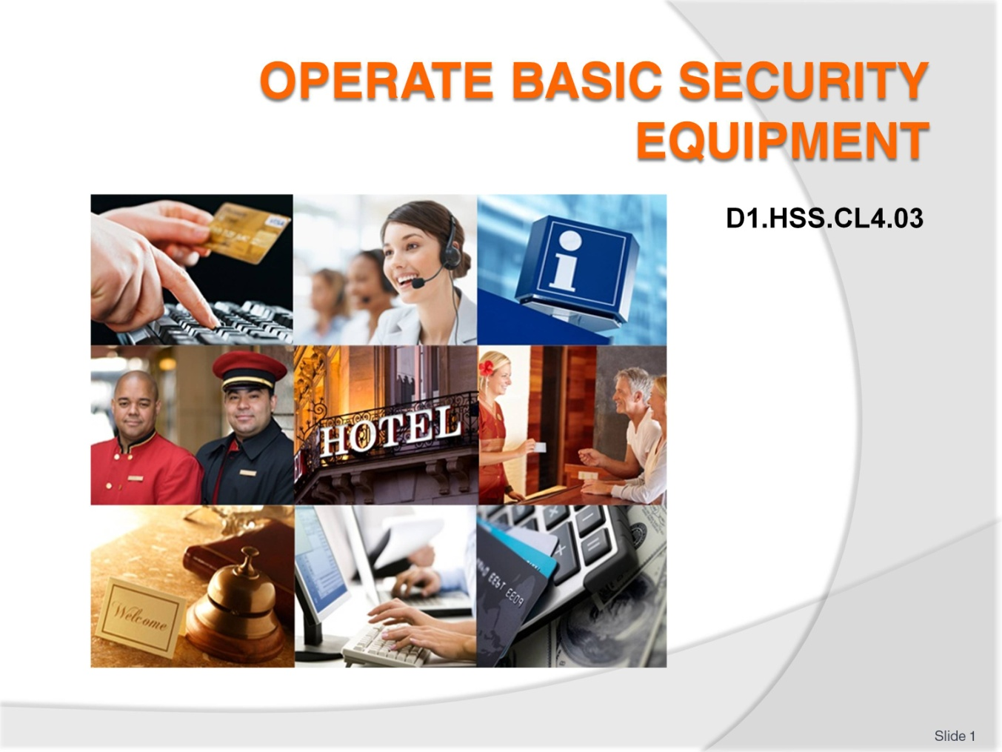
Slide No | Trainer Notes
 | Trainer welcomes trainees to class.

Slide
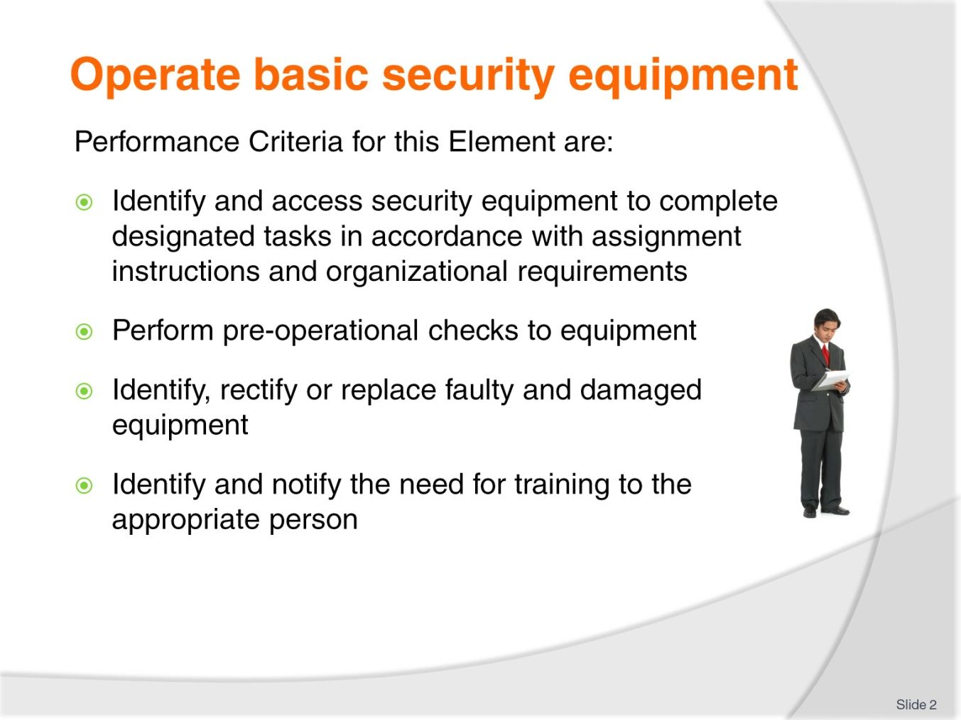
Slide No | Trainer Notes
Trainer identifies for trainees the Performance Criteria for this Element, as listed on the slide.
Class Activity – General Discussion
Trainer leads a general class discussion on selecting and preparing security equipment for use by asking questions such as:
- What security items, equipment and systems are you aware of?
- What is the role of security equipment in a venue?
- Who is involved in providing security in a venue?
- What rights do those involved with security have and what legal obligation must they comply with?
- What training do you think security staff receive?

Slide
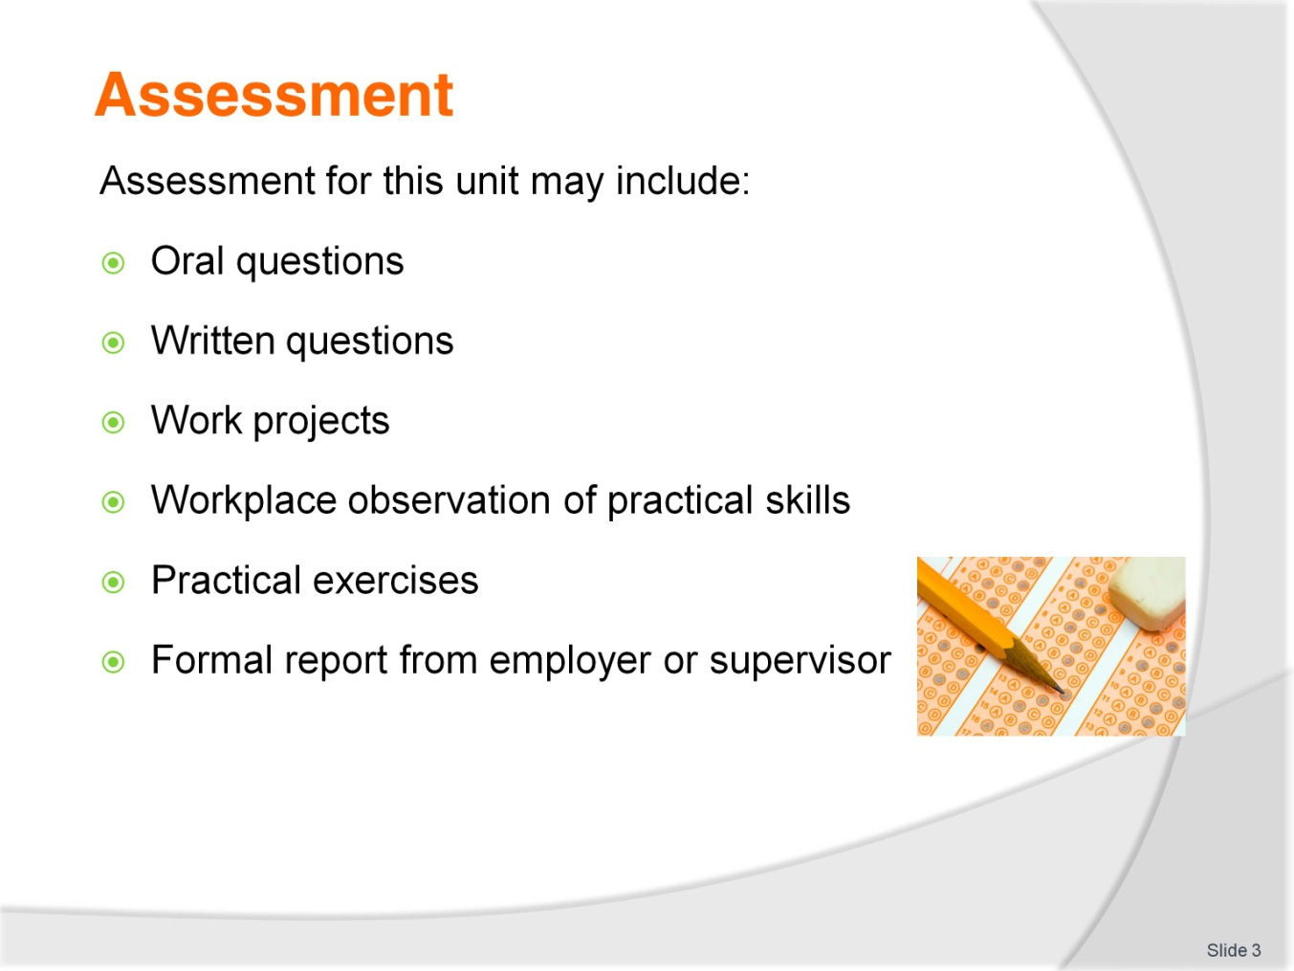
Slide No | Trainer Notes
Trainer advises trainees that assessment for this Unit may take several forms, all of which are aimed at verifying they have achieved competency for the Unit as required.
Trainer indicates to trainees the methods of assessment that will be applied to them for this Unit.

Slide
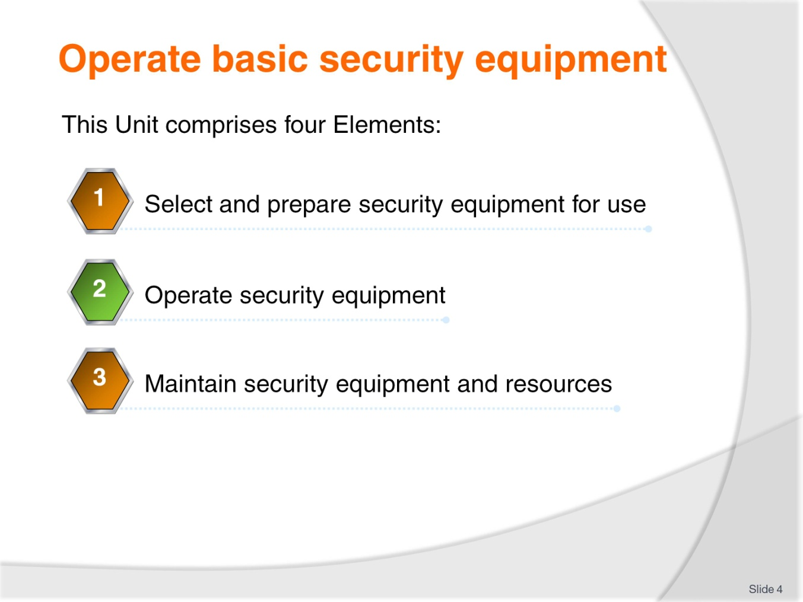
Slide No | Trainer Notes
Trainer advises trainees this Unit comprises three Elements, as listed on the slide explaining:
- Each Element comprises a number of Performance Criteria which will be identified throughout the class and explained in detail
- Trainees can obtain more detail from their Trainee Manual
- At times the course presents advice and information about various protocols but where their workplace requirements differ to what is presented, the workplace practices and standards, as well as policies and procedures must be observed.

Slide
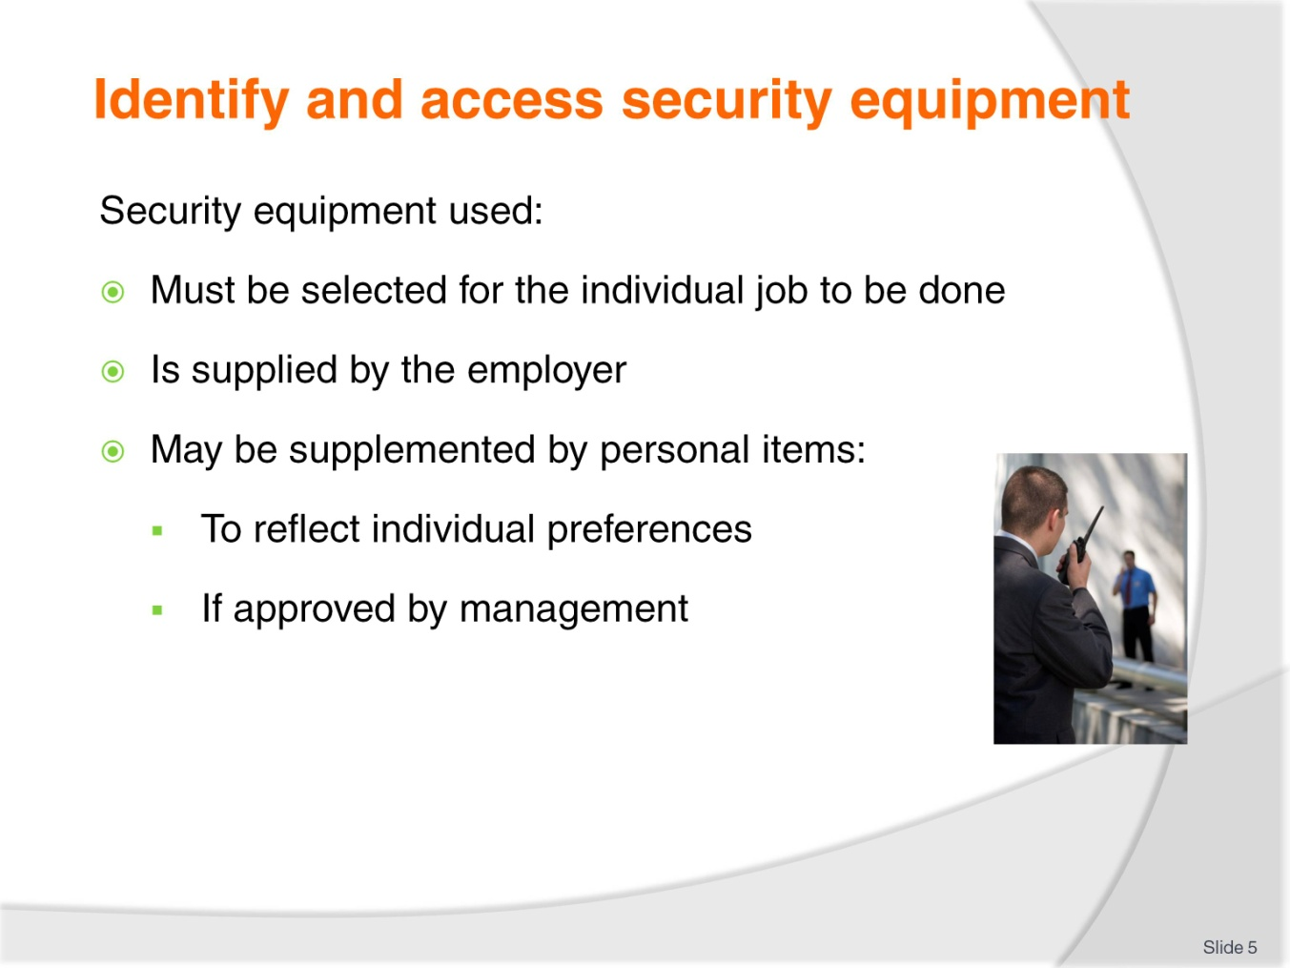
Slide No | Trainer Notes
Trainer states it is important to select the correct security equipment for the job to be completed explaining security equipment used in venues:
- Will be provided by management
- Is often supplemented by personal property of security staff who frequently have preferences for carrying and/or using certain items
- For example, management may provide hinged handcuffs but individuals may prefer to use, and buy their own, chained handcuffs
- Security staff also often have strongly-held preferences for asps and torches/flashlights
- Management must always approve the use of any personal security equipment or items used by employees.

Slide
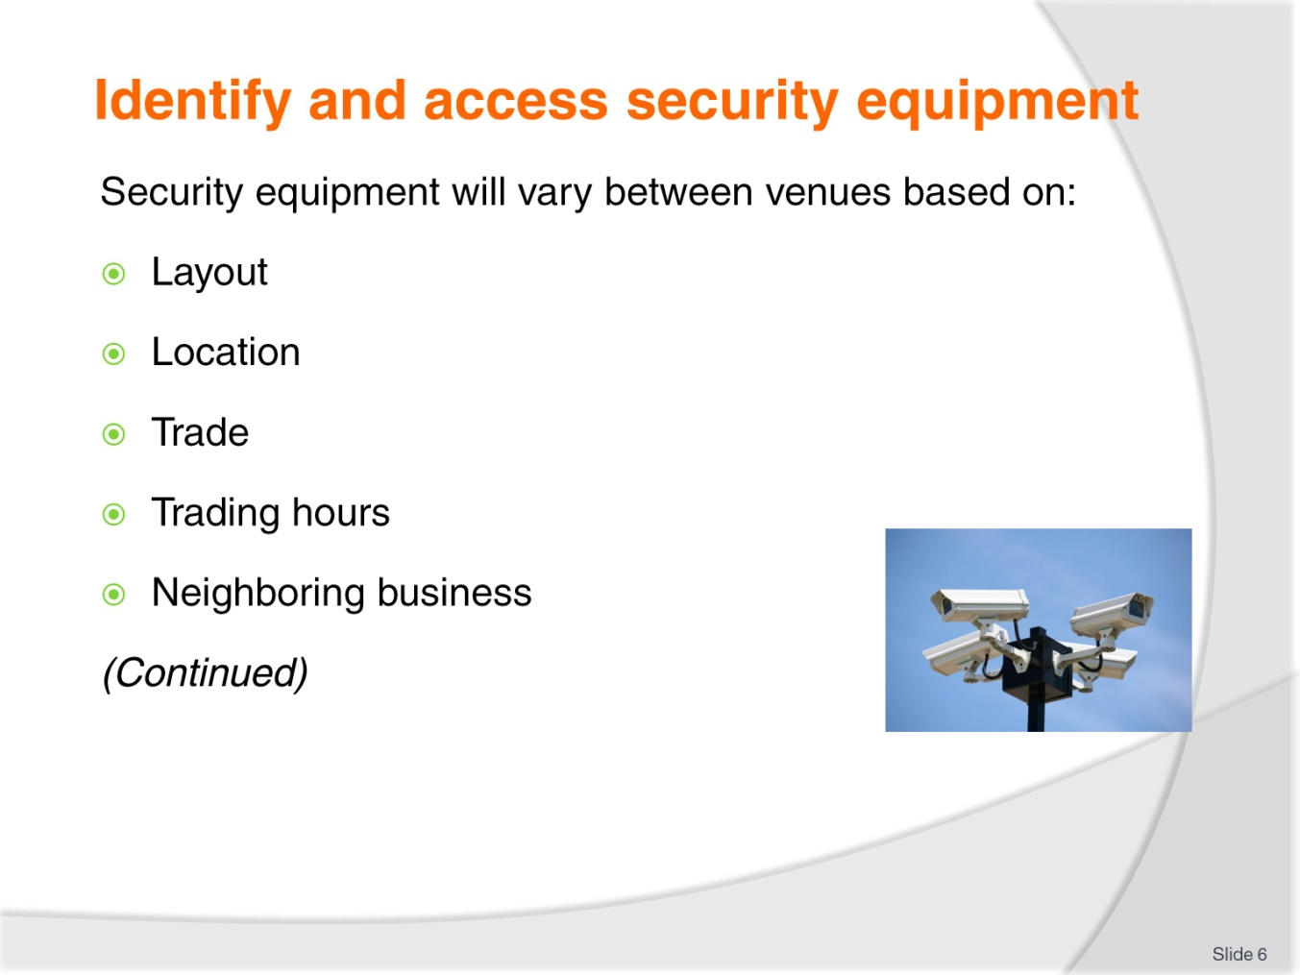
Slide No | Trainer Notes
Trainer identifies security equipment used by staff may vary between venues with variations based on:
- Layout of the venue – internally and externally
- Geographic location of the property
- Volume of trade, patronage or custom
- Hours the venue is open for business
- The proximity to other operations and the type/nature of those businesses and when they are open.

Slide
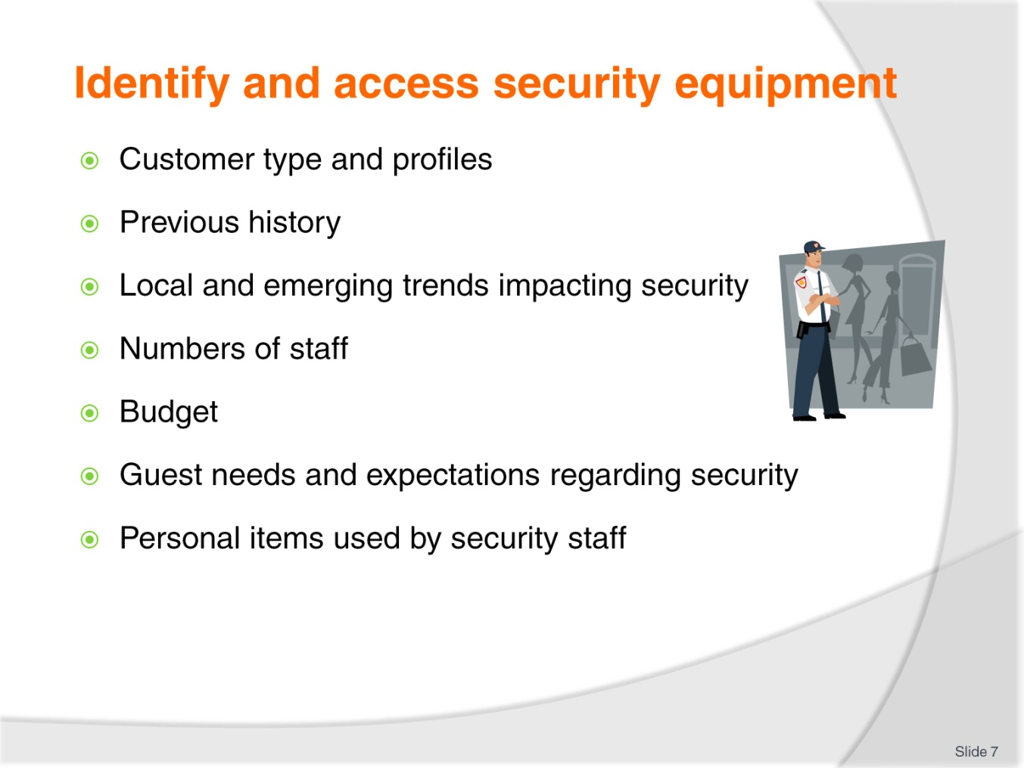
Slide No | Trainer Notes
Trainer continues identifying security equipment used at different venues:
- Type and nature of customers the venue attracts
- Previous history of the venue in terms of security incidents it has experienced
- Local and emerging trends in relation to security
- Number of staff employed
- Budget available
- Identified need regarding customer/guest expectations about security
- Personal items used/carried by individual staff.

Slide
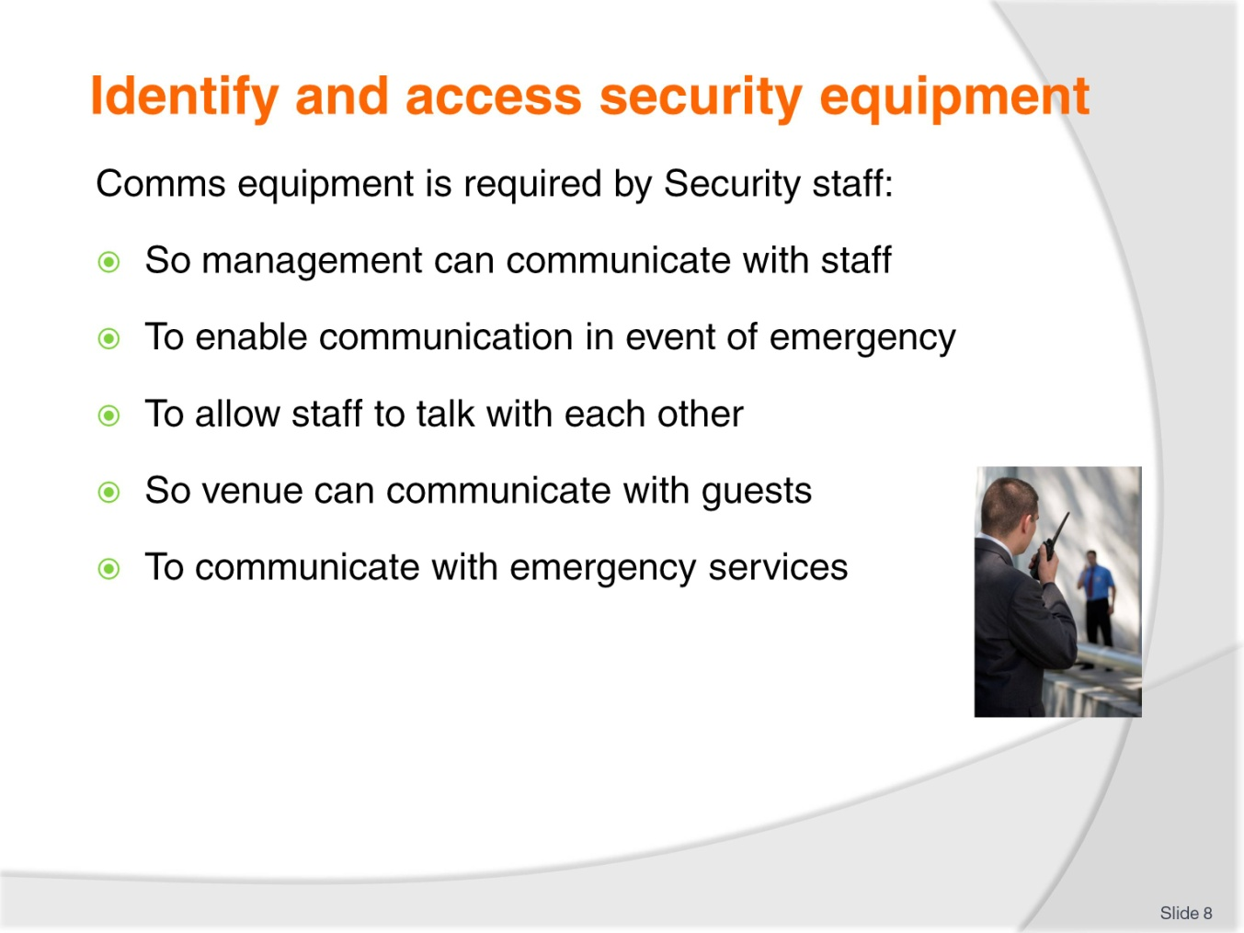
Slide No | Trainer Notes
Trainer explains communication equipment is required in relation to security:
- So management can communicate with security staff on an ongoing, day-to-day basis
- To communicate with security staff in the event of an emergency
- To allow security staff and management to communicate with each other
- So the venue can communicate with customers and guests
- To allow the venue to communicate with emergency authorities – such as when where there is a need to involve police, ambulance, fire or civil defence agencies).

Slide
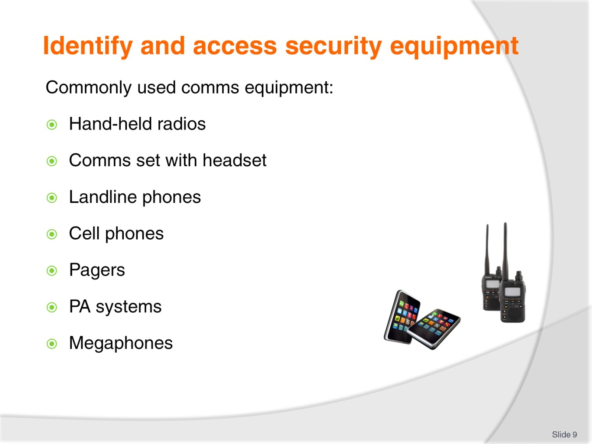
Slide No | Trainer Notes
Trainer identifies commonly used comms equipment:
- Hand-held two-way radios (UHF and VHF) – which may feature lapel microphones
- Communication headsets with earpieces – allowing the hands to be free for other work
- Landline telephones – such as the internal telephony system in a venue
- Cell phones – provided by management
- Pagers – of limited use but can be used as a back-up to summon assistance or ask a security officer to check in/contact someone
- Public address systems – can be used to communicate generally with customers, or the systems can be used in defined areas/sections (sectors) only
- Megaphones – for communicating with the public where the PA system does not operate, as an alternative to the PA system or during emergencies and evacuations.
Class Activity – Presentation, Explanation, Demonstration and Practical
Trainer obtains sample of each item listed on slide and:
- Identifies and presents each
- Demonstrates how to use each including demonstration of features
- Explains use of each including identification of limitations
- Provides opportunity for students to practice with same.
Slide
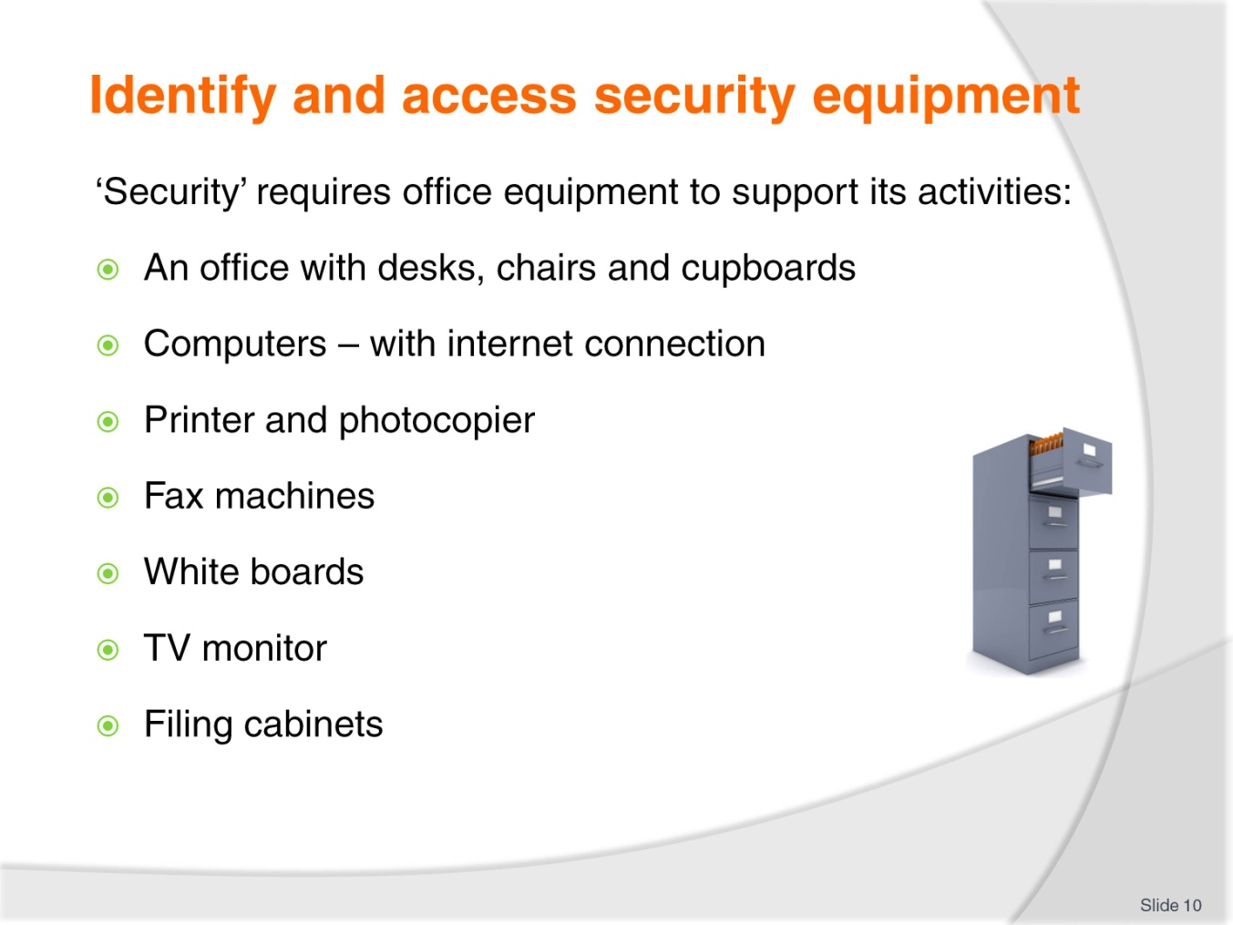
Slide No | Trainer Notes
Trainer notes office equipment is needed to support the efforts of security staff by providing the standard services required by all departments/workers in a venue – office equipment may include:
- Desks, chairs, cupboards, shelving
- Computers with internet connection – for general administrative tasks
- Printers – to produce hard copies of reports, plans, assignments
- Facsimile machines – to provide a back-up for email communication
- White boards – for planning and messages
- Photocopiers – for reproducing necessary documents
- TV monitor – for replaying surveillance vision
- Filing cabinets.
Class Activity – Discussion
Trainer asks trainees to identify what each of the items listed on the slide might be used for in relation to Security work/staff.

Slide
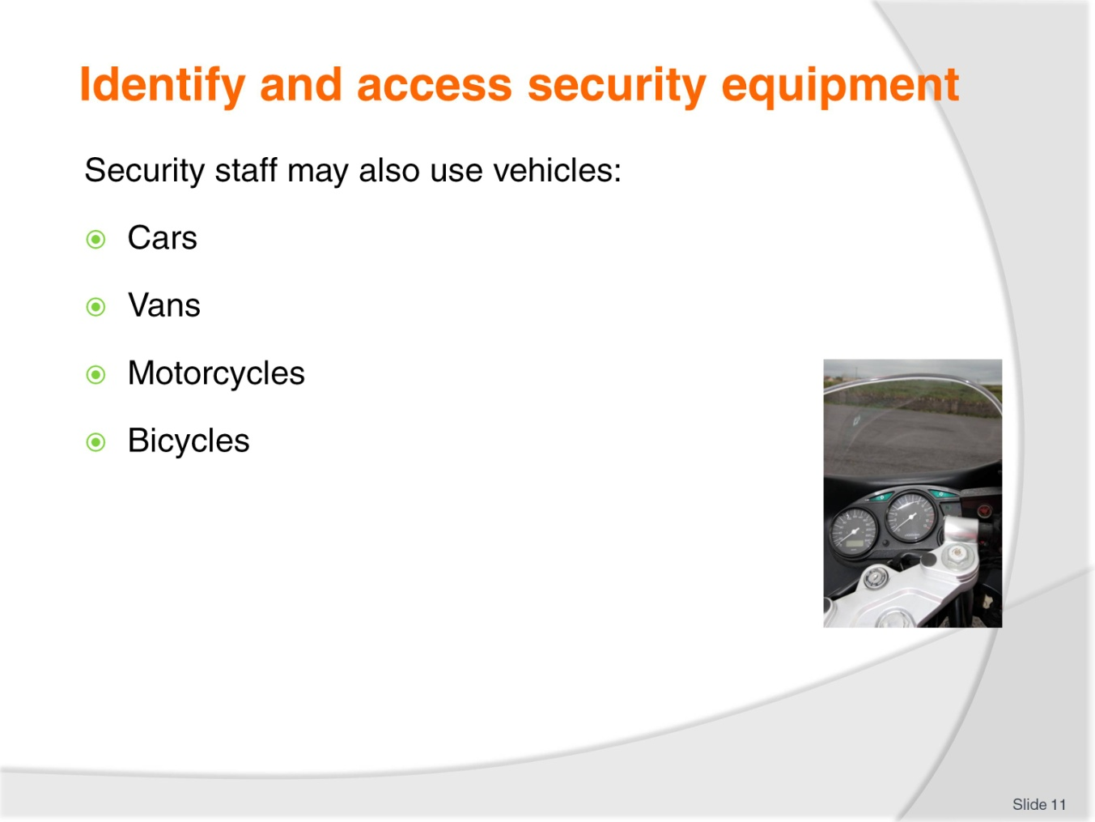
Slide No |  | Trainer Notes
Trainer highlights depending on size, location and layout of the property there can be a need for security staff to use a variety of transportation options such as:
- Cars – usually:
- Signed as ‘Security’ vehicles – but premises may use unmarked cars to enable covert surveillance, however most vehicles are intended to be a deterrent so high-profile/high visibility is important
- Equipped with communication
- Fitted with spotlight
- Carrying flashing lights
- Vans – commonly used where there is a need to:
- Carry guest valuable items
- Provide escort to people
- Move property assets
- Motorcycles – which:
- Are more cost-effective than cars or vans
- Can access areas cars/vans are unable to get into
- Bicycles – which:
- Are extremely cost-effective
- Enable the same quietness of a foot patrol while providing increased flexibility and coverage.
Slide
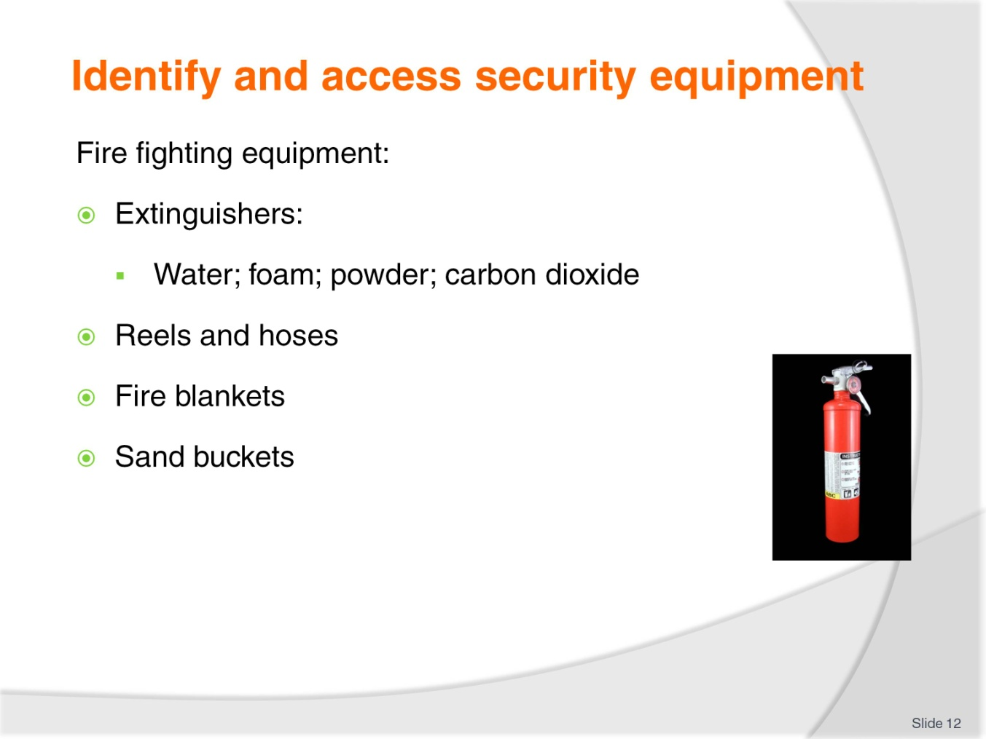
Slide No | Trainer Notes
Trainer introduces fire fighting equipment identifying:
- Water extinguishers – suitable for use on ordinary combustible materials but not safe for use on electrical fires or cooking oil/fat fires:
- They are ineffective on flammable and combustible liquid fires
- Foam extinguishers – dangerous if used on electrical fires:
- They are suitable for ordinary combustibles and for fires featuring flammable and combustible liquids
- Powder extinguishers – can be used on ordinary combustibles, fires featuring flammable and combustible liquids and electrical fires
- Carbon dioxide extinguishers are best for electrical fires – they have limited effectiveness on fires featuring flammable and combustible liquids, and cooking oil/fat fires
- Reels and hoses
- Fire blankets
- Sand buckets.
Class Activity – Presentation and Explanation
Trainer obtains samples of each item listed on slide and:
- Presents/identifies each to students
- Explains use of each.
Slide
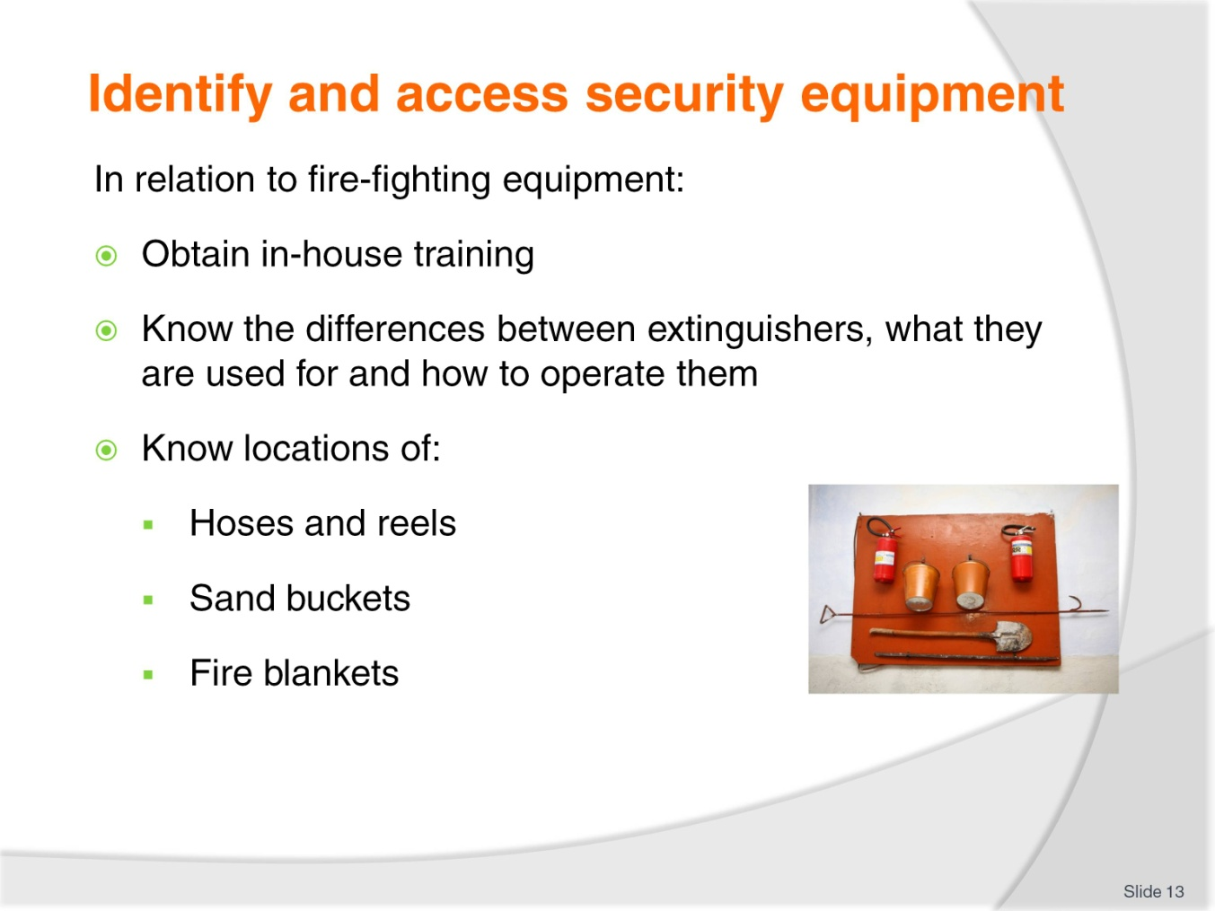
Slide No | Trainer Notes
Trainer continues discussing fire-fighting equipment advising students must:
- Obtain in-house training before using ANY fire fighting equipment
- Make sure they:
- Know how to differentiate between the different types of portable fire extinguishers – CO₂, dry chemical, water: their different colours is the quickest way to tell them apart
- Know what extinguishers can be used on what types of fires – never use water extinguishers or hoses on oil, fat or electrical fires
- Know how to operate the extinguishers effectively
- Know where the fire hoses are and how to operate them
- Know where sand buckets are located
- Know where the fire blankets are and how to use them.
Class Activity – Guest Speaker and Demonstration
Trainer arranges for local fire brigade to attend and:
- Talk to trainees about fire fighting
- Advise them how to summon emergency assistance
- Demonstrate how to use fire fighting equipment as listed
- Provide supervised practice for students in use of listed items.

Slide
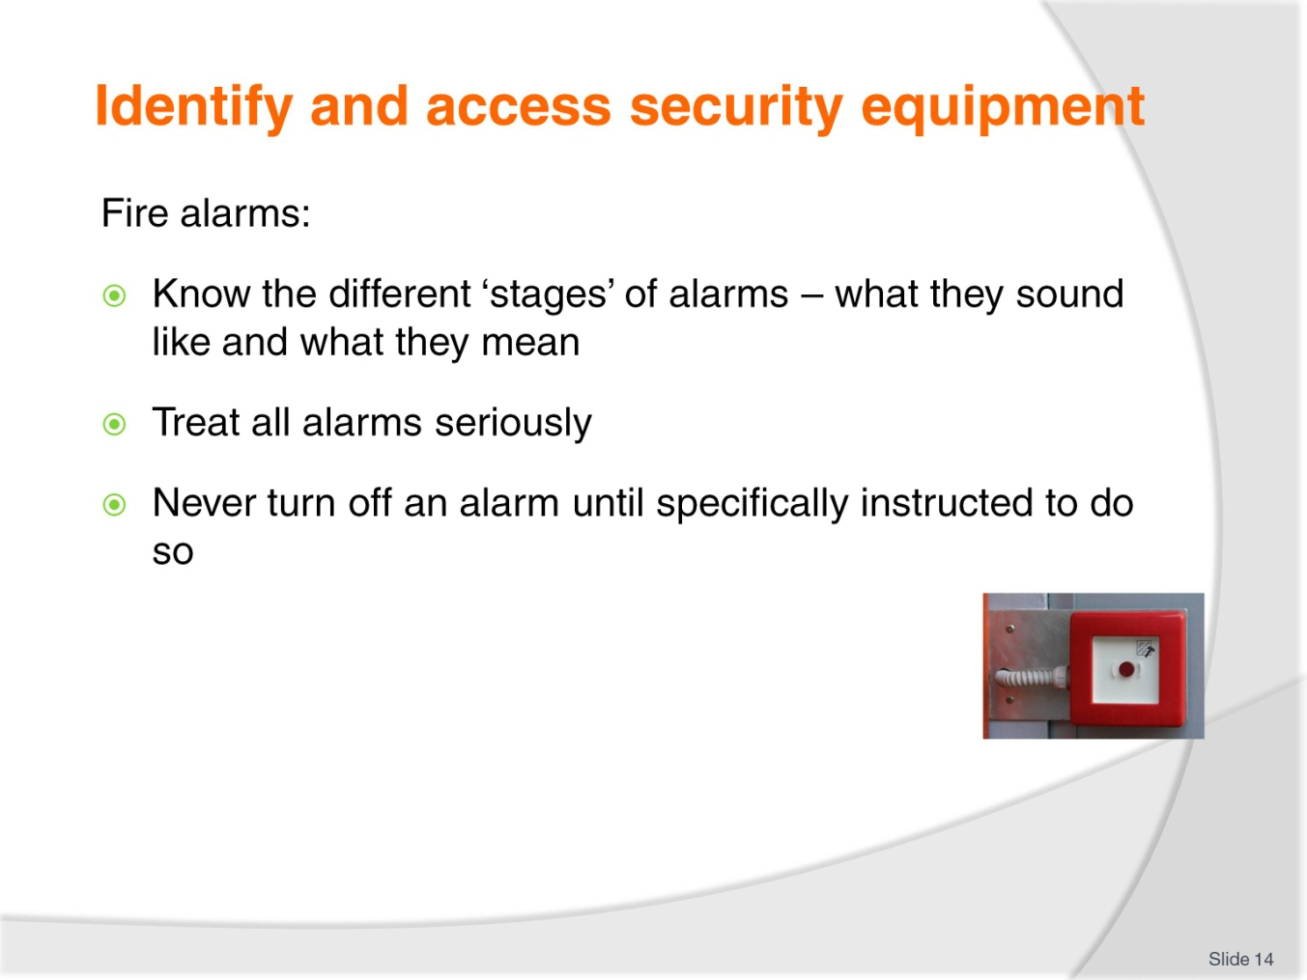
Slide No | Trainer Notes
Trainer talks about fire alarms:
- Fire alarms are used to notify people within the establishment there is a fire
- Fire alarms may have different sequences (or tones) to indicate various levels of alert, such as:
- Stage 1 – indicates ‘There is a fire in the building but there is no need to evacuate’
- Stage 2 – indicates ‘There is a fire in the building and there may be a need to evacuate’
- Stage 3 – indicates ‘Evacuate now’.
- Where such a system is in use you must know the sound of the different alarms and what they mean
- Always treat alarms seriously and regard them as genuine – never think ‘it’s only a drill’, or ‘it’s probably a false alarm’
- Never turn a fire alarm off unless specifically ordered to do so by your supervisor.

Slide
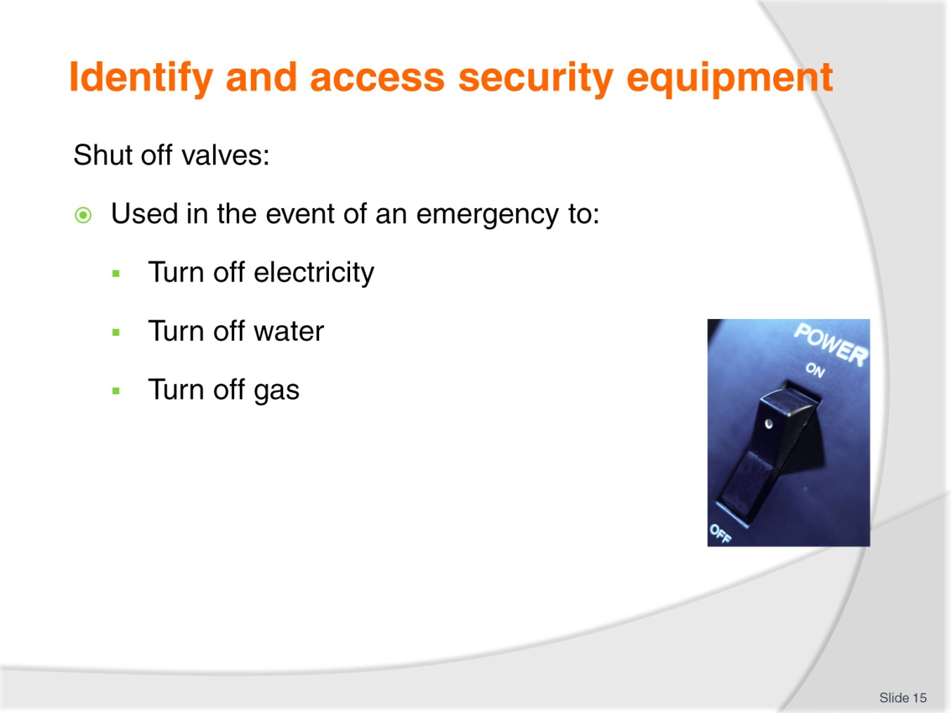
Slide No | Trainer Notes
Trainer introduces shut off valves:
- Depending on the type of emergency there may be a need to turn off supply valves
- In the event of a fire (for example) you may be required to:
- Turn off the electricity – at a meter box or similar
- Turn off the gas – using a shut off valve.
- In the event of other emergencies you may also be required to shut off the water (using a gate valve or similar).

Slide
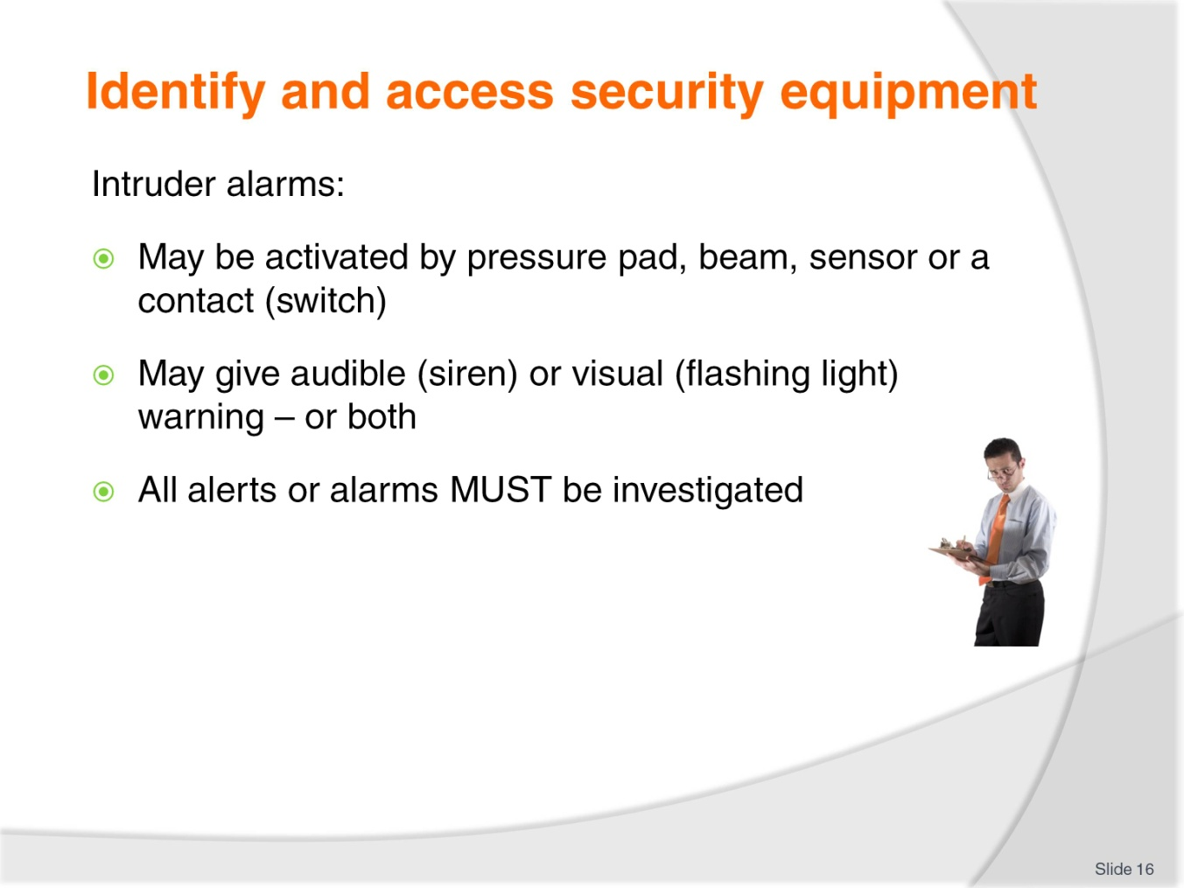
Slide No | Trainer Notes
Trainer mentions intruder alarms:
- May be activated by a pressure pad, beam, motion sensor or when a contact is made or broken
- These can give an audible or visual warning (or both) that unauthorised access has occurred in an area
- All alerts generated by these alarms must be investigated.

Slide
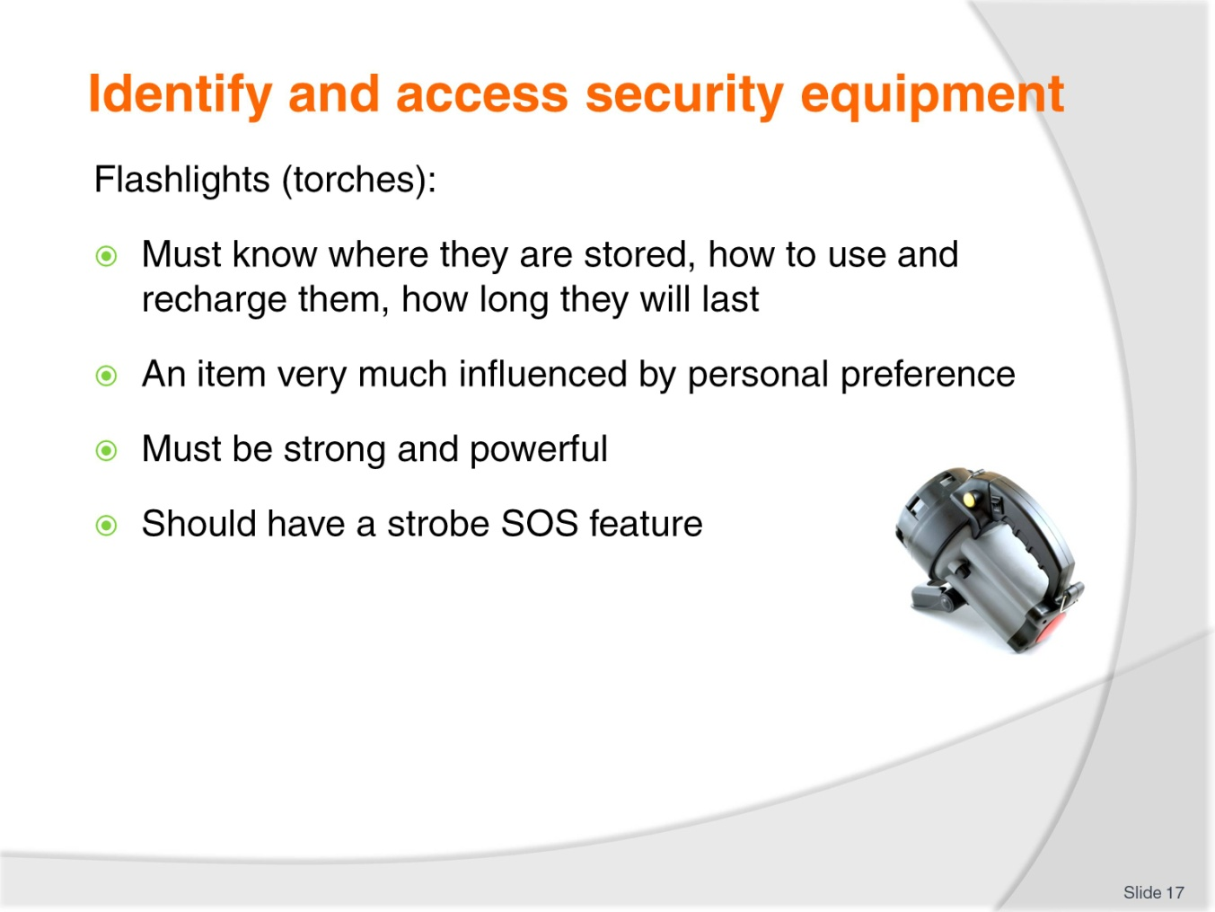
Slide No | Trainer Notes
Trainer introduces flashlights/torches:
- Flashlights are standard equipment and are used not only at nights but also to illuminate dark areas during daylight hours
- Must know:
- Where torches are located
- How to operate them
- How long they will last.
- Most security staff will use nothing but a Maglite® with many preferring the standard 4-cell ( or 5-cell or 6-cell) LED version (which can be used as a weapon), while many others opt for the more compact LED versions (such as the MagTac®) which is lighter and easier to carry/put on a duty belt
- The flashlight should:
- Be powerful/strong
- Contain a strobe facility – which can be used to attract attention or you’re your location as an SOS function.
Class Activity – Presentation and Demonstration
Trainer shows trainees samples of flashlights as identified above and demonstrates:
- Differences between them
- Features, benefits and drawbacks of each.
Slide
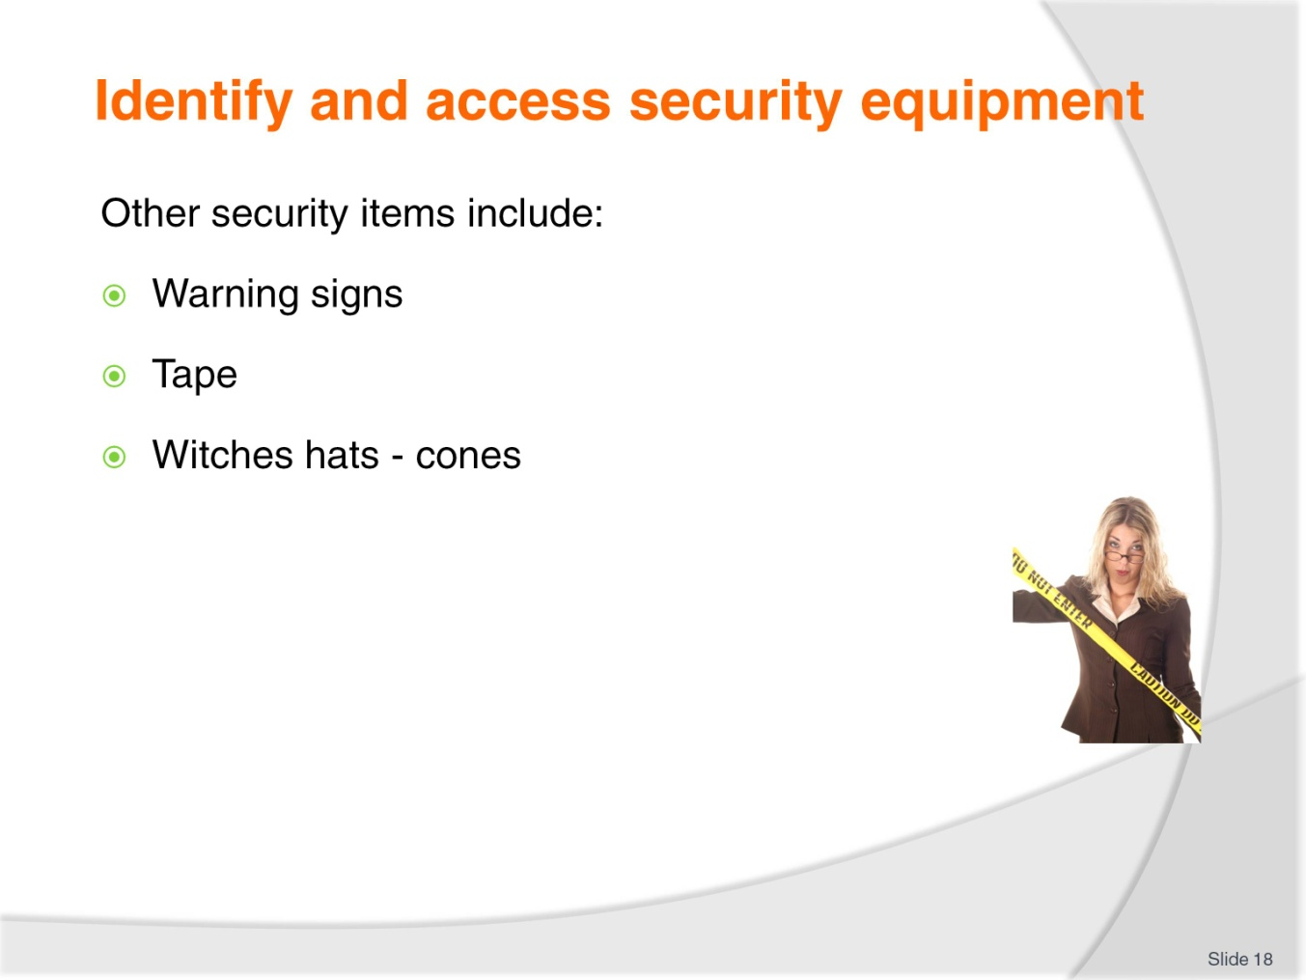
Slide No | Trainer Notes
Trainer talks about:
- Warning signs – ‘Danger’, ‘Do Not Enter’
- ‘Do Not Cross’ and ‘Do Not Enter’ tape
- Witches hats.
Class Activity – Presentation, Explanation and Discussion
Trainer obtains samples of items listed ion slide and:
- Explains what they are used for
- Demonstrates how to use them
- Asks students to identify when they may be used.

Slide
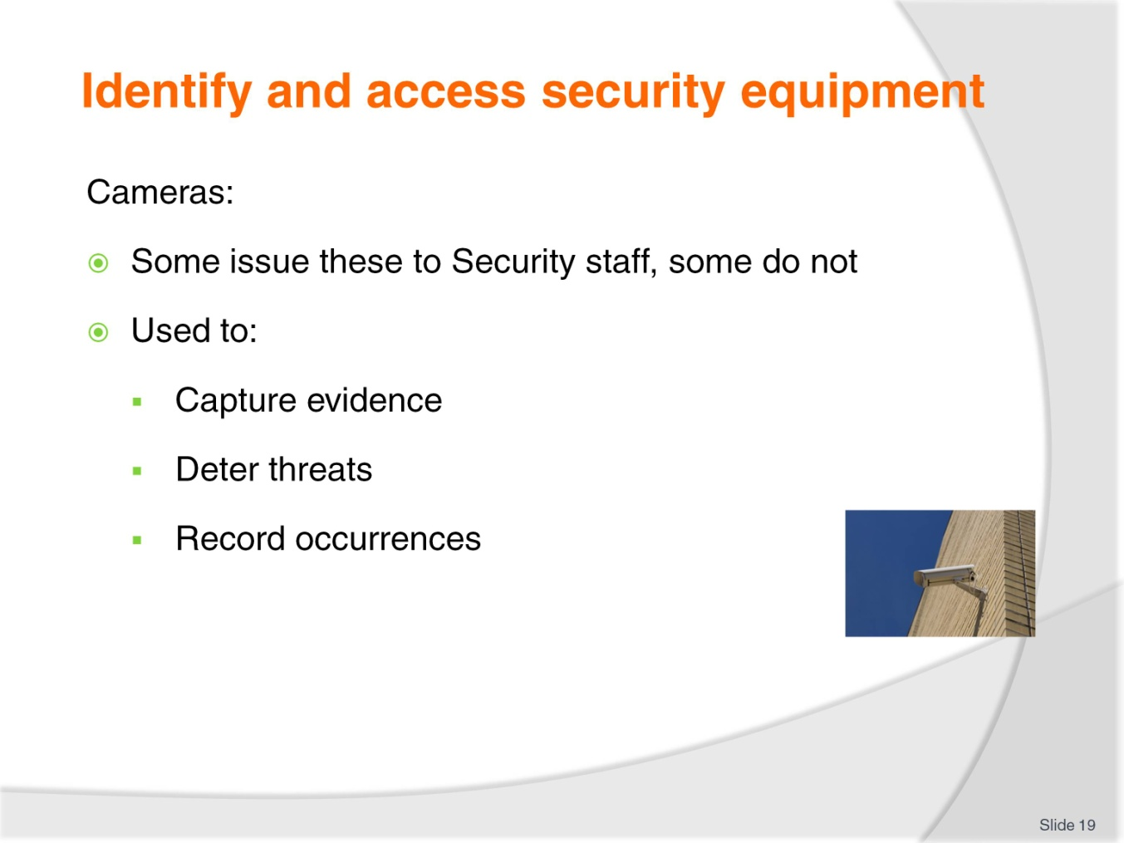
Slide No | Trainer Notes
Trainer highlights use of cameras:
- Some venues provide security staff with cameras
- A compact movie camera can be part of your EDC and used to:
- Capture evidence – for referral to the authorities; to support an insurance claim; to provide the basis for civil action against offenders
- Deter threats – many people will withdraw if they believe they are being filmed
- Record details/occurrences during an event/incident – which can be used later for analysis, identification and examination/investigation.

Slide
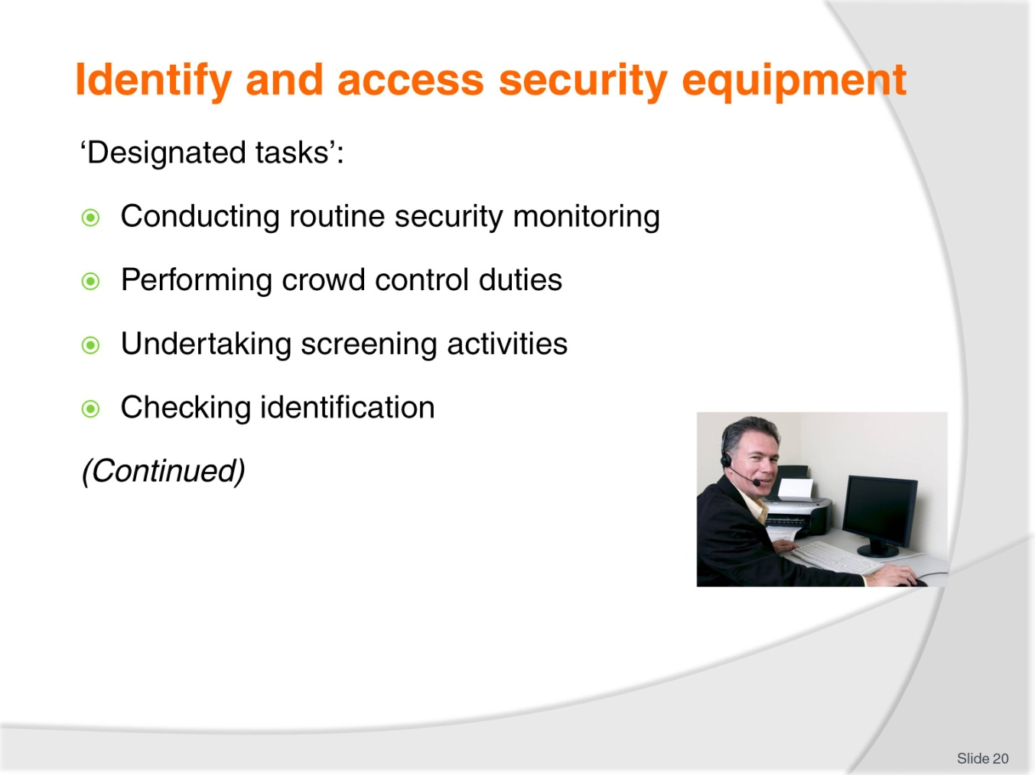
Slide No | Trainer Notes
Trainer identifies and explains possible ‘designated tasks’ for Security staff:
- Conducting routine security monitoring of the premises – these can include:
- Regular foot and vehicle patrols
- Static guard duties – providing a visible presence at an entrance or designated location
- Performing crowd control duties – which can include:
- Directing people
- Controlling vehicle movement – which can include controlling parking and traffic speed
- Preventing access to certain areas
- Deterring and responding to unacceptable behaviour
- Assisting patrons as required
- Undertaking screening activities – of people and/or property, which may involve:
- Operating luggage X-ray machine
- Policing electronic doorways/frames
- Using hand-held wands
- Inspecting and checking vehicles
- Checking identification of customers – with reference to:
- Ensuring under-age people to not enter licensed areas
- Only authorised persons are on the premises.
Slide
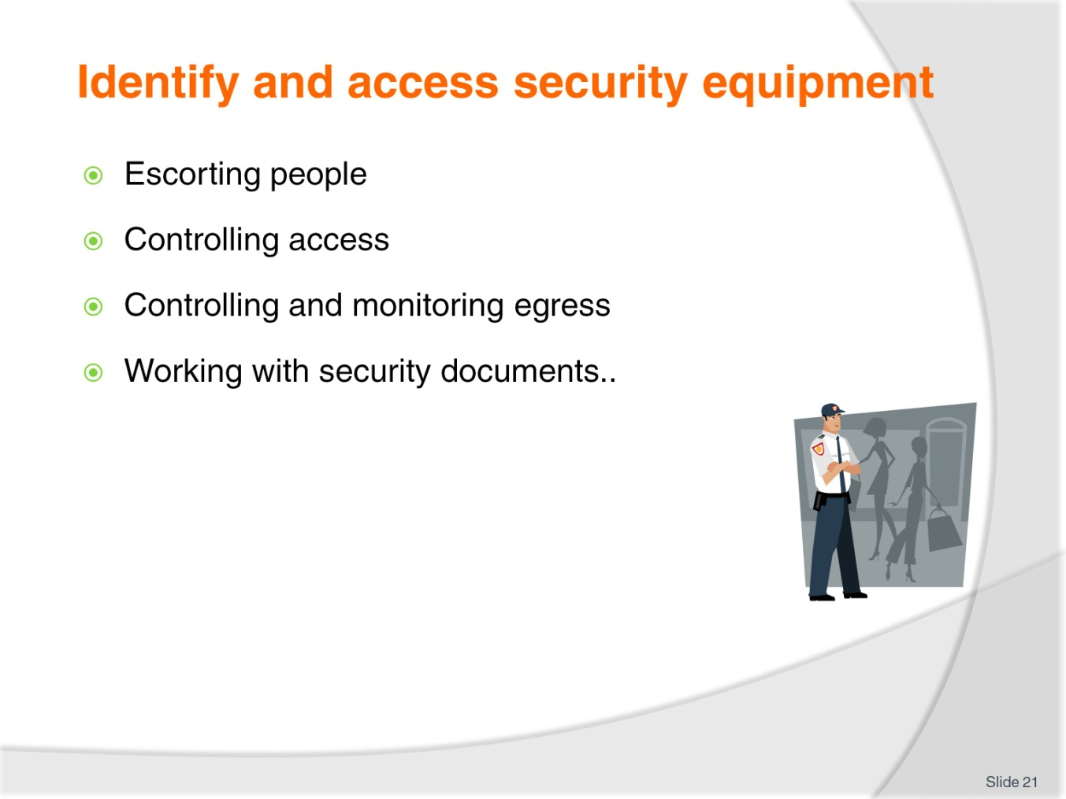
Slide No | Trainer Notes
Trainer continues identifying and explaining possible ‘designated tasks’ for Security staff:
- Escorting people – to:
- Protect individuals or groups
- Safeguard their property
- Deliver required services to VIP guests or those who request it
- Controlling access to the venue or designated areas – to:
- Deter unwanted people
- Assist guests/customers
- Refuse access to those who are unwanted or not entitled to be on the premises
- Check age and ID of people
- Monitoring egress of persons from the property – to:
- Control noise
- Prevent theft of assets
- Assist as required
- Respond to unacceptable behaviour
- Responding to alarms – this is a central role of security staff
- All alarms must be responded to and investigated
- It is CRITICAL you never believe an alarm is a false alarm even though the past 100 alarms have been
- Thieves often trigger regular false alarms in a certain area to lull staff into thinking the next alarm will also be a false alarm and therefore not worthy of a response – you must respond to all alarms, every time without exception.
- Working with security-related documents – such as:
- Creating patrol schedules and routes
- Developing plans for special escorts and carry requirements
- Making revisions to existing plans and SOPs
- Generating reports
- Completing checklists.

Slide
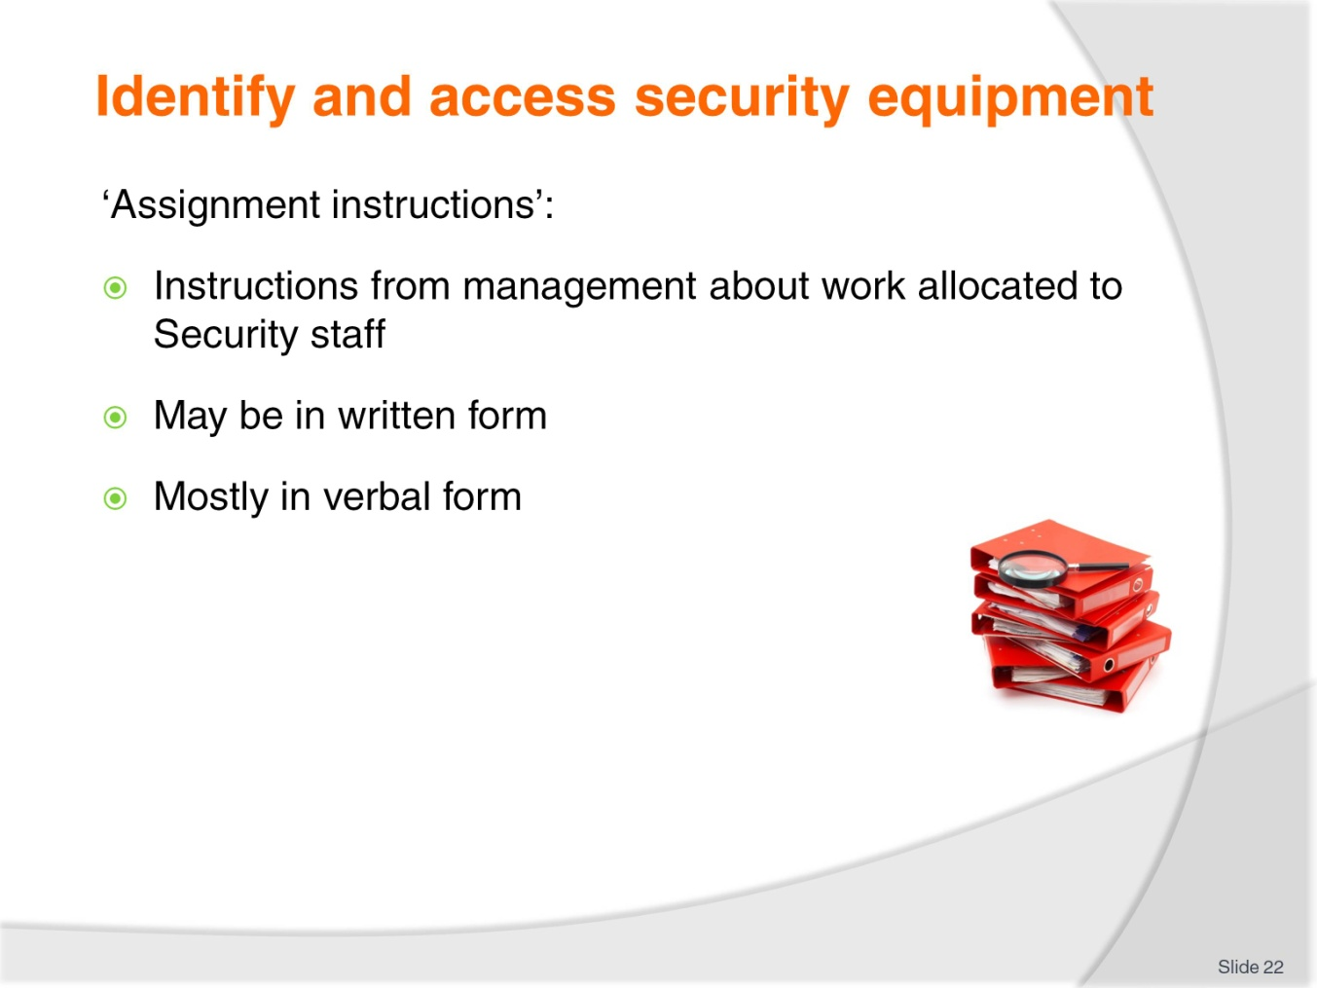
Slide No | Trainer Notes
Trainer advises trainees:
- ‘Assignment instructions’ are instructions provided by management to staff about activities they are required to undertake
- Some assignment instructions will be in writing but the majority will simply be verbal instructions.

Slide
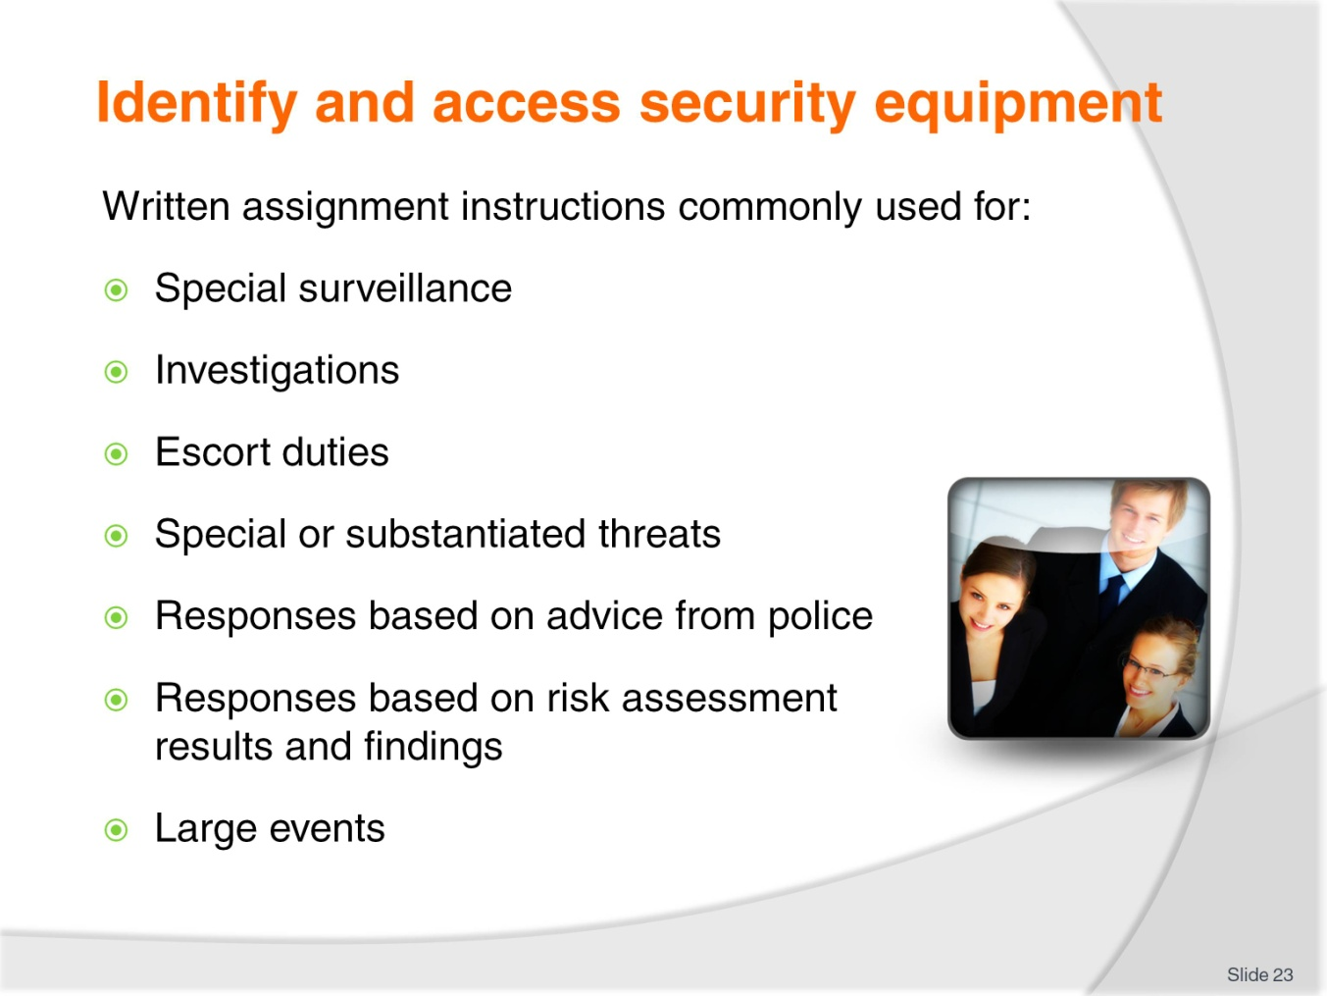
Slide No | Trainer Notes
Trainer indicates examples of situations commonly requiring written instructions:
- Special surveillance of an area of person
- Investigation into an event or incident
- Escort duties – for people, money, valuables
- Special or substantiated threats from multiple targets or previous offenders
- Responses based on advice from external authorities
- Responses to situations where risk assessment has determined there is a high probability and a substantial potential (negative) result/outcome
- Large events (which may be defined by numbers attending, variety of activities, range of venues being used) where specialist security action is required (such as crowd control, security checks, vehicle inspections, traffic control, liaison with authorities).
Class Activity – Guest Speaker
Trainer arranges for relevant industry person (manager, security head) to attend and:
- Discuss the role of security at their venue
- Identify the Security staff present – numbers, roles, responsibilities, experience, training
- Give examples of designated tasks
- Provides examples of assignment instructions.
Slide
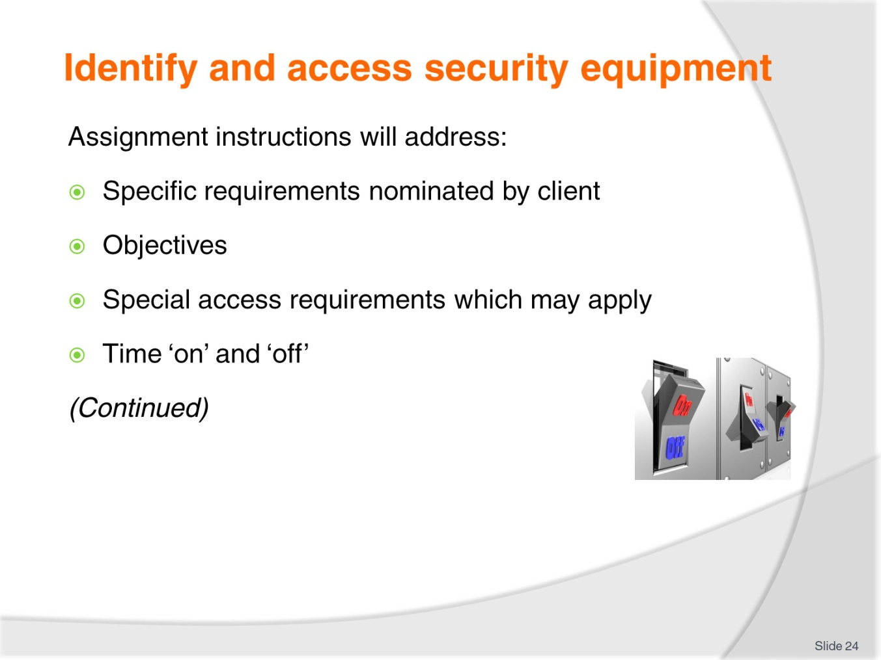
Slide No | Trainer Notes
Trainer states regardless of whether assignment instructions are given verbally or in writing they will/should address the following:
- Any specific requirements identified by a guest/client/customer – in relation to the provision of service, such as:
- Number of staff required
- Skills and/or experience required
- Meeting points
- Timing issues
- Known or anticipated threats
- Threat levels.
- Objectives for the assignment – which may be:
- Patrol
- Escort
- Monitor
- Surveillance
- Investigation.
- Special access arrangements – as appropriate to the circumstances, including reporting requirements ‘on arrival’
- Time on and time off – duration of assignment.
Slide
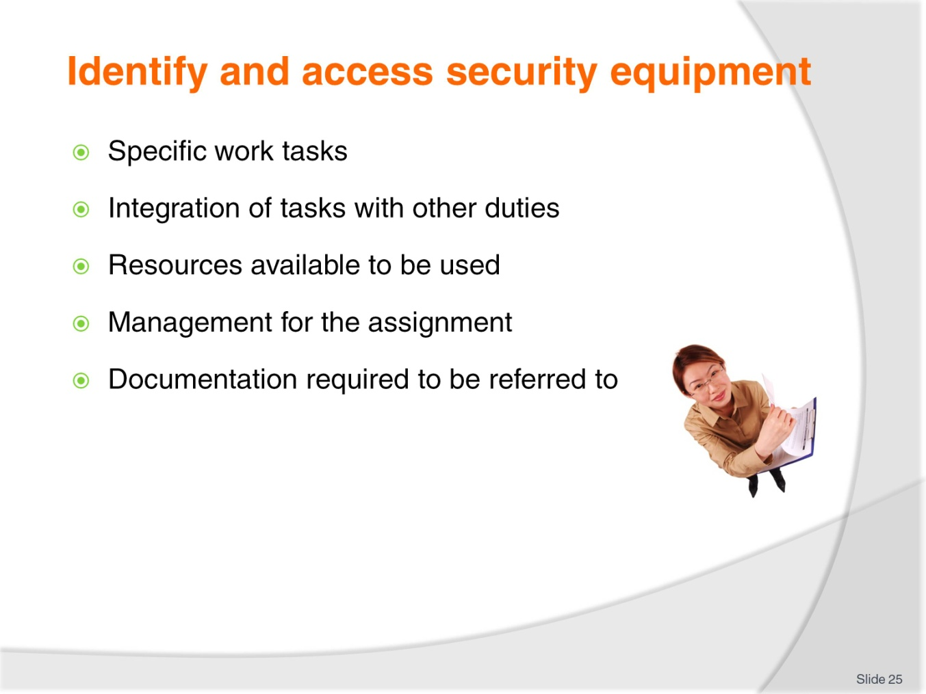
Slide No | Trainer Notes
Trainer continues to identify contents of assignment instructions:
- Specific work tasks which comprise the assignment – for example an assignment may be ‘Provide security for guests arriving at ASEAN symposium’ and the specific work tasks may be:
- Monitor vehicles on arrival and restrict vehicular access to central car park only
- Oversee unloading of vehicles
- Scan luggage of all arrivals into Ballroom
- Check ID of all attendees
- Patrol toilets, entrance foyer and Asian Room.
- Integration of assignment-specific duties with other normal/scheduled security obligations and tasks
- Resources to be used to achieve the objectives – these can include requirements relating to:
- Human resources – by name and number
- Physical resources – such as barricades, scanning devices, comms, PPE, weapons
- Intelligence – information about the event/situation.
- Management – detailing:
- Who is in charge
- Reporting protocols
- Command and control authority.
- Documentation – involving:
- Issuing of relevant forms, logs, registers as appropriate to/necessary for the assignment
- Provision of relevant plans, routes and schedules
- Distribution of any paperwork needing to be completed as part of the assignment, or when the assignment has been finalised.
Class Activity – View Online Information and Videos
Trainer arranges for students to view and discuss following sites:
Equipment and items
- http://www.alibaba.com/showroom/hotel-security-equipment.html
- http://www.motorola.com
- http://www.systemteq.com/hotel-security.htm
- http://weien.en.alibaba.com/product/370593456-200123753/hotel_security_equipment_GC_1001.html
- http://www.digisec.com/resort_facilities.html
- http://www.alibaba.com/showroom/hotel-security-equipment.html
- http://w3.siemens.com/market-specific/global/en/hospitality/hotels-resorts-casinos/hotel-safety-security/hotel-security/pages/hotel-security.aspx.
Using fire extinguishers
- http://www.youtube.com/watch?v=ZCSms-jyOao
- http://www.youtube.com/watch?v=0wahXwItLRY.

Slide
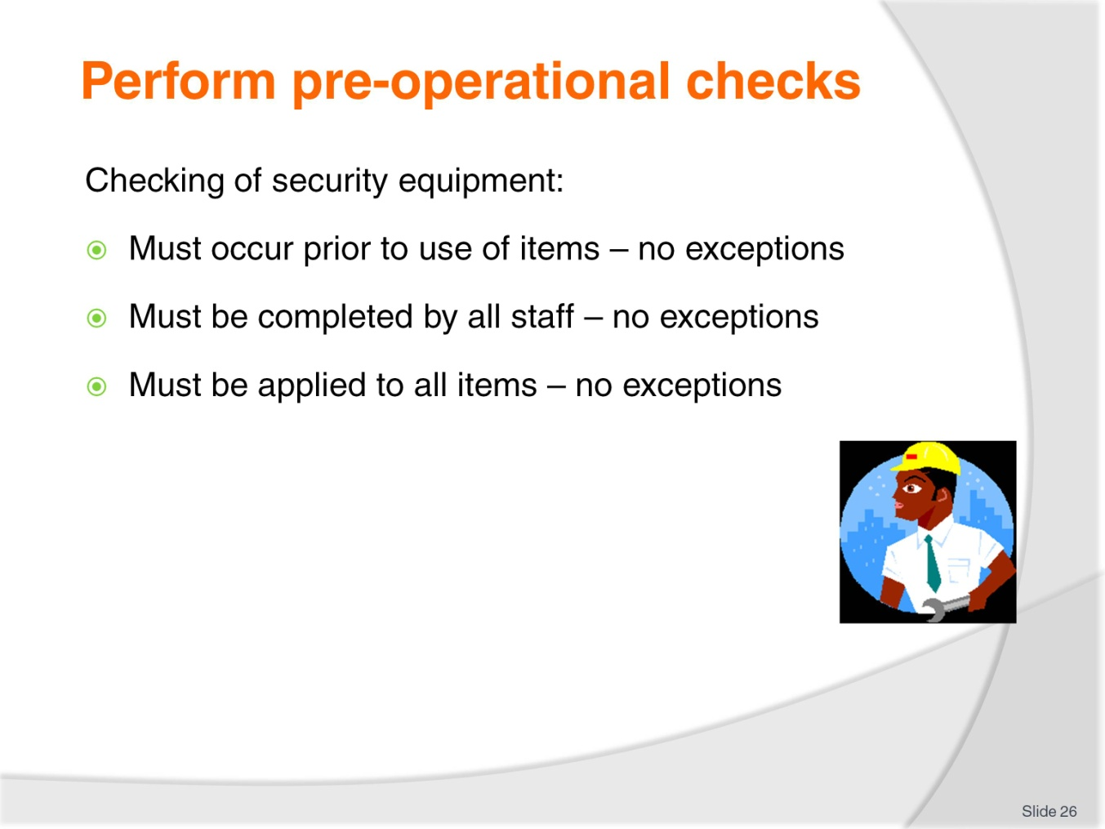
Slide No | Trainer Notes
Trainer states all security equipment must be checked before it is used highlighting it must be checked:
- Before it is used – on every occasion without exception
- By every staff member taking equipment for use – regardless of whom they are.

Slide
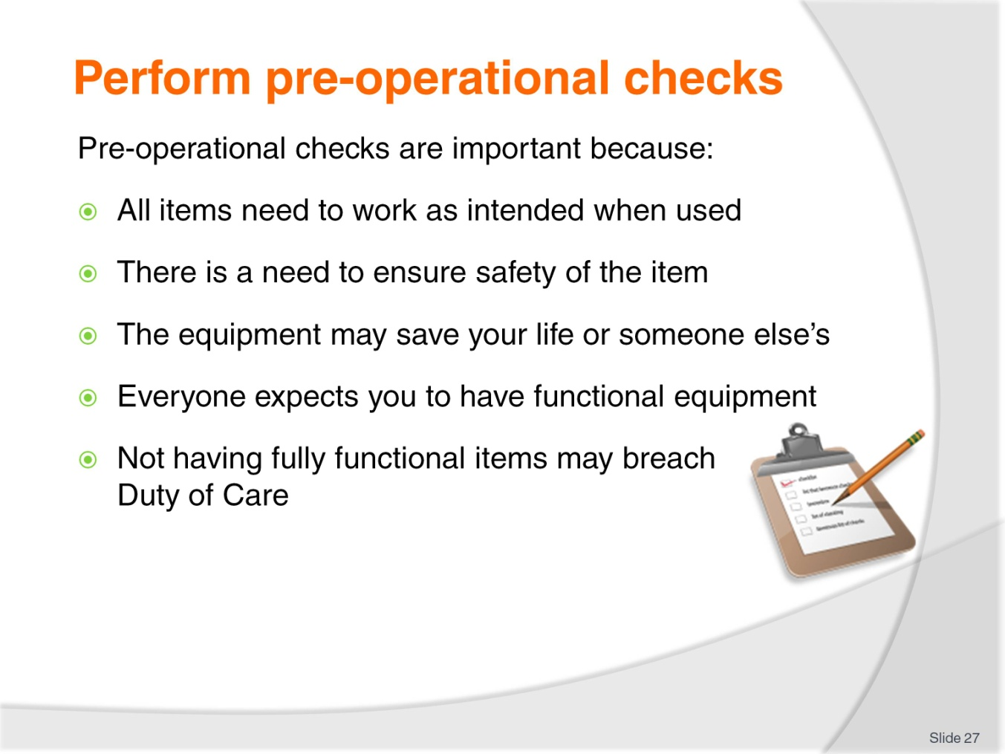
Slide No | Trainer Notes
Trainer explains these checks are important because:
- Every item must work as expected when called on to do so
- You must ensure the safety of the item before you take it/use it
- The life you save may be your own
- Guests and management expect you to be equipped with equipment which worked/functions when needed
- Not ensuring you have fully-operational equipment may be interpreted as a breach of your Duty of Care obligations.

Slide
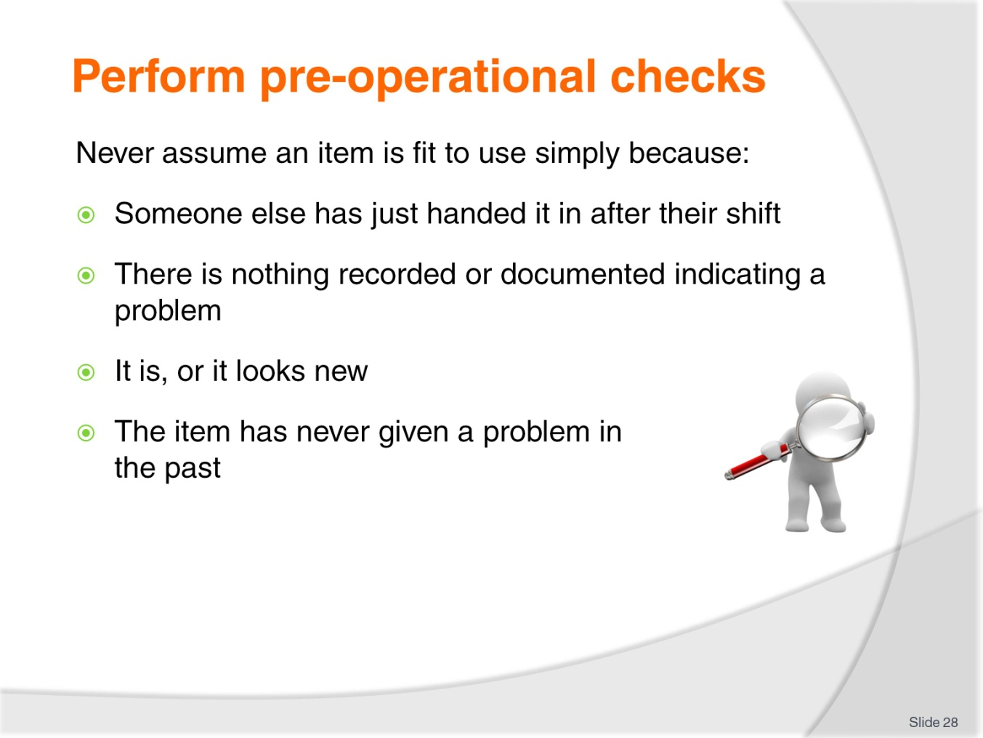
Slide No | Trainer Notes
Trainer emphasises students must never assume an item is fit to use simply because:
- Someone else just handed it in at the end of their shift
- Nothing has been documented about it
- It is/looks new
- It has never been a problem in the past.
There is nothing worse – or potentially more dangerous (even fatal) – than reaching for an item of equipment only to find it does not work as expected.

Slide
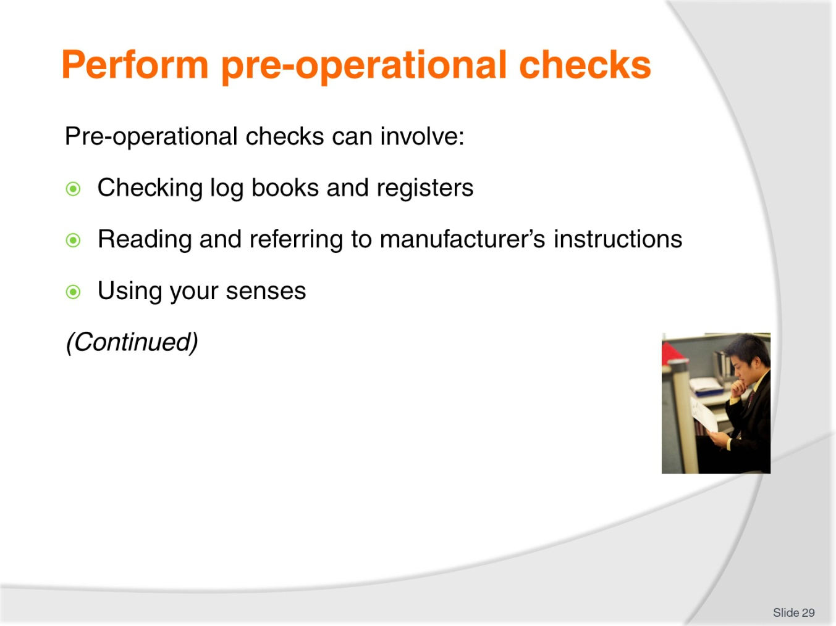
Slide No | Trainer Notes
Trainer states there are a wide variety of activities comprising pre-operational checks and most people would not appreciate what is involved highlighting standard activities include:
- Checking log books and maintenance registers – to see if items have been logged as presenting problem/operational issues recently:
- Where there are multiple items of the same type (such as torches, handcuffs, batons or pepper/OC spray) they will each have their own individual identifier/number to distinguish one item from another.
- Reading/referring to manufacturer’s instructions – where you are not familiar with all the aspects of an item (such as a conveyor X-ray machine) you will need to read these instructions in order to:
- Identify the checks/tests which need to be undertaken
- Determine how to conduct the tests/.checks
- Verify the results/outcomes of the tests/checks.
- Using your senses to determine operational readiness – this can involve:
- Visual observation of the item
- Verifying lights have illuminated as required
- Listening for sounds/noises which indicate a problem – including audible alerts (from system checks)
- Conducting alarm tests – for fire boards and intruder alarms.
Class Activity – Demonstration and Practical
Trainer:
- Demonstrates pre-operational checks as identified in the slide
- Provides opportunity for students to practice actions (where appropriate).

Slide
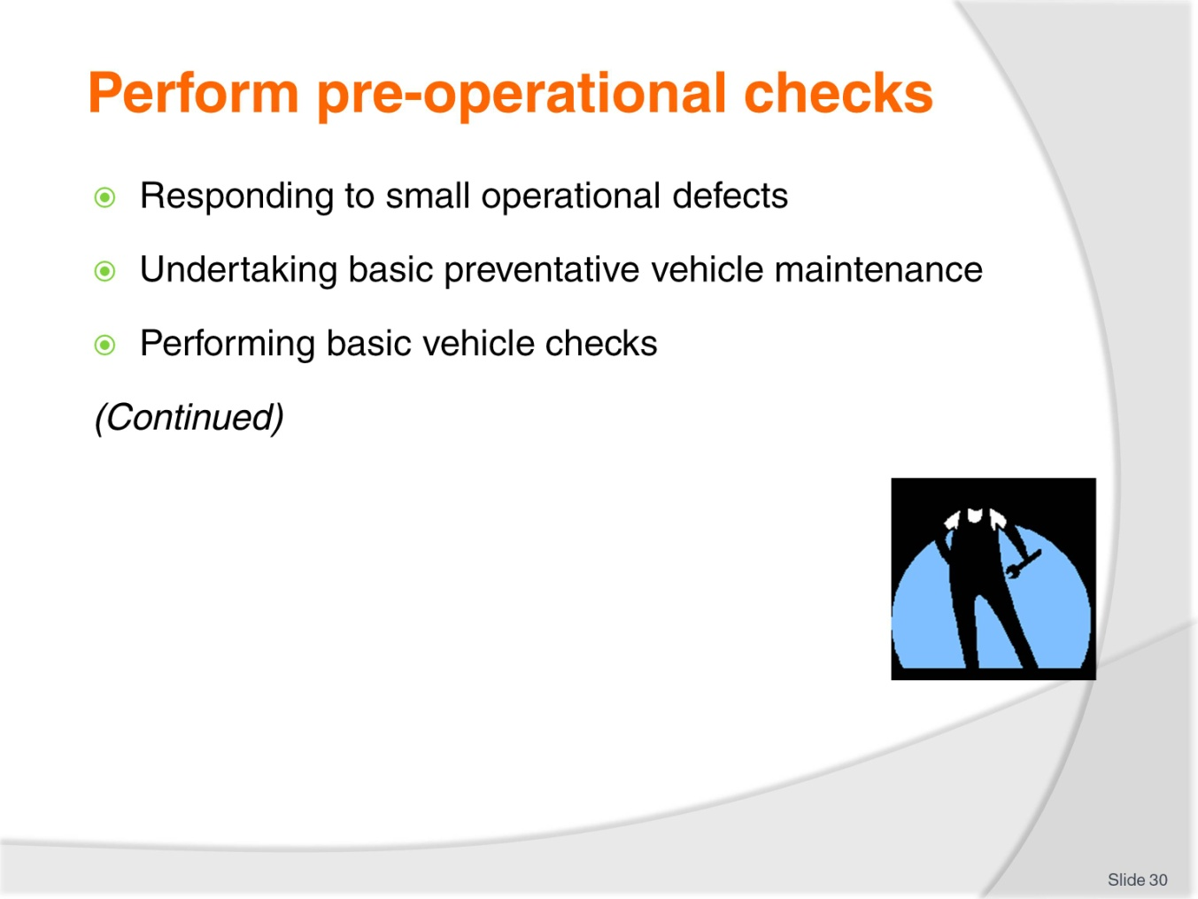
Slide No | Trainer Notes
Trainer continues identifying activities involved in conducting pre-operational checks of security equipment:
- Responding to small operational defects by, as appropriate:
- Cleaning items
- Priming
- Tightening – connections, nuts, screws
- Undertaking basic repairs – according to User Manuals/Operating Instructions
- Making adjustments – to (for example) clearances and tension, location and line of sight, focus, settings and sensitivity.
- Undertaking basic preventative vehicle maintenance (a checklist may be provided to assist) – such as:
- Checking oil
- Checking water
- Filling with fuel
- Verifying tire pressures.
- Undertaking basic vehicle-related checks (a checklist may be provided to assist) – such as:
- Testing comms/radio
- Testing spotlight
- Verifying first aid kit
- Testing headlights and flashing lights
- Verifying presence of other standard in-car assets.
Class Activity – Demonstration and Practical
Trainer:
- Demonstrates pre-operational checks as identified in the slide
- Provides opportunity for students to practice actions (where appropriate).

Slide
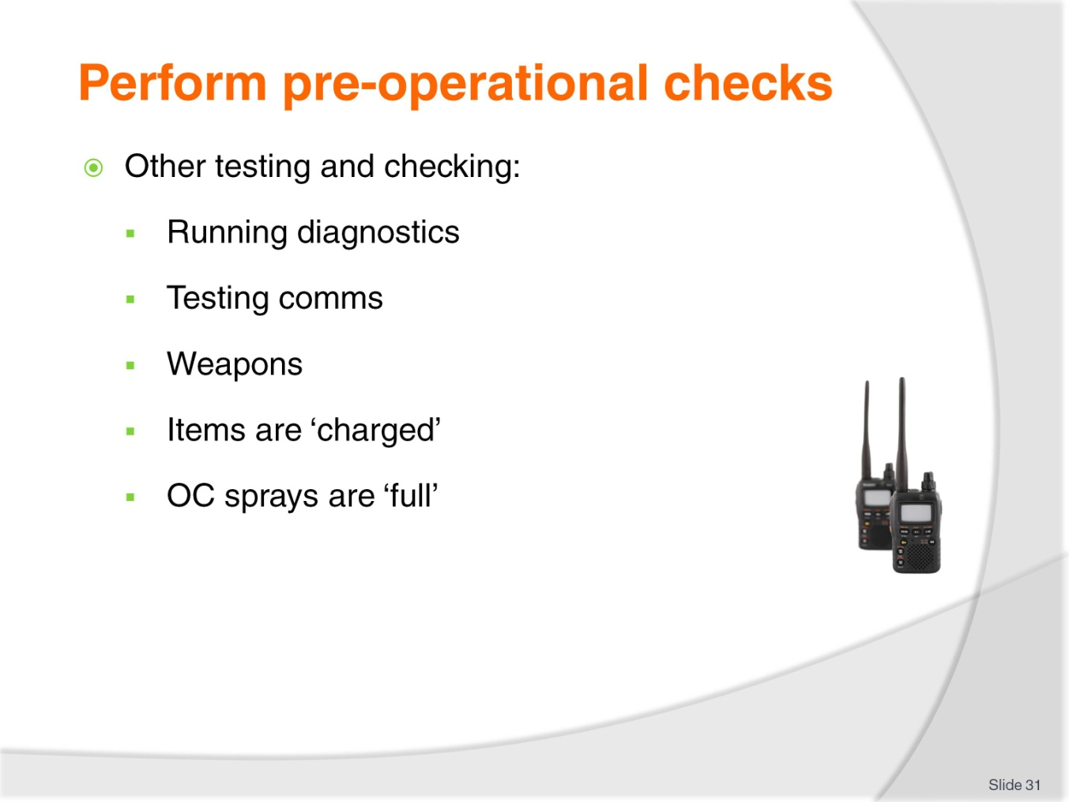
Slide No | Trainer Notes
Trainer continues identifying activities involved in conducting pre-operational checks of security equipment:
- Other testing and checking – such as:
- Running diagnostics on nominated systems – which will self-diagnose issues
- Making test transmissions on two-way radio
- Weapons:
- Are loaded – spare ammunition is available as permitted
- Mechanisms works.
- Verifying charge on cell phone
- Verifying charge on rechargeable torch
- Shaking sprays to determine if contents are sufficient for shift/upcoming assignment.
Class Activity – Demonstration and Practical
Trainer:
- Demonstrates pre-operational checks as identified in the slide
- Provides opportunity for students to practice actions (where appropriate).

Slide
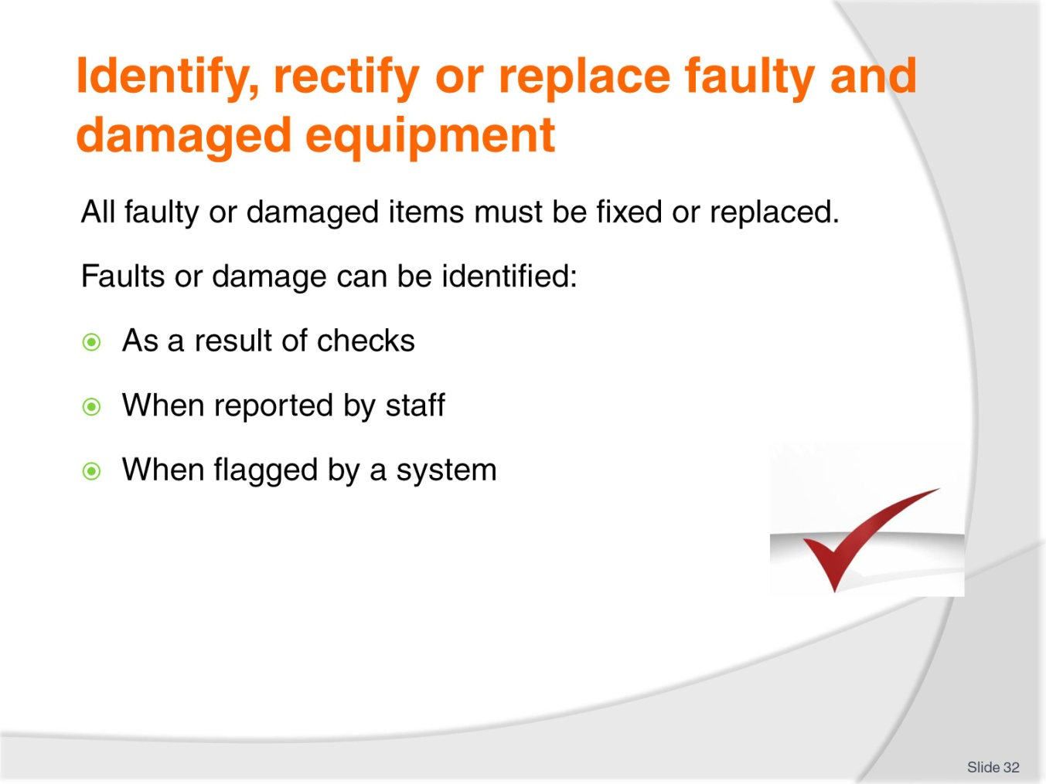
Slide No | Trainer Notes
Trainer stresses if an item is identified as being faulty or damaged during a pre-operational check it must be rectified or replaced highlighting faulty or damaged equipment may be identified:
- As a result of pre-operational checks
- When reported to you by other staff
- When flagged by the system as needing attention.

Slide
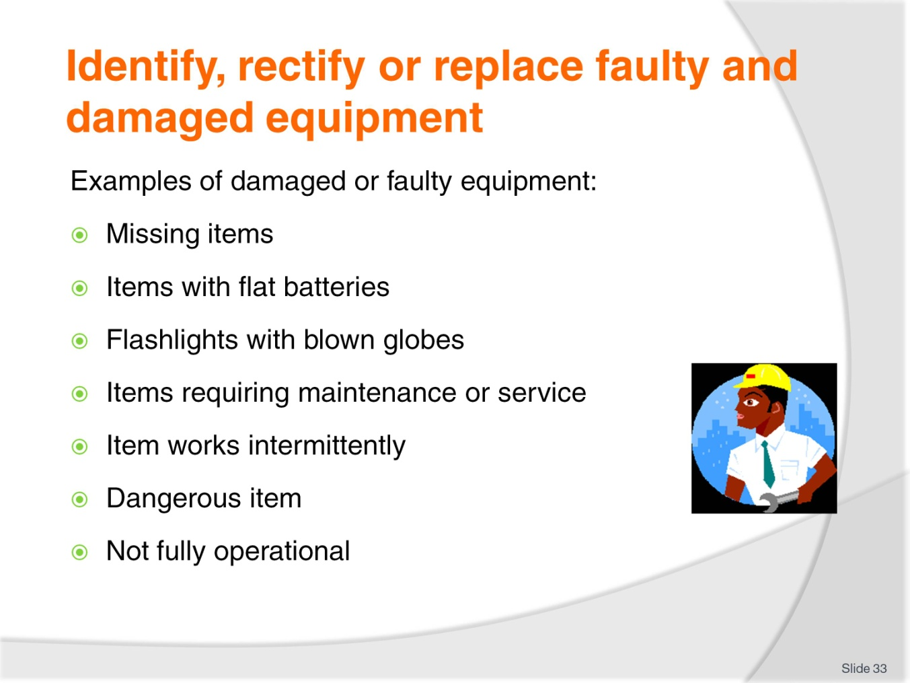
Slide No | Trainer Notes
Trainer explains there is a very liberal interpretation of what constitutes ‘faulty or damaged equipment’ stressing items do not need to be ‘broken’ to require attention and indicating examples of faulty and damaged equipment can include:
- Missing items – these can be:
- Items which have been removed for repair or service – that is, they may have been returned to the manufacturer or supplier for service or they may be with the Maintenance department being repaired
- Items which have been stolen or misplaced – it is relatively common for smaller security item to ‘go missing’ when an event occurs
- Items which have been disposed of – because of their condition or age
- Items which have flat batteries – or batteries which will no longer hold an effective charge for the required period
- Torches with blown globes
- Items (equipment, machines and systems) requiring:
- Preventative maintenance in accordance with established servicing schedules
- Service in response to requests for repairs/maintenance
- Any item which works intermittently
- Any item which it dangerous to use – for whatever reason (dangerous to you or members of the public)
- Any item or system which fails to operate as intended.
Note: many systems, pieces of equipment and items will present with one aspect not performing as intended but all other features showing full operational readiness. In these cases items are usually kept in service if the one aspect is a relatively minor component of the overall system/item.

Slide
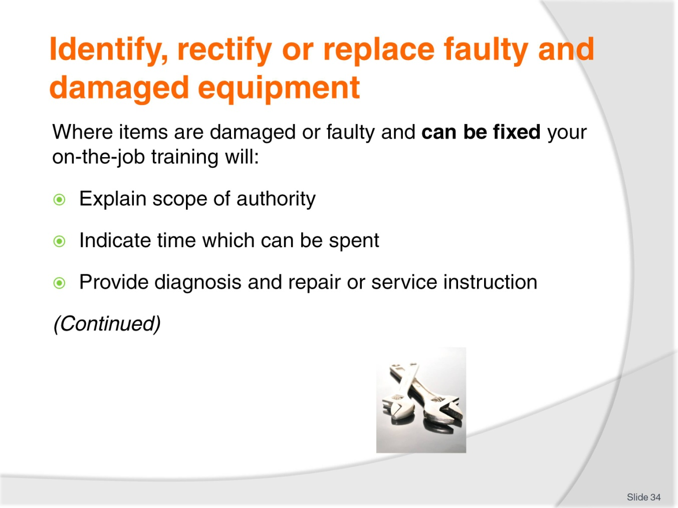
Slide No | Trainer Notes
Trainer states when students identify an issue with equipment they must follow house procedures explaining for items which can be fixed/repaired on-the-job training will:
- Explain your scope of authority for repairing security equipment – detailing:
- The items you can attempt to repair/fix – for example:
- Replacing batteries and globes would be approved
- Adjusting trigger pressure on a firearm would not
- Oiling the lock on handcuffs would be authorized
- Attempting repairs to a conveyor belt on a scanner which is under warranty would not
- Adjusting the sensitivity of a walk-through metal detector would be approved
- Re-aligning CCTV cameras to cover different areas would not.
- Limits regarding aspects such as:
- Time to be spent on fixing the problem
- Budget
- Where repairs can be undertaken
- When/if you are authorized to call in an external service provider to undertake immediate on-the-spot repairs in (say) an after-hours situation.
- Provide instruction on how to:
- Trouble-shoot – diagnose and determine causes of faults
- Repair, service and maintain items you have been authorized to work on.

Slide
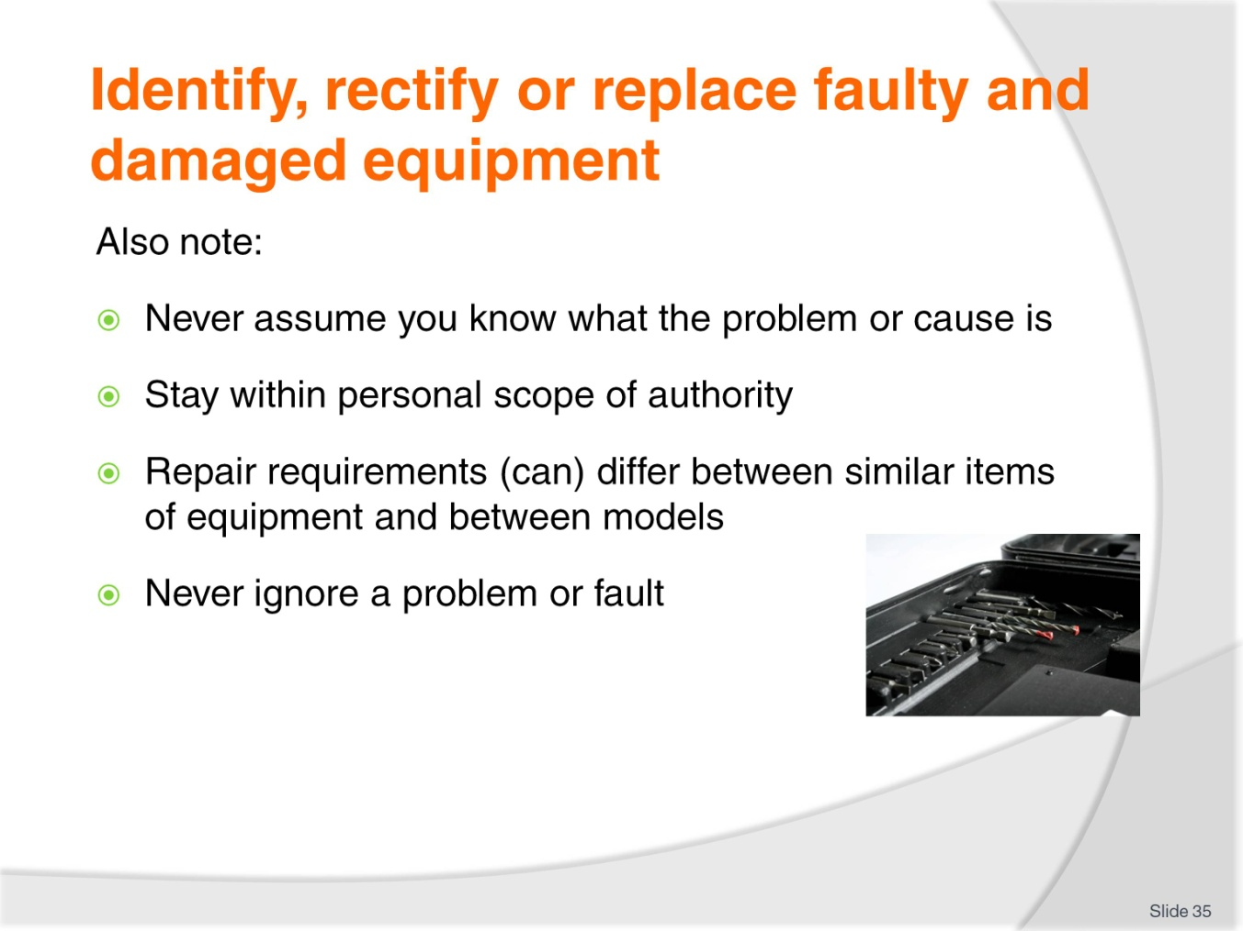
Slide No | Trainer Notes
Trainer provides additional information regarding taking action when a problem with equipment is identified:
- You must never assume you know what is wrong with an item unless you have been properly trained in diagnosing faults
- You must adhere strictly to your delegated scope of authority – failing to do so can have legal implications where the repair causes a problem or breaches the legally-binding requirements of a service contract, guarantee or warranty
- Just because you know how to repair one type, brand or model of equipment does not mean you can automatically repair all similar (but different) types, brands and models
- You must never ignore a fault or problem – you must either:
- Fix the issue
- Make arrangements for required repairs/service
- Report the issue.

Slide
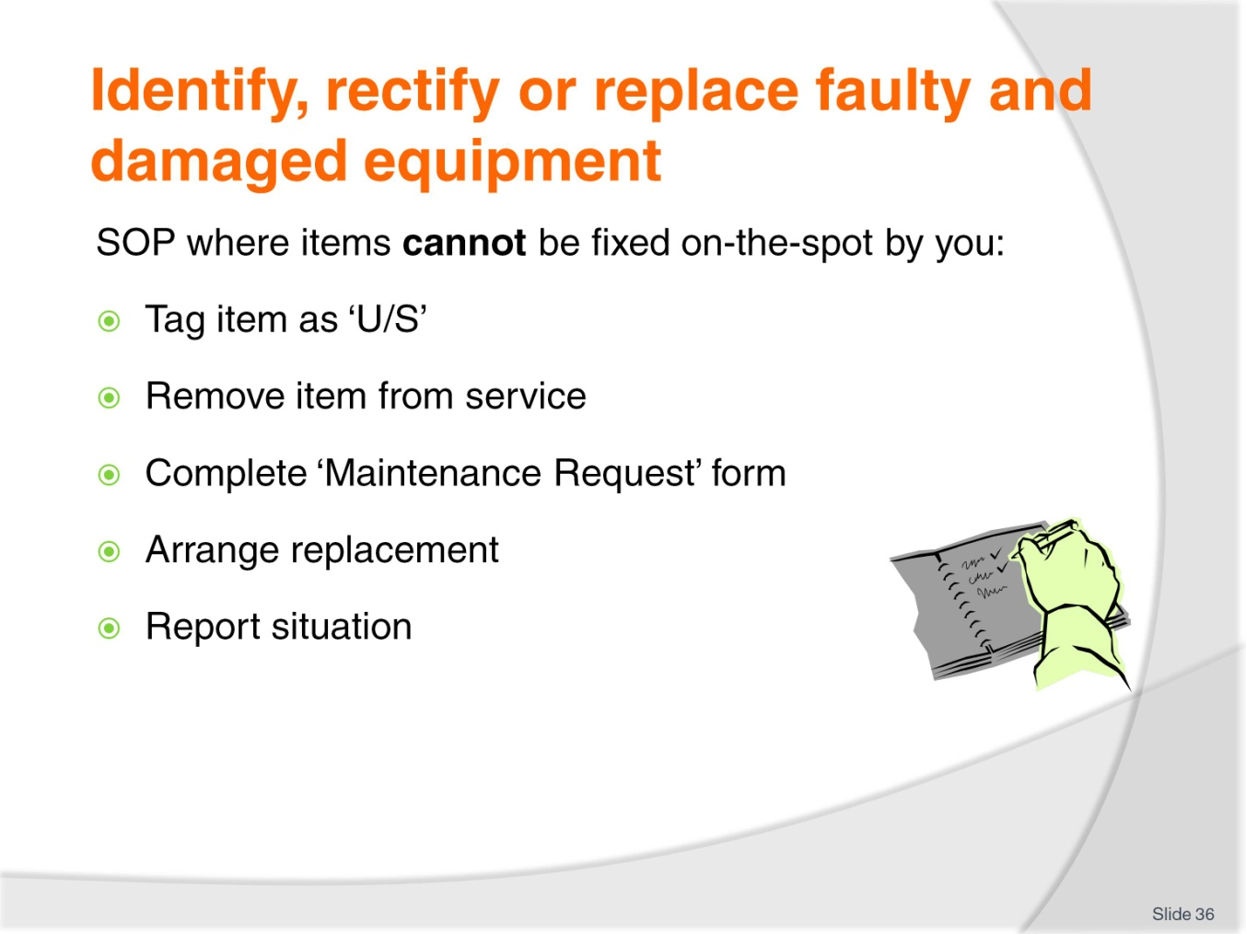
Slide No | Trainer Notes
Trainer presents possible SOP for situations where faulty/damaged security items which cannot be fixed have been identified:
- Identifying and tagging the item – as ‘U/S’
- Segregating the item from other items – so others do not take/use it and they know it is unavailable
- Taking action to initiate repair or replacement – such as:
- Completing a ‘Maintenance Request form’
- Handing the item in to a designated person/department.
- Attempting to arrange a replacement or substitute item
- Reporting the situation problem – which may require:
- Verbal notification
- Some form of written form/report
- Calling in an external technician (where authorised under your scope of authority) so immediate on-site service/repair can take place.
Class Activity – Demonstration
Trainer demonstrates procedures for dealing with an item of security equipment which staff would not be able to fix on-the-spot.

Slide
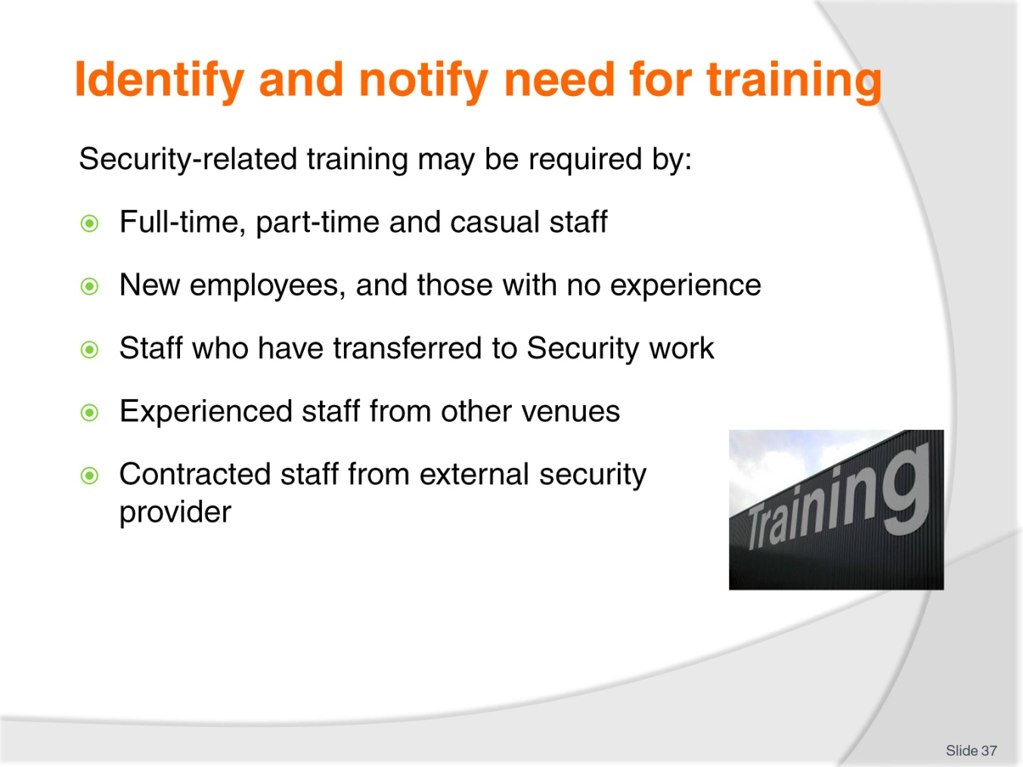
Slide No | Trainer Notes
Trainer identifies those who may need security-related training:
- Traditionally security training may be required by full-time, part-time and casual staff as follows:
- New employees – people who are new to the industry and new to the venue
- Existing employees who have transferred to duties involving security work/responsibilities
- Experienced staff – who have worked in security at other venues but not at their current workplace
- Contracted security staff from an external security company who have no previous experience at the venue – these people may be used:
- To support when a large event is taking place
- To support when a specific threat has been identified
- To replace a staff member at the last minute who has:
- Not attended for their rostered shift
- Had to leave work due to accident, injury or illness.

Slide
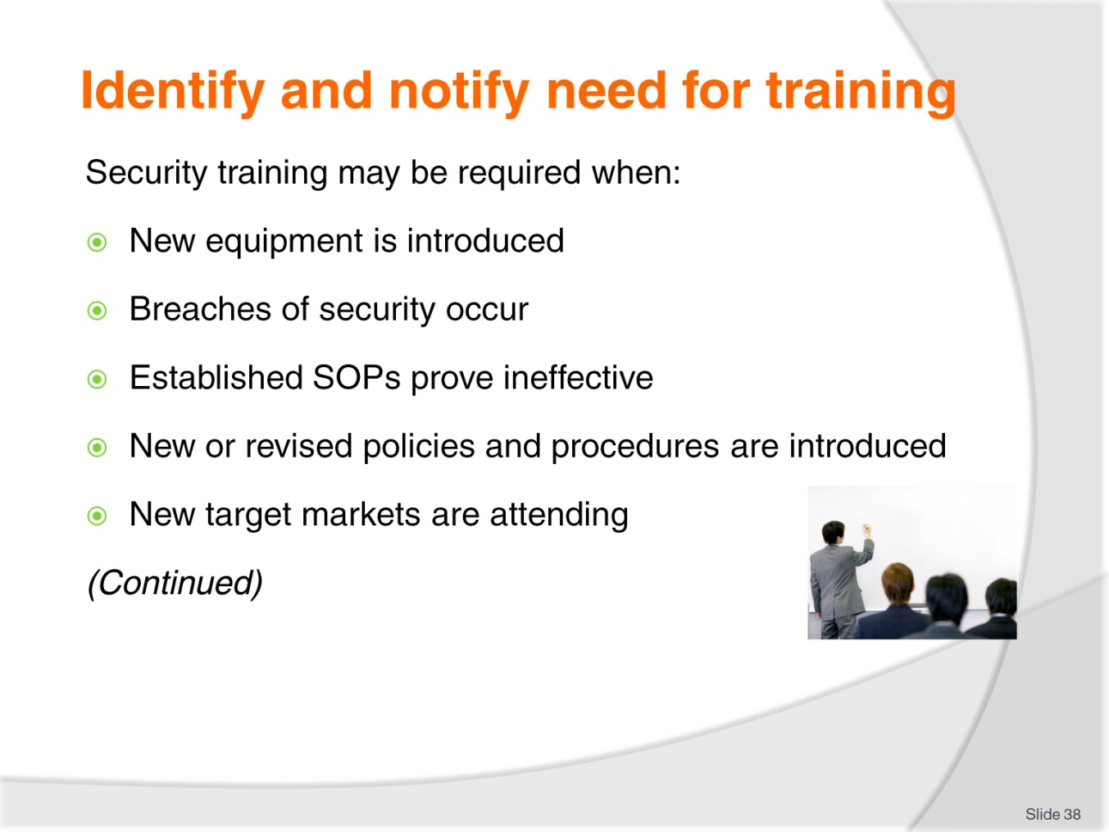
Slide No | Trainer Notes
Trainer advises security-related training may be required when:
- New equipment is bought and/or installed
- Breaches of security occur
- Established protocols prove ineffective in addressing a situation
- Employer introduces new (or revised) policies and procedures – nearly all new/revised policies and procedures have the potential to impact existing security arrangements or protocols
- A new target market/demographic is attending the venue.
Class Activity – Discussion
Trainer leads a class discussion on the need for security training asking students, for each of the points listed on the slide:
- Why security might be required
- The nature/type of training which may be required
- How it may be delivered/provided.

Slide
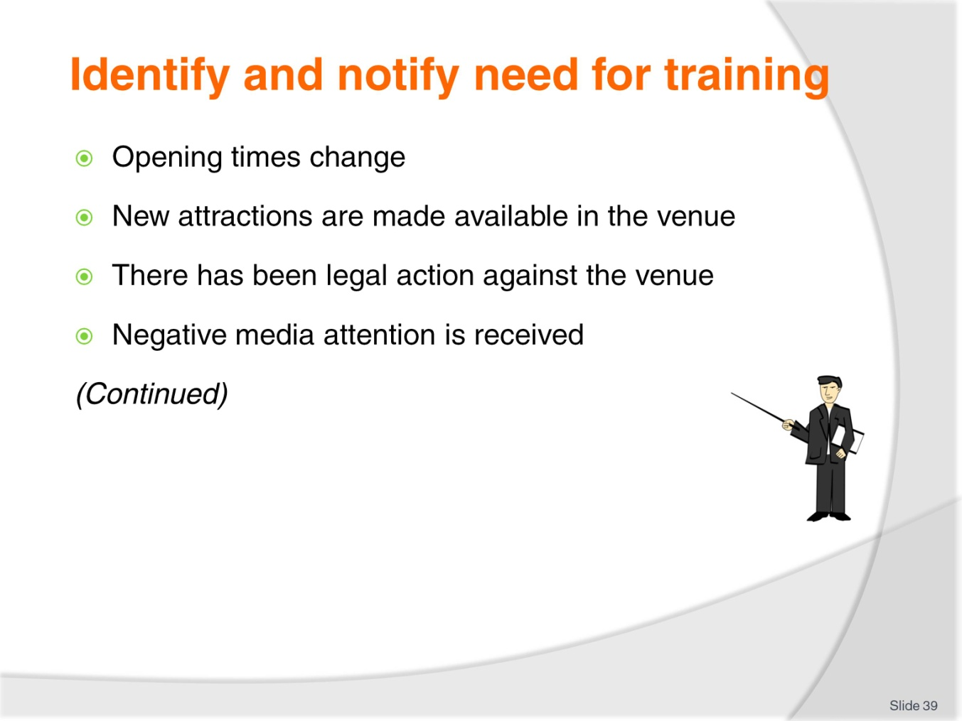
Slide No | Trainer Notes
Trainer continues advising security-related training may be required when:
- The property changes its opening/trading times
- New attractions are brought into the venue which alter demand/patronage
- Legal action has been taken against an employee or the venue
- Adverse media attention occurs about the conduct/operation of the venue.
Class Activity – Discussion
Trainer leads a class discussion on the need for security training asking students, for each of the points listed on the slide:
- Why security might be required
- The nature/type of training which may be required
- How it may be delivered/provided.

Slide
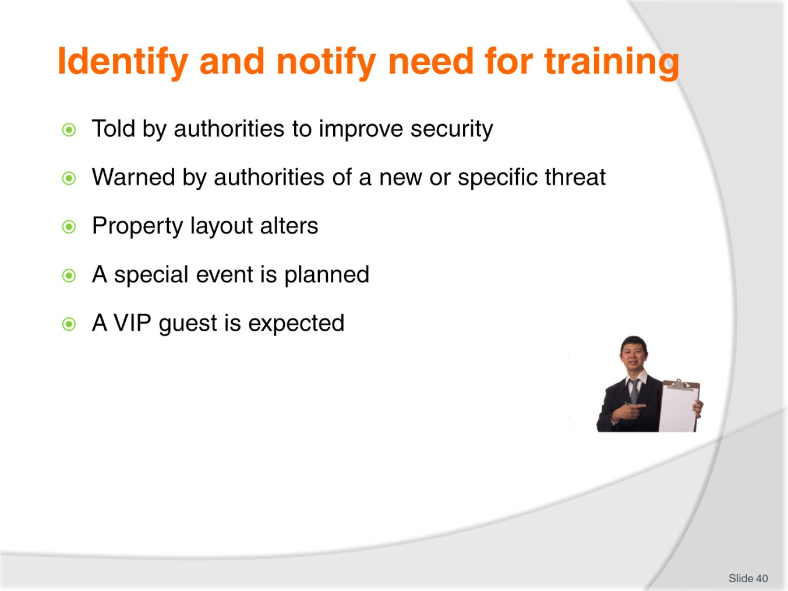
Slide No | Trainer Notes
Trainer continues advising security-related training may be required when:
- Authorities advise the venue needs to improve/modify its security
- Authorities warn the venue of an identified/expected new threat
- The layout of the property changes – which creates new risks, choke points/bottlenecks and potential for theft and other issues
- A special or important event is expected
- A VIP guest requires special security arrangements not normally provided by the venue.

Slide
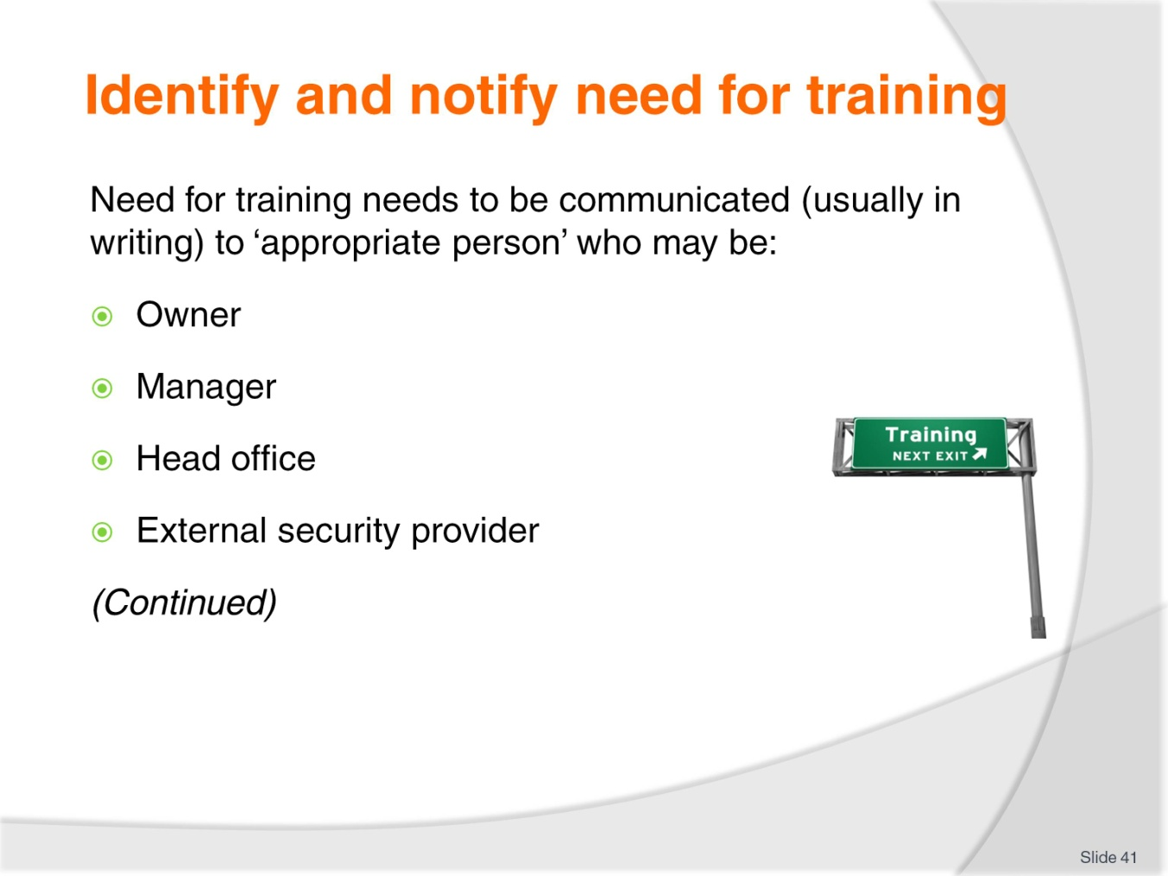
Slide No | Trainer Notes
Trainer notes when the need for security-related training has been identified the normal course of action is to put the identified need into a formal written request and submit it to the ‘appropriate person’ or group in the venue. The ‘appropriate person’ may be:
- Owner
- Manager
- Head office
- External security provider – where the venue out-sources its security.

Slide
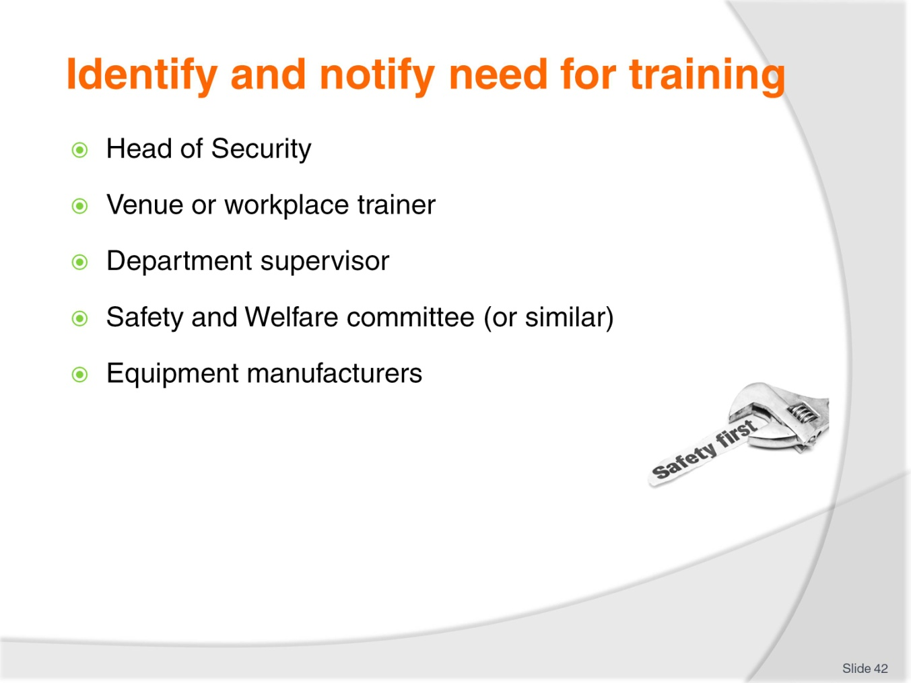
Slide No | Trainer Notes
Trainer continues identifying who the need for security training may need to be reported to:
- Head of Security
- Venue trainer
- Department supervisor
- Safety and Welfare (or similar) Committee
- Equipment manufacturers – suppliers of systems and large equipment will often provide training on their items (sometimes free; sometimes on a fee-for-service basis).

Slide
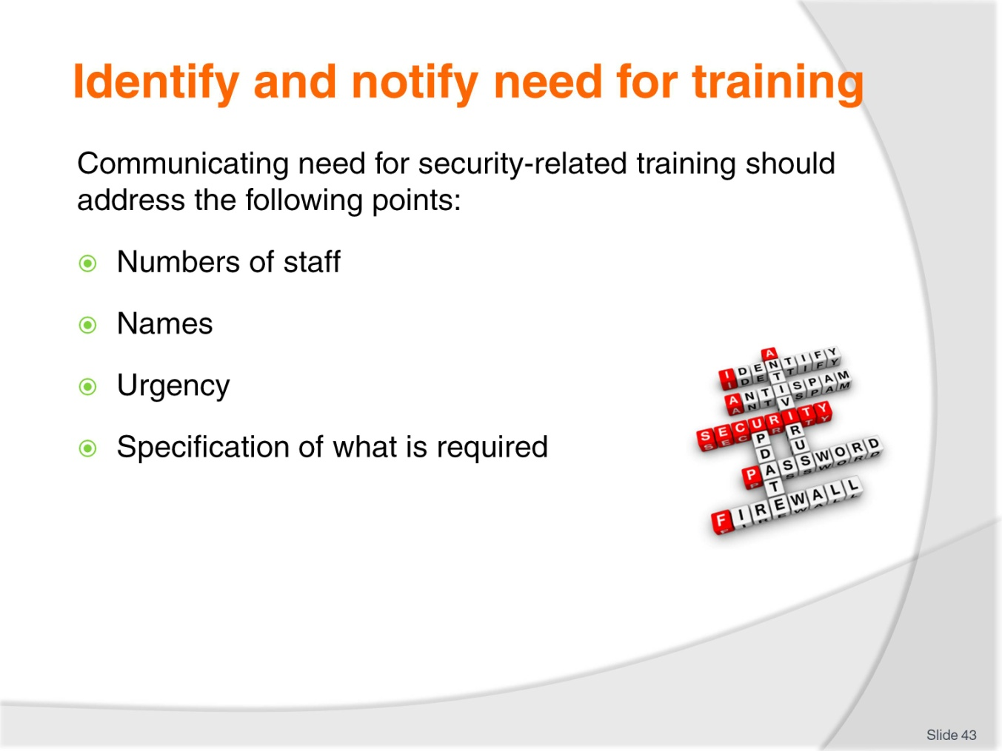
Slide No | Trainer Notes
Trainer notes when reporting security training requirements the following should be communicated:
- Number of staff requiring training
- Names of staff – with contact details
- Urgency of the request for training
- Specification of the type/nature of the training required.
Class Activity – Guest Speaker
Trainer arranges for venue manager to attend and:
- Discuss SOPs for reporting faulty/damaged security items
- Describe pre-operational checks made on security equipment
- Give examples of venue training provided for security staff
- Describe how need for security training is identified and met.

Slide
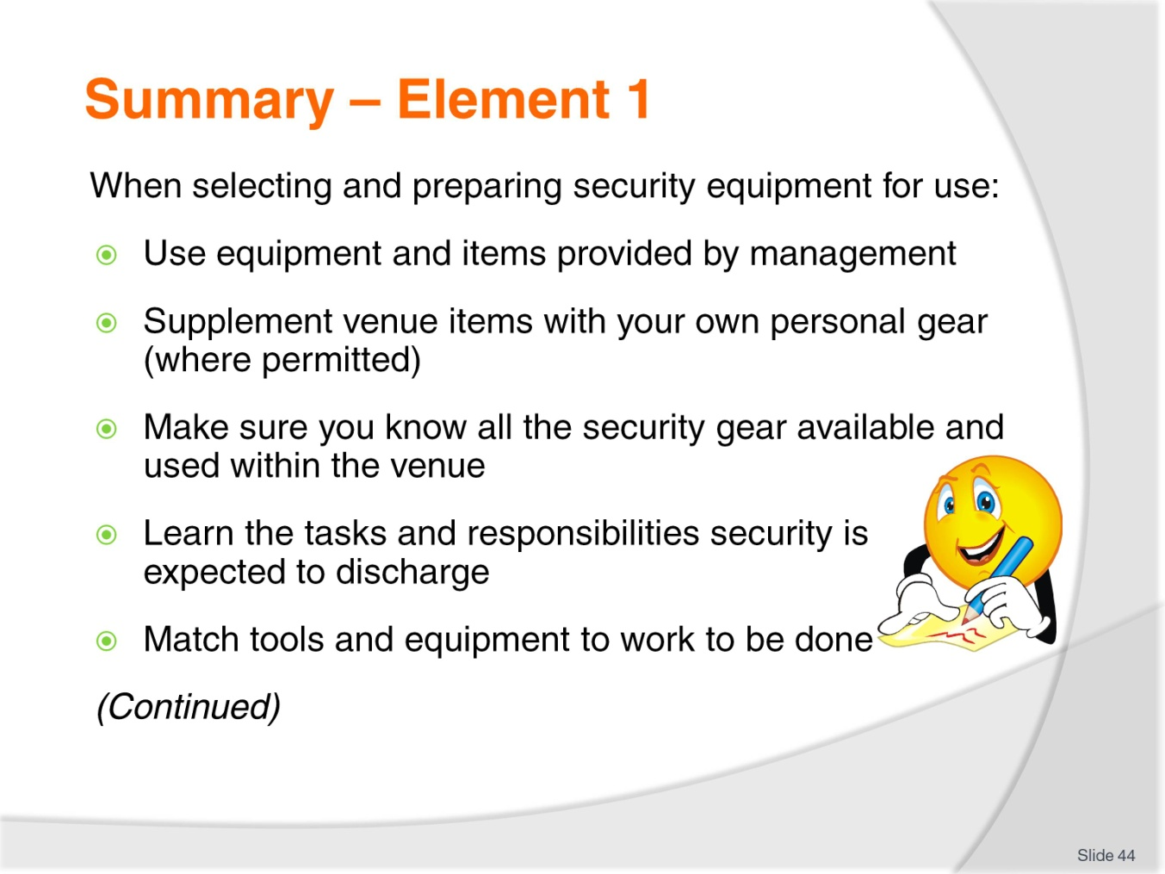
Slide No | Trainer Notes
 | Trainer provides a recap of the Element asking questions to check trainee understanding and responding to questions from trainees, as required.

Slide
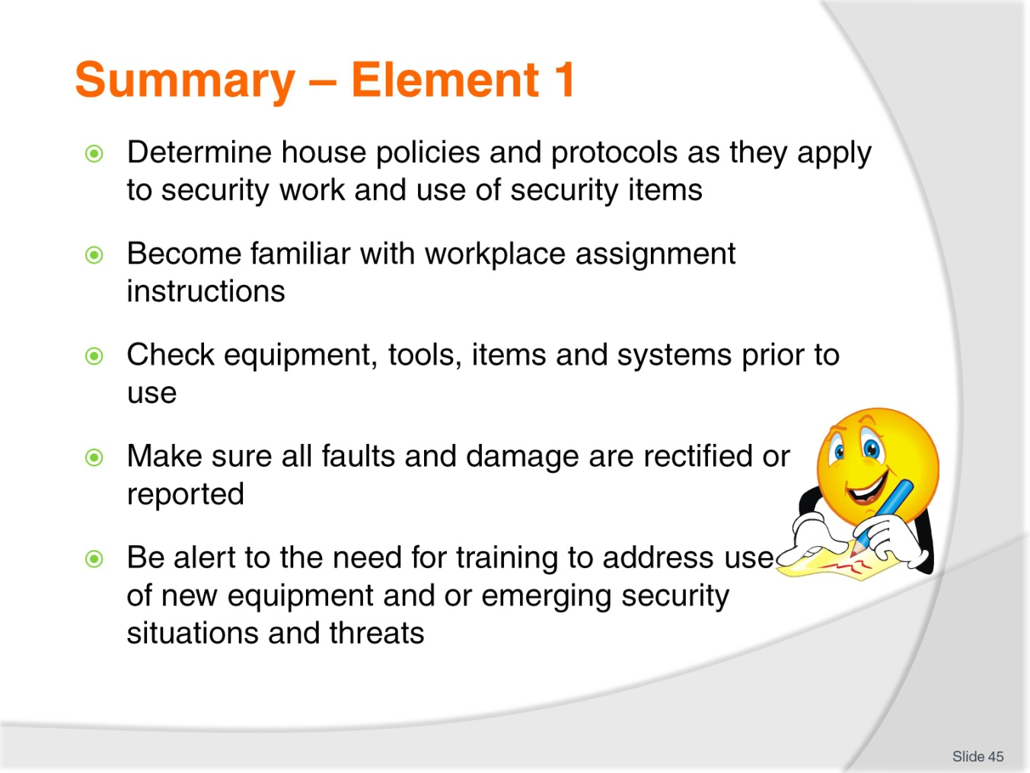
Slide No | Trainer Notes
 | Trainer provides a recap of the Element asking questions to check trainee understanding and responding to questions from trainees, as required.

Slide
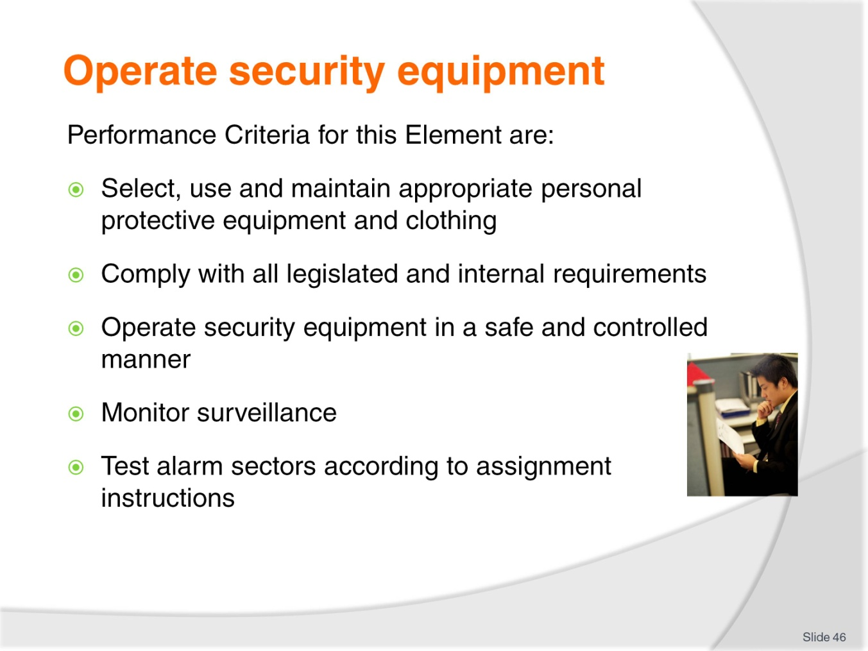
Slide No | Trainer Notes
Trainer identifies for trainees the Performance Criteria for this Element, as listed on the slide.
Class Activity – Discussion
Trainer leads a discussion on operating security equipment by asking students questions such as:
- What experience have you had with operating security equipment?
- Why is it important to know how to operate security equipment?
- How can you learn how to operate security equipment?
- What items of personal protective equipment and clothing do you know of?

Slide
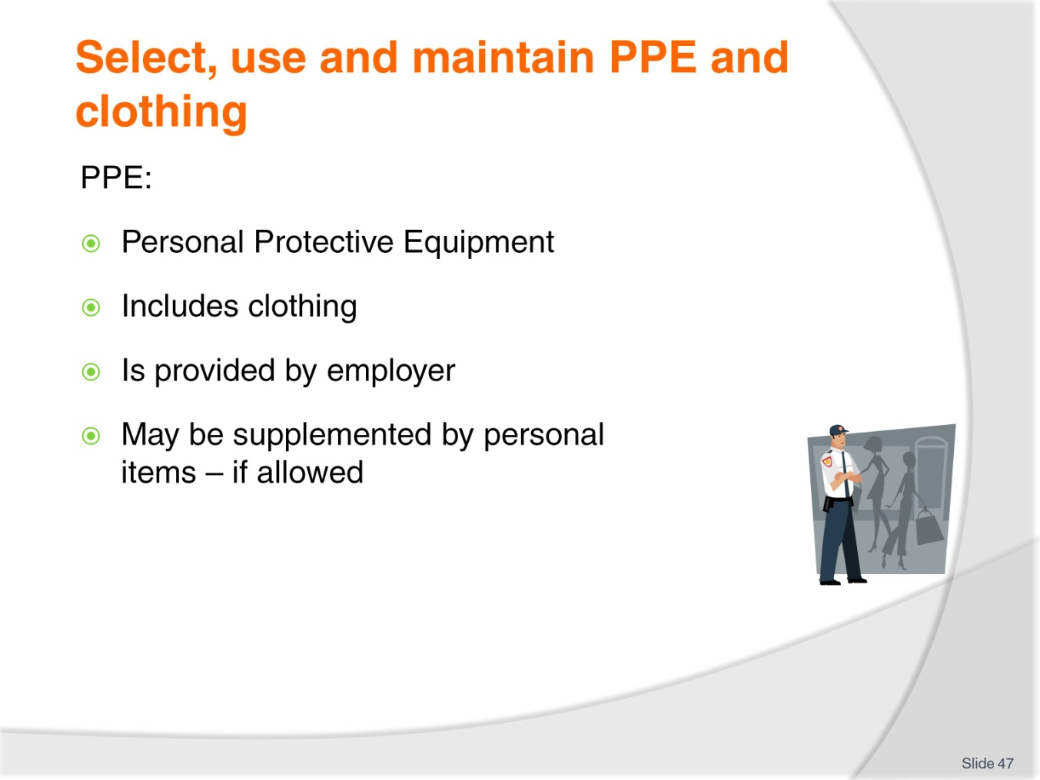
Slide No | Trainer Notes
Trainer introduces PPE stating PPE:
- Stands for Personal Protective Equipment
- Includes reference to protective clothing
- Is provided by employer
- May be supplemented by personal items – permission needs to be obtained from management.

Slide
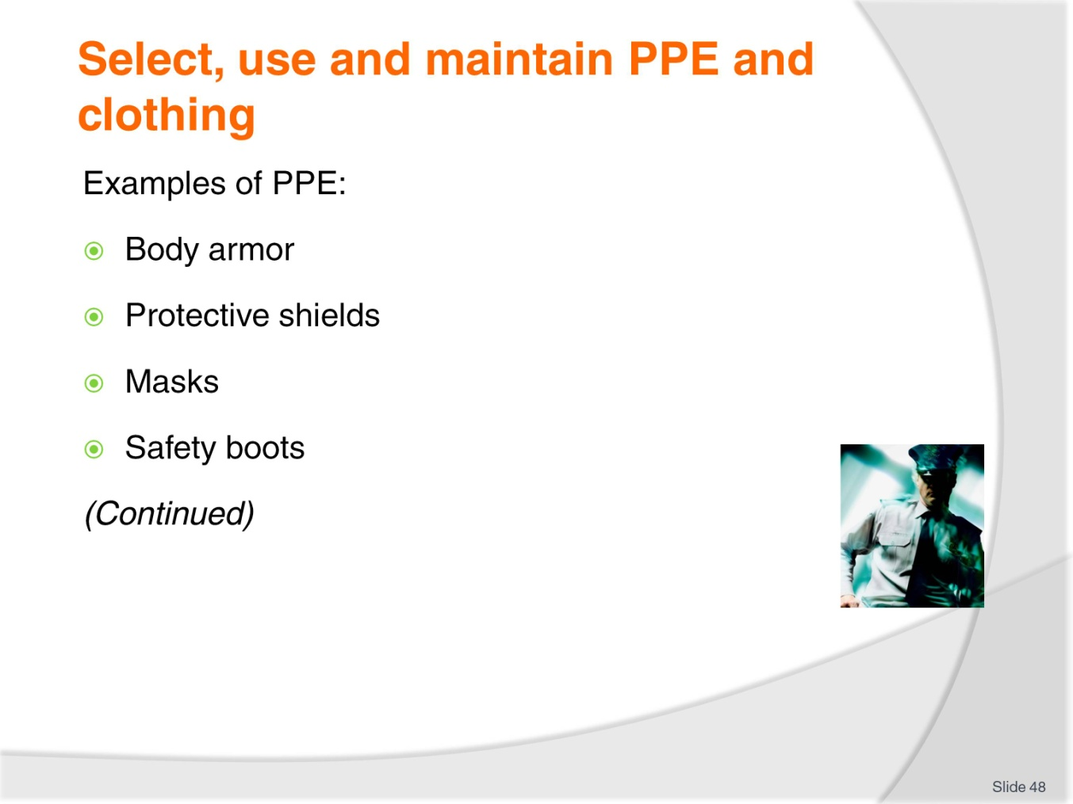
Slide No | Trainer Notes
Trainer presents examples of PPE:
Body armour
These are items worn to protect the body against bullets and knives.
They can be covert (worn so they cannot be seen – so it does not alarm guests) or overt (meaning they are worn ‘obviously’) sending a message to potential aggressors you are aware of a threat and are prepared for it.
Body armour is not commonly worn and most venues will not have body armour as part of their standard stock of PPE.
Protective shields
Protective shields provide personal protection in close contact/crowd control situations and may be used as equipment to encourage/force people to ‘move away’.
Masks
Masks are used to protect the face and eyes against:
Physical attack
Gas attack.
As with external/overt body armour, wearing a mask signals preparedness and readiness to act.
Safety boots
It is a standard requirement all security staff wear steel-capped boots for personal protection of the feet as well as enabling a supplementary attack option.
Class Activity – Presentation, Explanation, Demonstration and Practical
Trainer:
- Presents examples of PPE as listed on slide
- Explains when and how items may be used
- Demonstrates use
- Provides opportunity for students to practice use of items.

Slide
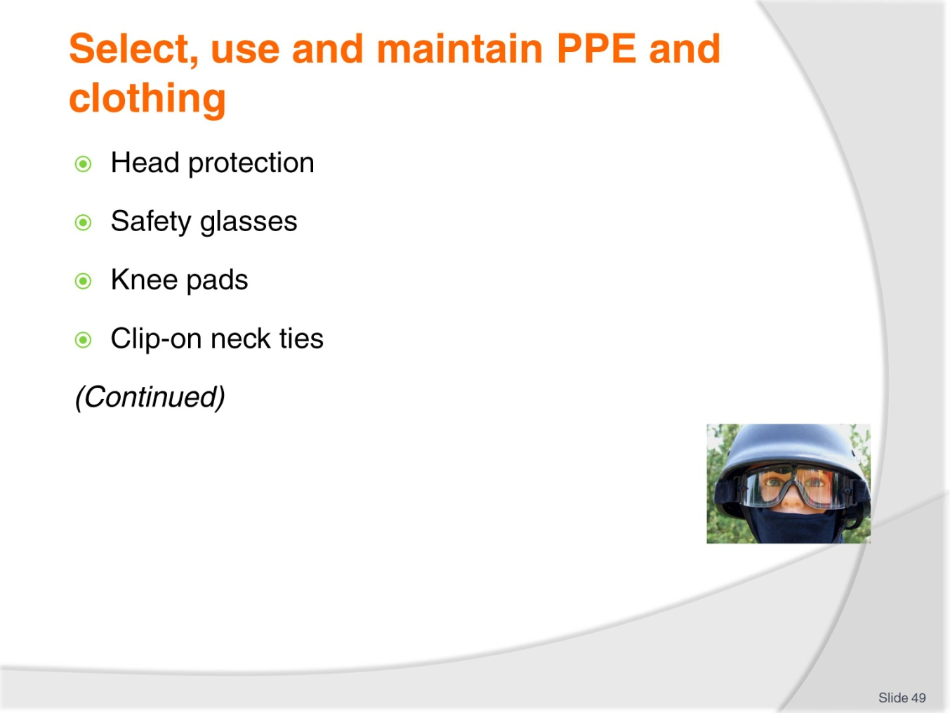
Slide No | Trainer Notes
Trainer continues presenting examples of PPE:
Head protection
Helmets are not commonplace in venue security as they tend to alarm guests.
Where planning and analysis of a situation indicates helmets are required they will usually need to be borrowed, bought or hired.
Once again, wearing a helmet conveys an image of readiness, willingness and preparedness.
Safety glasses
These are commonly combined into head gear or masks and are used when personal attack is expected to protect the eyes.
They will/should protect against acid attack.
Again, wearing safety glasses can be part of the intimidation provided by a fully-equipped officer in an incident response situation.
Knee pads
May be worn in crowd control situations to protect the knees in the event you are pushed to the ground.
As with steel-capped boots, they also provide an attack option.
Neck ties
Many/most uniforms for security staff do not require the wearing of neck ties.
Where they are required they should always be of the clip-on type so they pull off if someone grabs them.
This prevents an aggressor being able to pull you towards them when they grab your tie.
Class Activity – Presentation, Explanation, Demonstration and Practical
Trainer:
- Presents examples of PPE as listed on slide
- Explains when and how items may be used
- Demonstrates use
- Provides opportunity for students to practice use of items.

Slide
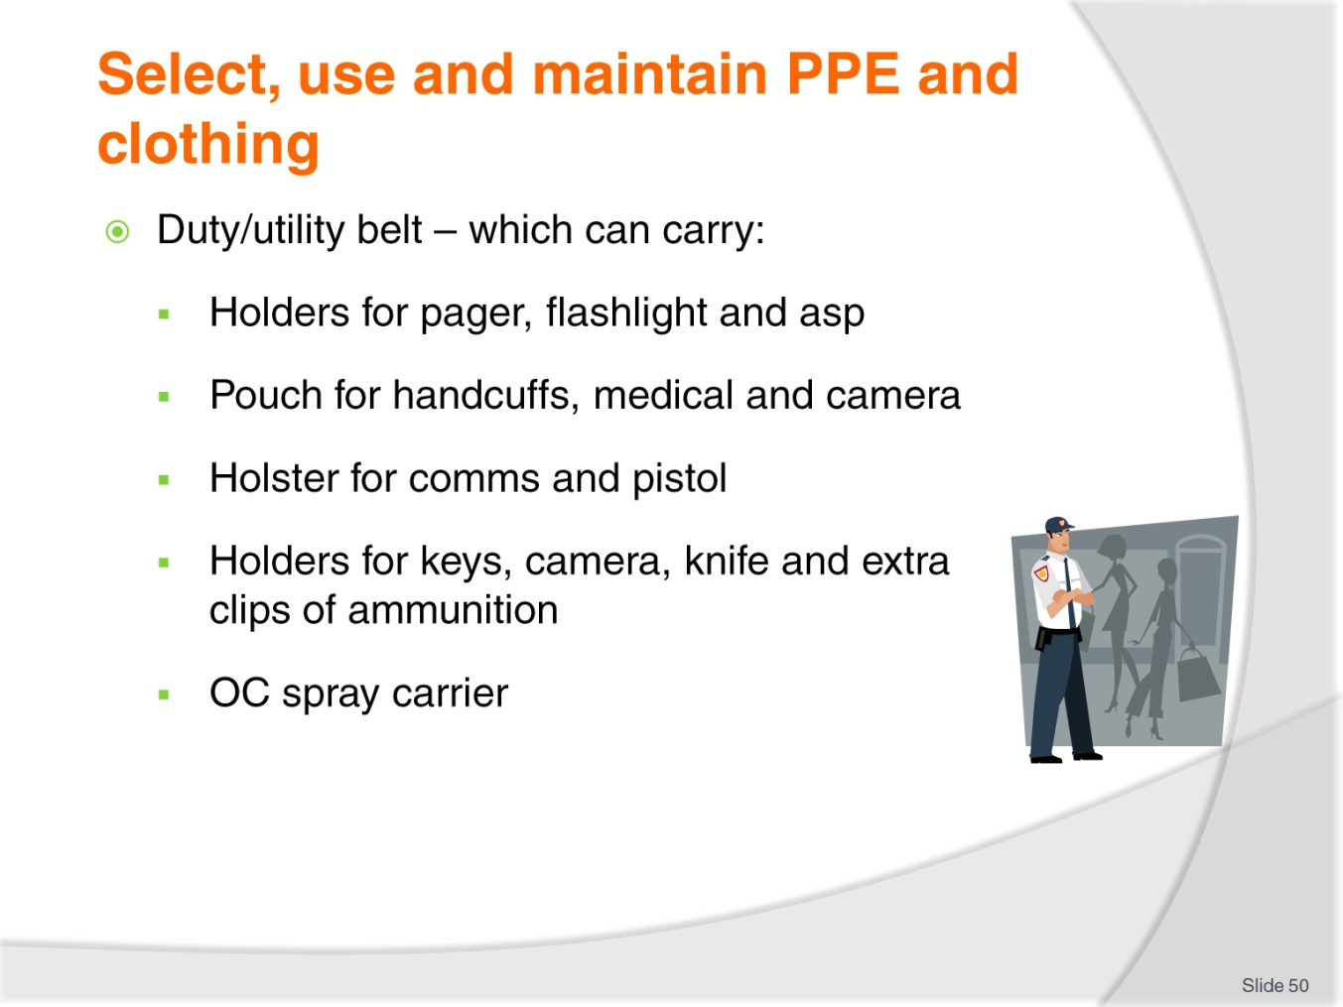
Slide No | Trainer Notes
Trainer continues presenting examples of PPE:
Duty belt
Also known as utility belt this is used to carry equipment/items you require when undertaking security work/patrolling the premises.
You may be supplied with this belt by the venue or you may purchase your own.
The duty belt has many attachments and holsters/pouches which carry the equipment.
It is your choice as to how your belt is set up (that is, exactly where on the belt you position items).
A standard belt set-up for staff who are not armed may/should include:
- Pager holder – with pager
- Flashlight holder – with torch
- Asp/baton holder – with asp or baton
- Handcuff pouch – with handcuffs
- Comms holster – for radio
- Medical pouch – containing disposable gloves and CPR mask
- OC spray carrier – with spray
- Key holder – with handcuff keys and other keys as required
- Camera case/pouch – with camera
- Knife holder – with knife.
A duty belt for an armed officer will add a pistol and holster plus one (or two) magazine pouch to house an extra clip of ammunition.
The duty belt is attached to your normal belt by a number (six to eight) belt-keepers. The duty belt does not replace the belt you use in your trousers.
Class Activity – Presentation, Explanation, Demonstration and Practical
Trainer:
- Presents examples of PPE as listed on slide
- Explains when and how items may be used
- Demonstrates use
- Provides opportunity for students to practice use of items.

Slide
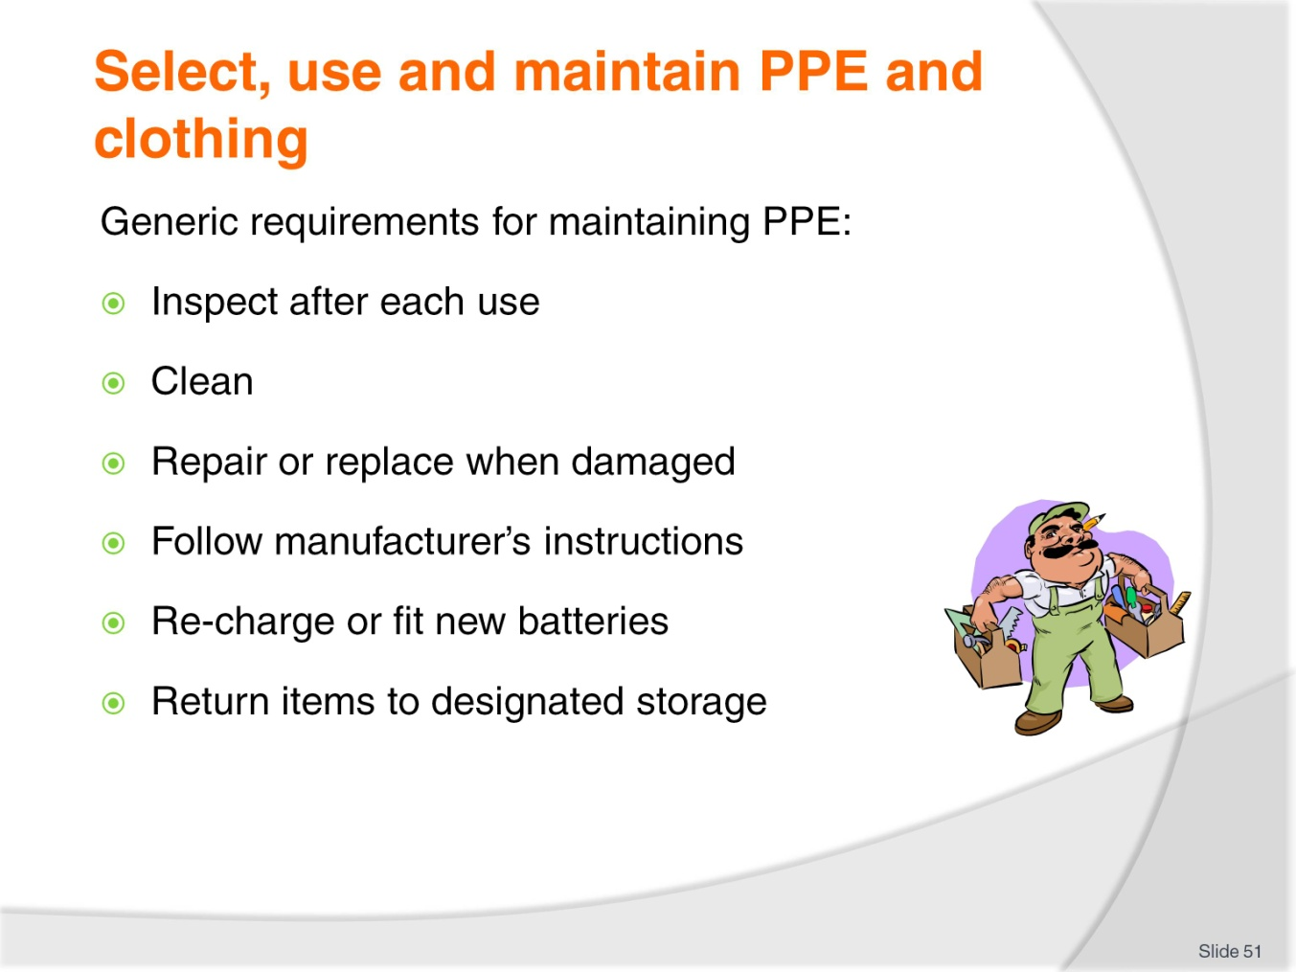
Slide No | Trainer Notes
Trainer identifies generic requirements for maintaining PPE are:
- Inspect after reach use
- Clean after each use
- Replace or repair when damaged – the preference is for replacement
- Follow manufacturer’s instructions
- For battery-powered items:
- Re-charge as required
- Fit with new batteries as required.
- Return items to designated storage locations after maintenance/cleaning – so they are available for others to use.

Slide
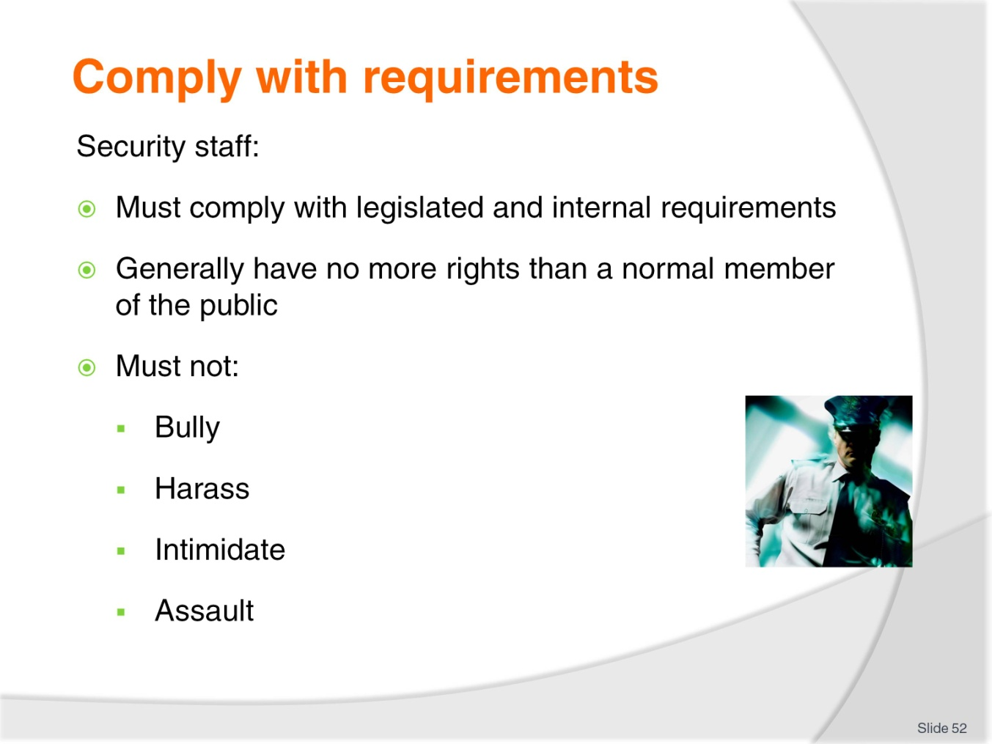
Slide No | Trainer Notes
Trainer states all security staff:
- Must comply with all relevant legislated and internal requirements stressing It is vital security staff understand the legal limitations relating to what they are entitled to do when working as security staff
- In the main, security staff can do little more than other staff or members of the public when it comes to responding to incidents and when taking action in response to unacceptable behaviour by people
- Do not have ‘a right’ to:
- Bully
- Harass
- Intimidate
- Assault.

Slide
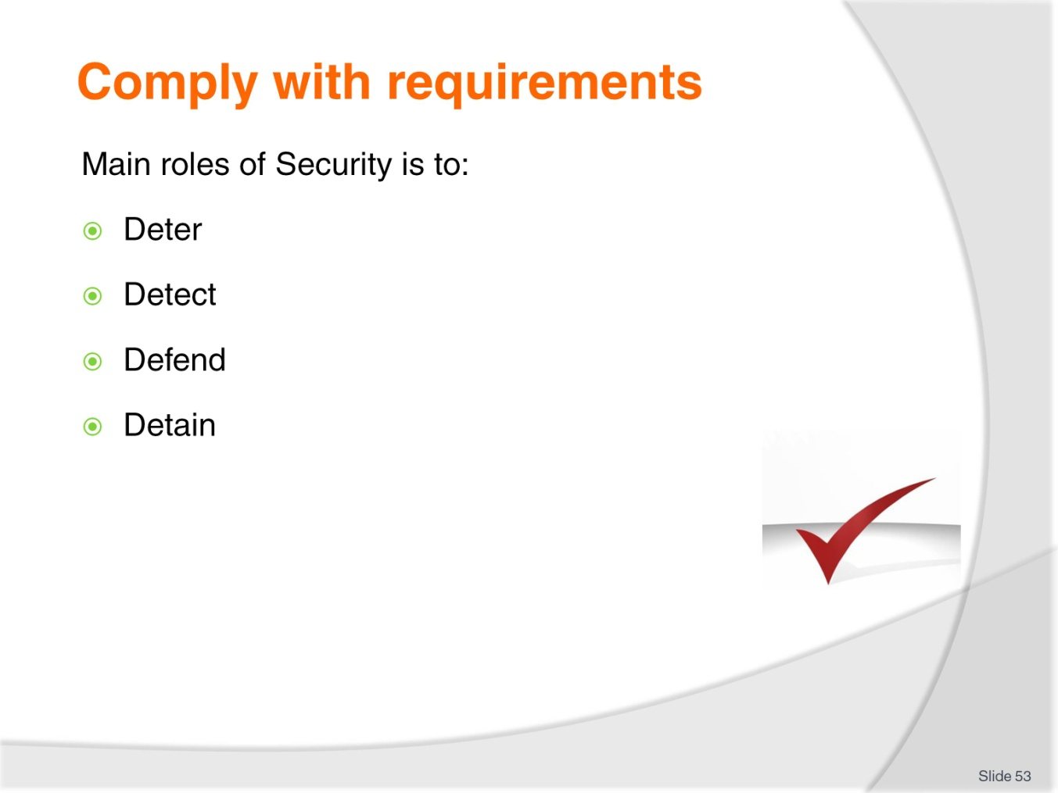
Slide No | Trainer Notes
Trainer identifies the four main roles of Security staff are to:
- Deter:
- Customers/guests from behaving in an unacceptable manner – by their physical presence
- Theft from the venue – through their loss prevention activities (observing activities and people (staff and patrons), monitoring alarms and anti-theft devices (including EAS devices), patrolling areas.
- Detect:
- Offences which have been committed
- Unauthorized access to, and use of, facilities
- The presence of people on the premises whose presence renders the venue liable to an offence – such as identifying intoxicated persons or under-age people on the premises.
- Defend:
- People from unwanted and/or potentially dangerous/harmful or offensive actions or behaviour of others
- The property against damage.
- Detain:
- People who have broken the law – see ‘Making an arrest’ (below).

Slide
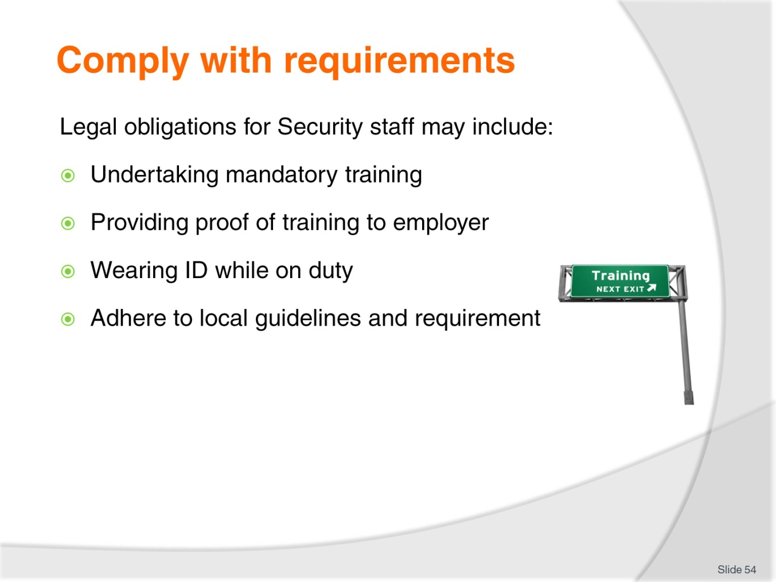
Slide No | Trainer Notes
Trainer advises in order to work as a security person the following requirements generally apply but students need to check what applies in their country and in the specific venue where they are employed.
They may need to:
- Undertake and successfully complete nominated security training/courses – in some countries/regions/locations there can also be a need to undertake refresher training every two to three years to maintain currency of accreditation/certification
- Provide your employer with proof of:
- Training which has been completed
- Currency of certification
- Wear nominated identification so members of the public can:
- Identify you as a member of security staff
- Identify you as a specific individual by name or number
- Adhere to the requirements of national or local guidelines developed to govern the actions of security staff in order:
- Members of the public can have faith and confidence in them
- Their actions are controlled so they remain legal and ethical.

Slide
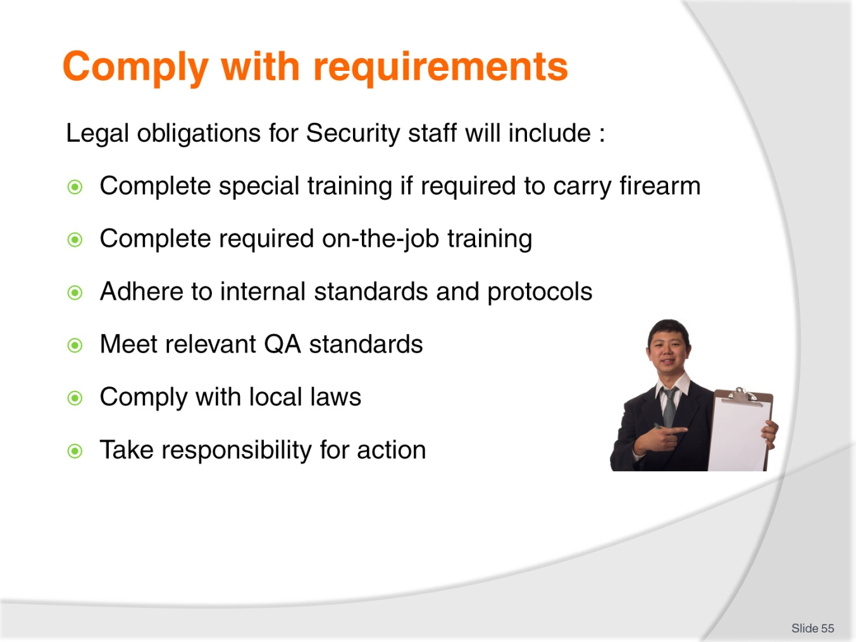
Slide No | Trainer Notes
Trainer states in addition students will need to:
- Complete necessary official training if you wish to carry a firearm
- Complete any internal, on-the-job training required to familiarize you with venue requirements, SOPs, systems, venue layout and the unique factors relating to individual properties or tasks
- Adhere to the standards and protocols of your employer when undertaking security work
- Meet all relevant QA standards as they apply to the security work being performed
- Comply with the laws of the country as they apply to security work and the limitations and restrictions imposed on anyone undertaking security work
- Be responsible for your actions – every action you take (or elect not to take) is always subject to scrutiny and analysis: always remember you are on show to the public and someone (or something) is always watching you.

Slide
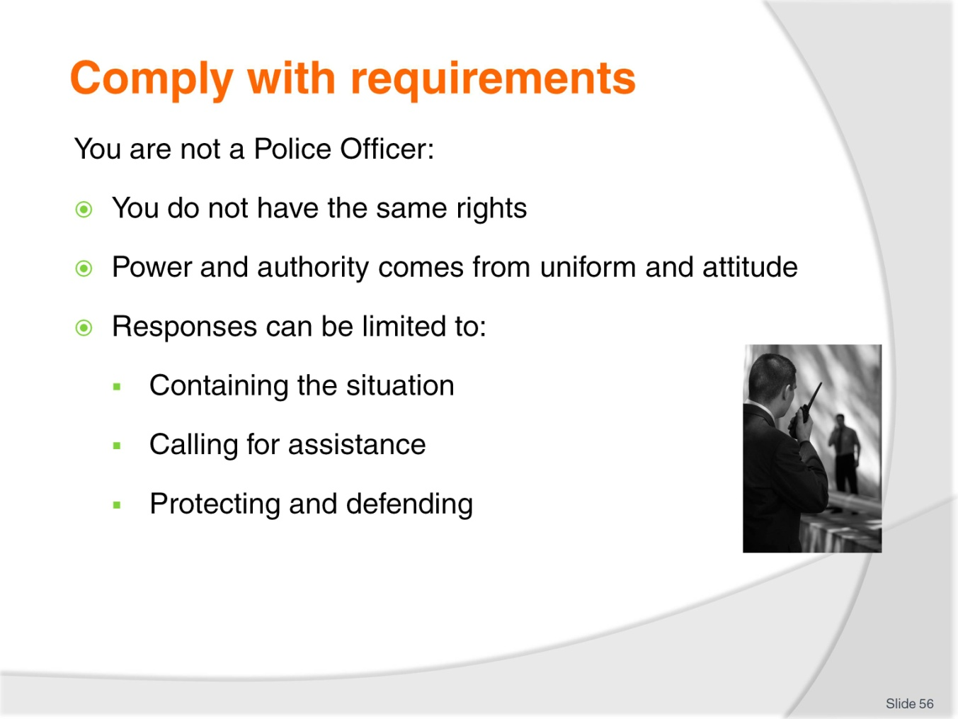
Slide No | Trainer Notes
Trainer urges students to understand performing security work in a venue does not make them a police officer making the following points:
- They do not have the same rights as a police officer
- They do not have the same right to stop people or to demand their name. They may, of course, request it/ask for it but people do not have to comply:
- As already stated your rights as a security officer are, in reality, no more than the rights of the ordinary citizen.
- ‘Power’/’authority’ often comes from:
- The fact you are in uniform – and most people respect the uniform
- Your demeanour/attitude and appearance – and sometimes your size.
- The reality of many security jobs is if a problem occurs your job is to:
- Contain the situation to the best of your ability – by, for example:
- Moving people away from the situation
- Restricting access to an area.
- Call for assistance from external security or local authorities
- Protect and defend – always put the protection of lives/people above the protection of assets/physical resources (including cash).
Class Activity – Guest Speaker
Trainer arranges for local Police officer to attend and:
- Discuss legal rights/limitations regarding what Security staff can and cannot do
- Offer suggestions for dealing with situations
- Identify how to summon police assistance.

Slide
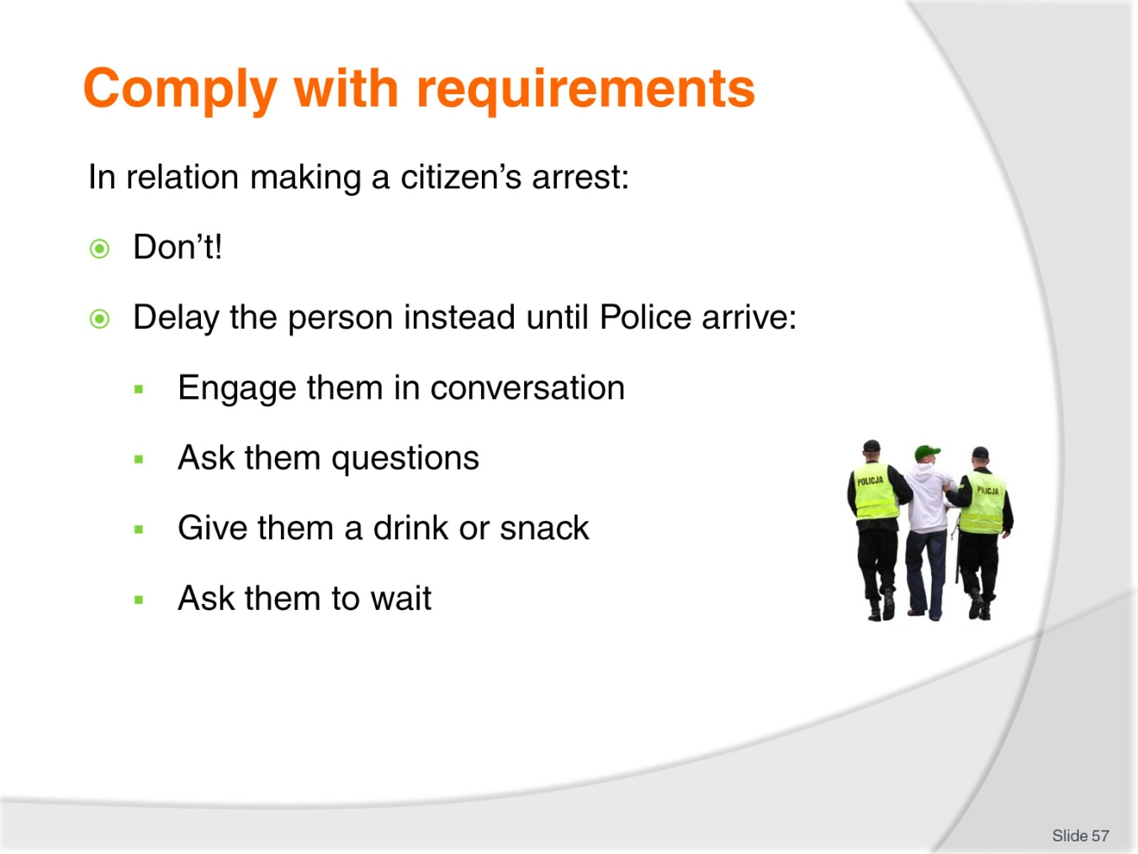
Slide No | Trainer Notes
Trainer discusses topic of Security staff making an arrest offering:
- They should avoid doing this – as there are too many possible legal implications (being sued for wrongful arrest or similar)
- They should instead try to delay the person identifying strategies to delay ‘offenders’ until police arrive can include:
- Engaging the person in conversation – to distract them/keep them ‘on scene’
- Asking them questions – which again occupies them and keeps them present
- Providing them with a drink or something to eat
- Asking them to wait for the police to arrive.
Class Activity – Demonstration and Practical
Trainer:
- Demonstrates techniques to delay an offender until police arrive
- Provides opportunity for students to practice same.

Slide
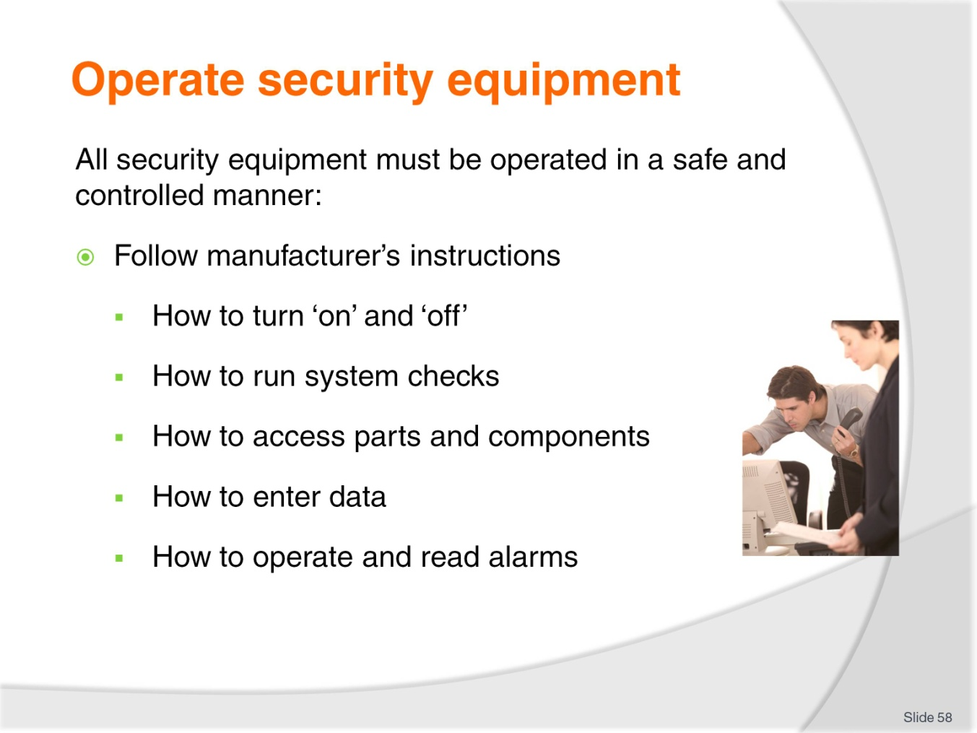
Slide No | Trainer Notes
Trainer explains all security equipment must be operated in a safe and controlled manner at all times highlighting need to:
- Follow manufacturer’s instructions:
- How to turn the system/technology on and off:
- To log on and log off
- To access nominated sections of the system
- To access/read nominated sectors of the business.
- How to run system checks – where the system/technology conducts internal audits of its capacity and generates a Situation Report’ detailing the ‘status’ of all its component parts
- How to adjust element of the system – such as:
- How to focus cameras
- How to adjust sensitivity of scanners
- How to change passwords and access codes.
- How to access parts of the system:
- To run checks
- To retrieve data
- To interrogate the system
- To generate hard and soft reports.
- How to enter data into the system:
- To update information/data fields
- To add new staff – or remove access for nominated staff
- To accommodate SOPs for data entry, archiving data and completion of records, reports and electronic documentation.
- How to operate and read alarms systems – including:
- Determining type and location of threat/problem from an alarm board, indicator or other system alert
- Knowing how to activate and de-activate the entire system or required aspects of it.
Class Activity – Demonstration
Trainer shows students how to use a selection of security equipment according to manufacturer instructions.

Slide
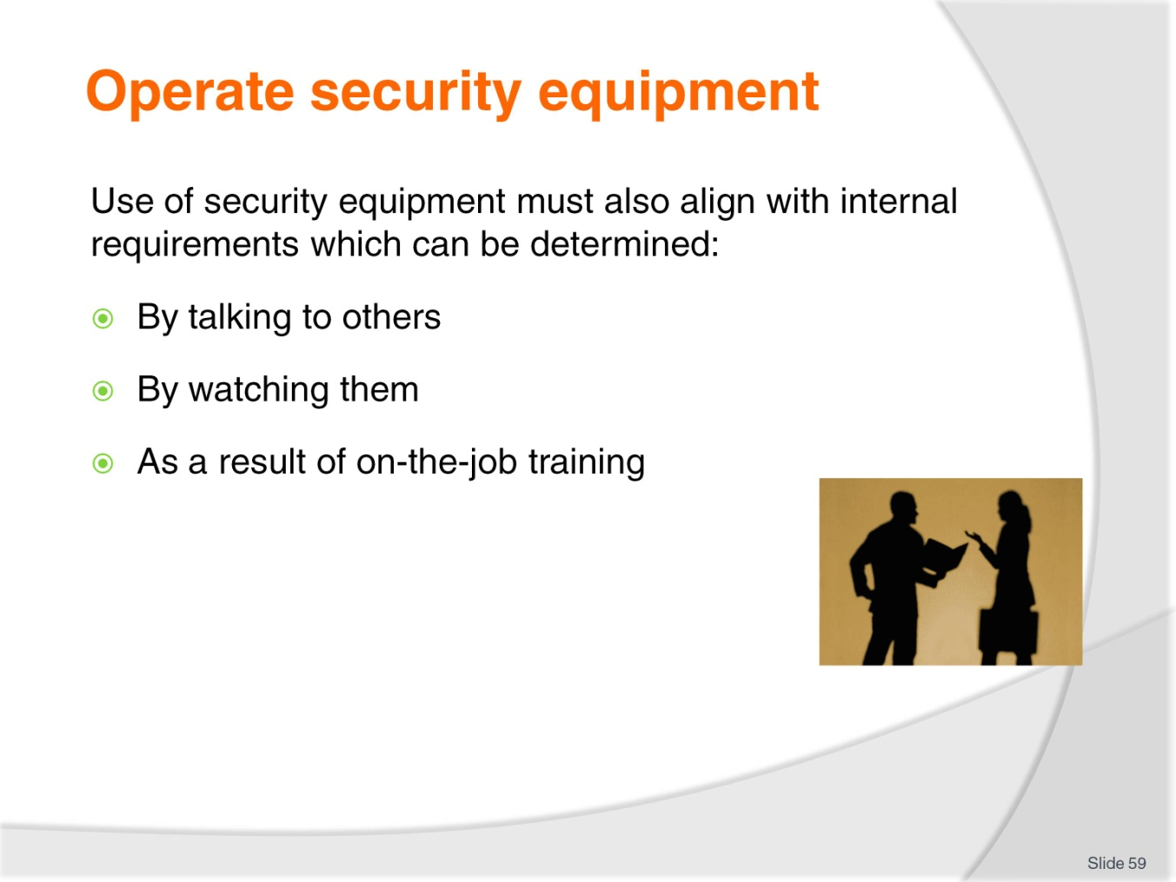
Slide No | Trainer Notes
Trainer mentions security equipment must also be operated in accordance with internal requirements explaining students can identify what these are in each workplace through:
- Discussions with your colleagues and supervisor
- Observing their actions
- As a result of formal, internal training.

Slide
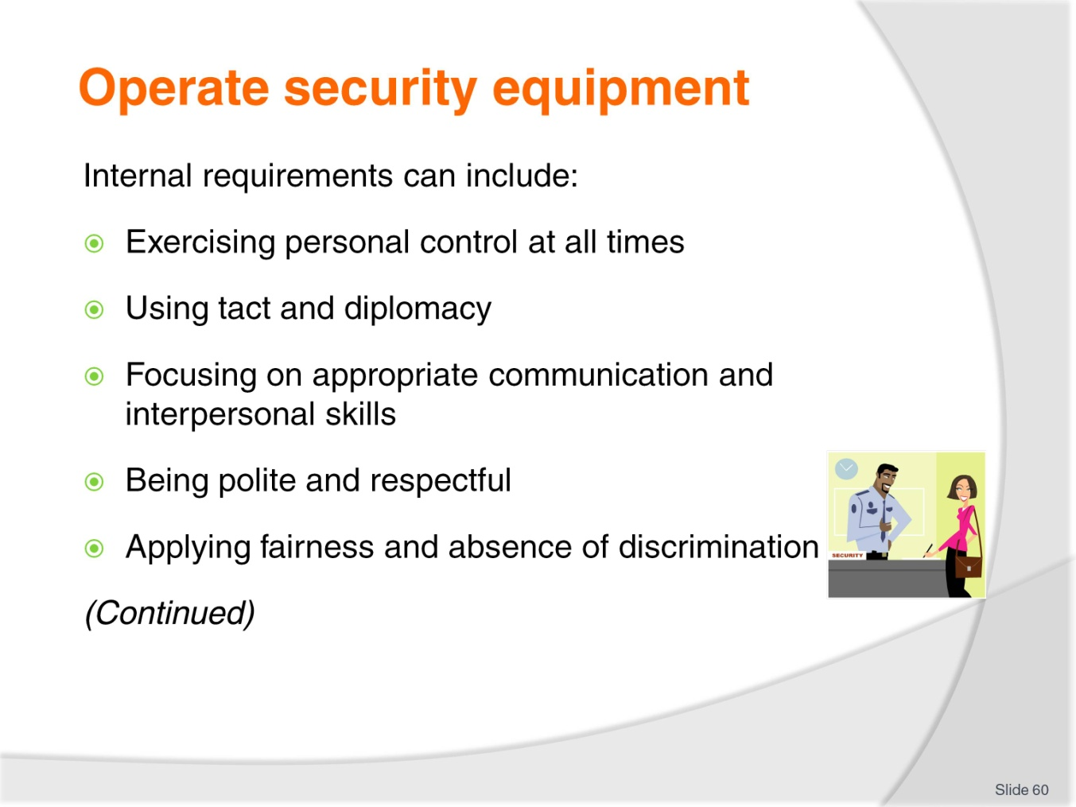
Slide No | Trainer Notes
Trainer indicates sample internal requirements regarding safe and controlled operation of security equipment:
- Exercise personal control at all times – customers can be very abusive and even antagonistic but it is important you control your response and never resort to verbal or physical abuse
- Use tact and diplomacy at all times when interacting with members of the public
- Focus on the use of appropriate communication and interpersonal skills (such as discussion, mediation, conflict resolution, negotiation) rather than physical alternatives or the use of force
- Communicate in a polite and respectful manner using moderate language and avoiding offensive language and swearing
- Act fairly towards all customers/guests/members of the public – do not discriminate on the basis of (for example) age, gender, race or religion).

Slide
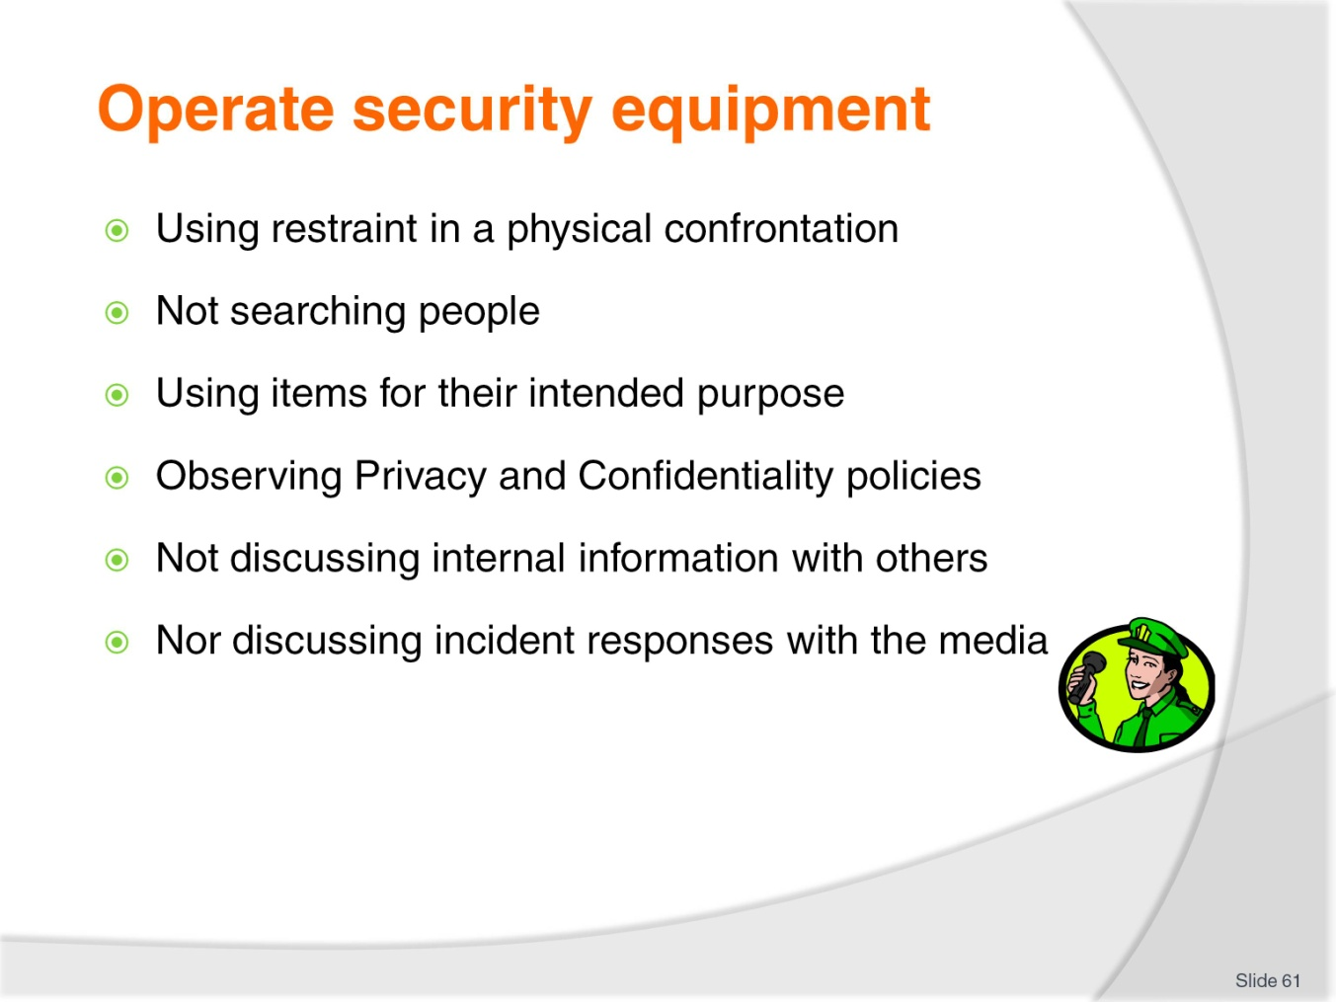
Slide No | Trainer Notes
Trainer continues indicating sample internal requirements regarding safe and controlled operation of security equipment:
- Use restraint when a physical response is necessary – you never have the right to use more than ‘reasonable’ force to address a situation/threat
- Refrain from searching people
- Only use security items for their intended purpose
- Observe the requirements of the venue Privacy and Confidentiality policies at all times
- Never discuss revenue, occupancy levels or matters to do with security, cash movement, asset protection protocols (guards,. patrols, routes, alarms, position of cameras, response plans/options) with anyone
- Do not discuss security-related matters or responses to incidents/threats with the media.
Class Activity – Online Activity
Trainer provides students with internet access and asks them to visit the following sites to gain information of user information for security items:
- http://www.wi-ltd.com/security/Scanning_and_Screening/X_Ray_and_Screening_Systems/Baggage_Scanners/WG_IS6545_X-Ray_Hand_Baggage_Scanner
- http://www.protectwest.com.au/manuals/Ademco%20Vista%2050%20user%20manual.pdf
- http://www.adtsecurity.com.au/home-security/resource-centre/alarm-panel-user-manuals.

Slide
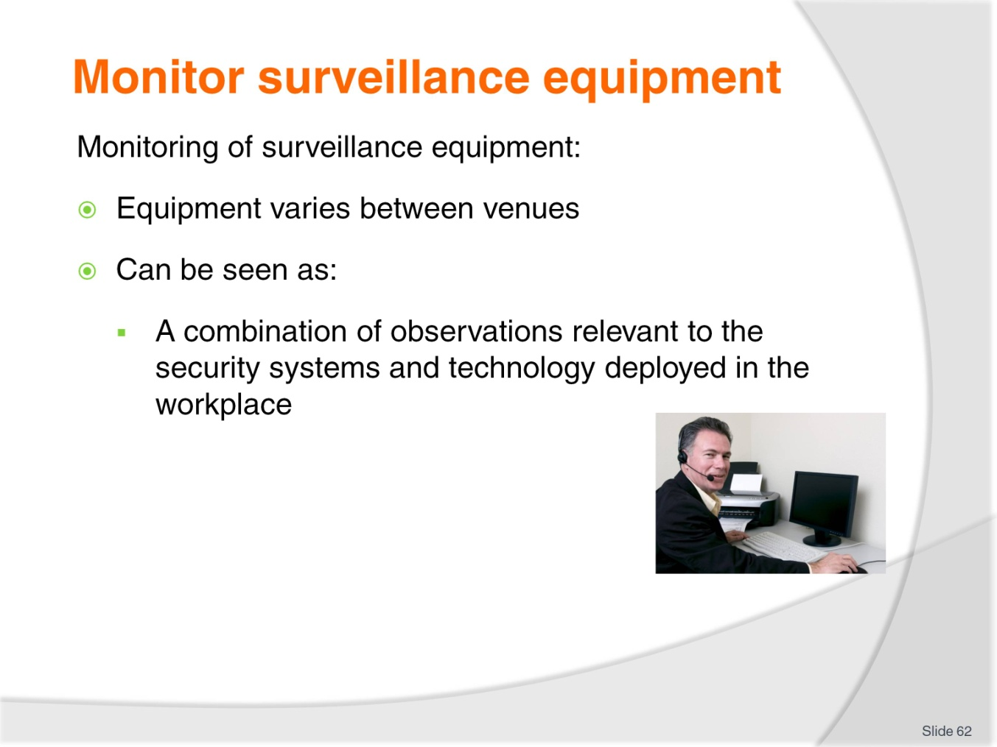
Slide No | Trainer Notes
Trainer introduces monitoring of surveillance equipment stating:
- Surveillance equipment (systems and technology) will vary between venues
- There is also no precise definition of exactly what ‘monitoring’ is or what ‘surveillance equipment is but it may be seen as:
- “A combination of observations relevant to the security systems and technology deployed in the workplace.”

Slide
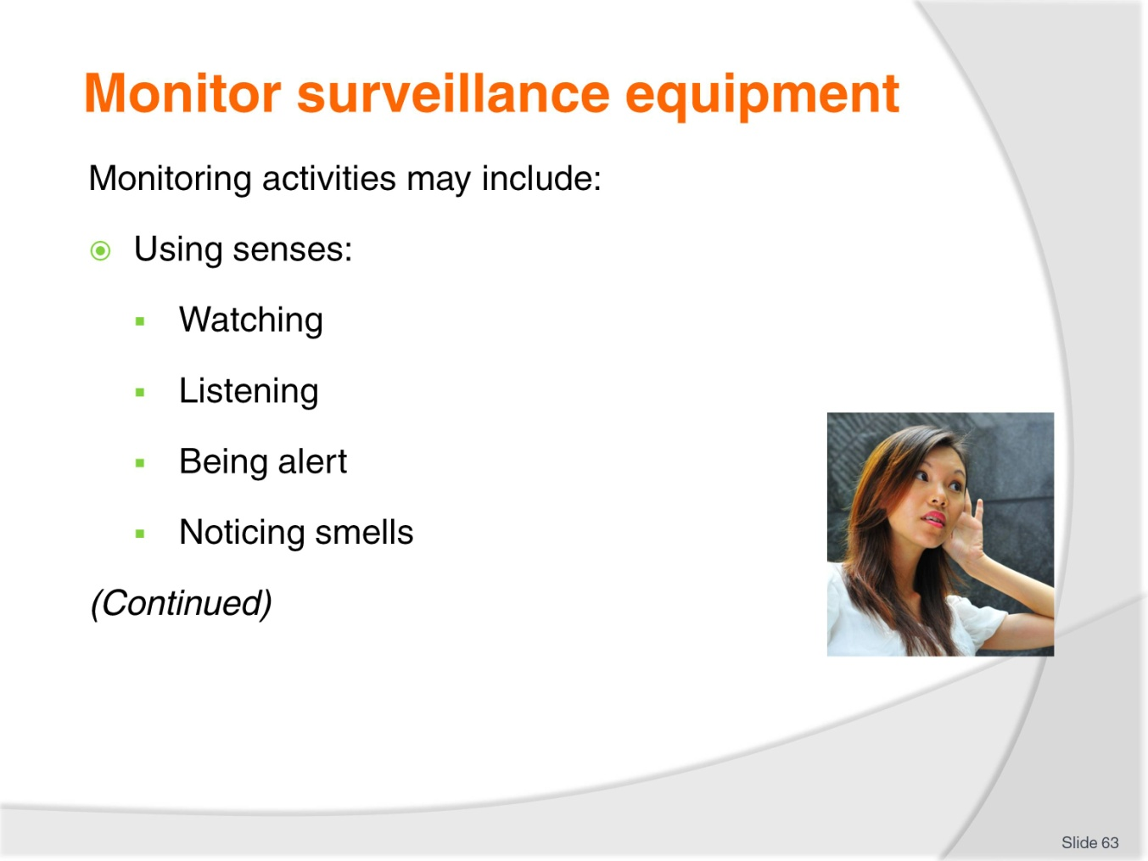
Slide No | Trainer Notes
Trainer presents examples of possible monitoring activities:
- Using your basic senses – for example
- Watching for visual alarms – flashing lights, illuminated displays
- Listening for audible alarms – bells, sirens, tones
- Being alert to environmental cues – such as open doors which should be closed, unlocked doors which should be locked, unattended items, suspicious persons, loud noises/shouting, indicators of distress, unacceptable behaviour
- Noticing smells – which may indicate smoke/fire, a gas leak, a chemical spill, a petrol leak.

Slide
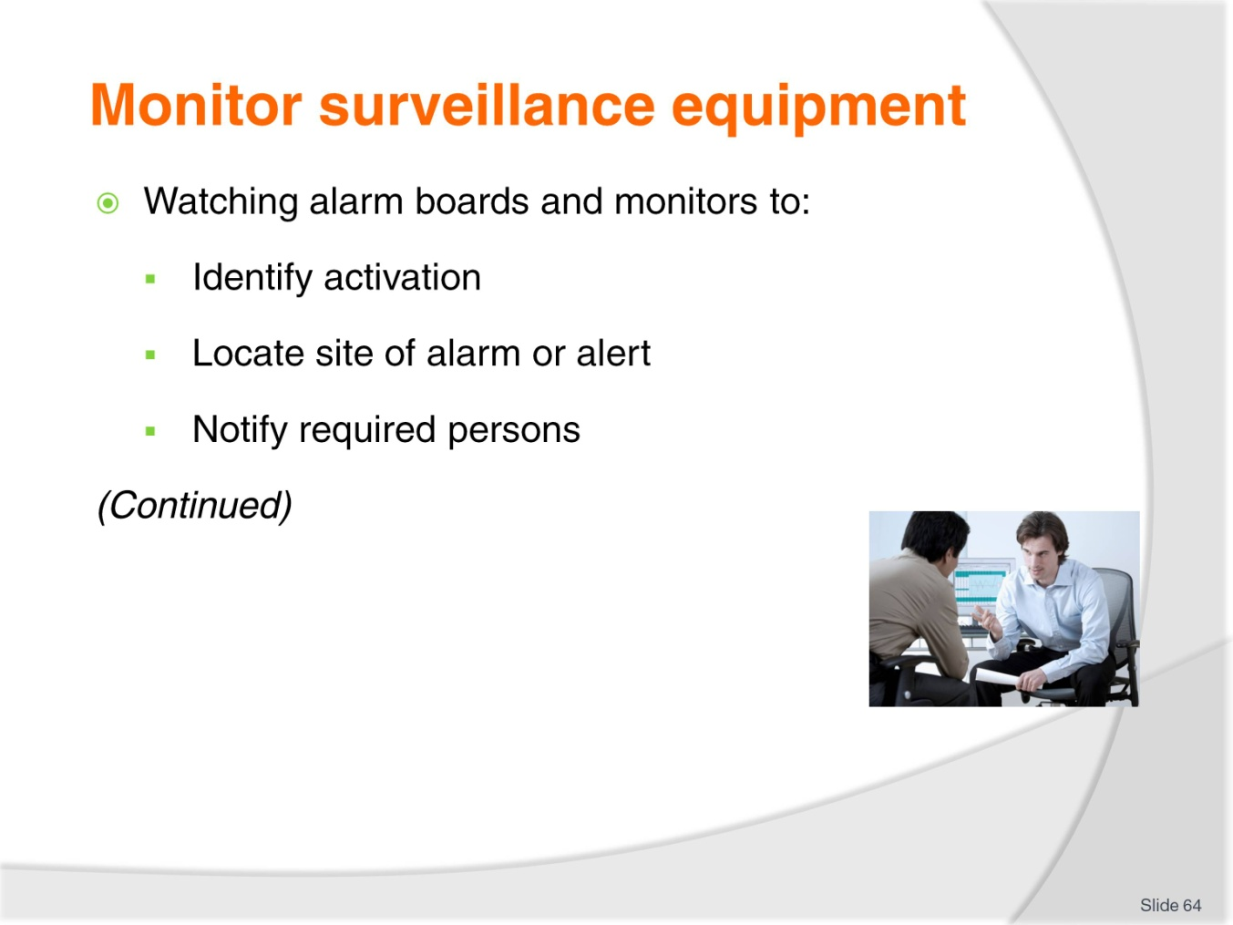
Slide No | Trainer Notes
Trainer continues presenting examples of possible monitoring activities:
- Watching alarm and security boards and monitors/screens to:
- Immediately identify activation
- Locate site of alarm
- Notify internal personnel and external authorities – in accordance with alarm type and SOPs. For example, many venues require immediate notification of fire authorities when a fire/smoke alarms activates even before the alarm is investigated and/or even though flames cannot be seen and there is no smell of smoke.
Where this SOP applies it is a mandatory requirement regardless of when the alarm is detected or where the fire/smoke has been detected.

Slide
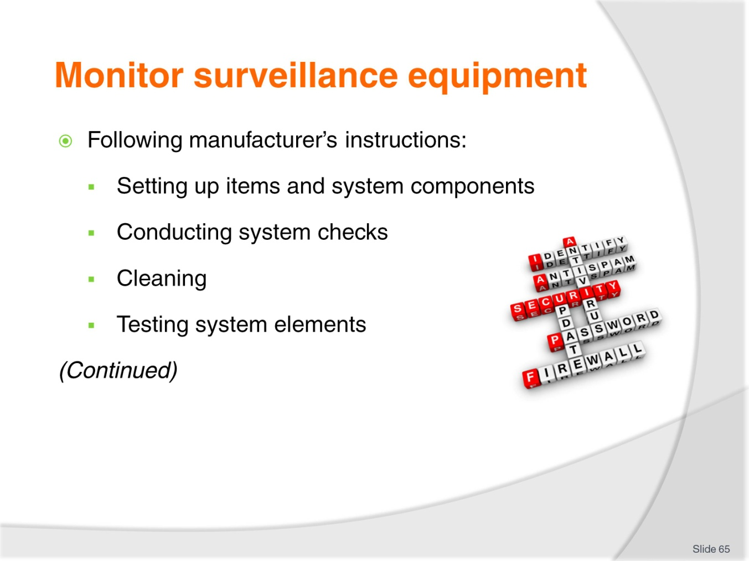
Slide No | Trainer Notes
Trainer continues presenting examples of possible monitoring activities:
- Following all manufacturer’s instructions for the use of all aspects of the security technology in use – this may apply to:
- Setting up equipment in accordance with manufacturer’s instructions – for items such as:
- Sensors and detectors
- Screens, monitors and boards
- CCTV cameras – with special attention to line-of-sight/coverage, and picture resolution
- Walk-through and conveyor-belt scanners.
- Conducting system checks – which relates to:
- Scheduling and implementing regular system checks – to check for correct operation of the system and alerts/alarms
- Running system diagnostic checks
- Cleaning component parts
- Verifying actual coverage by the system is in accordance with expected/required coverage
- ‘Green lights and red lights’ – referring to visual monitoring of system displays which indicate (as appropriate to different systems):
- Normal operation – ‘nothing detected’
- Issues and alerts – to be investigated.
- Testing – such as verifying alarms are operational, surveillance cameras can be remotely controlled, test packages are run through X-ray machines and scanners.

Slide
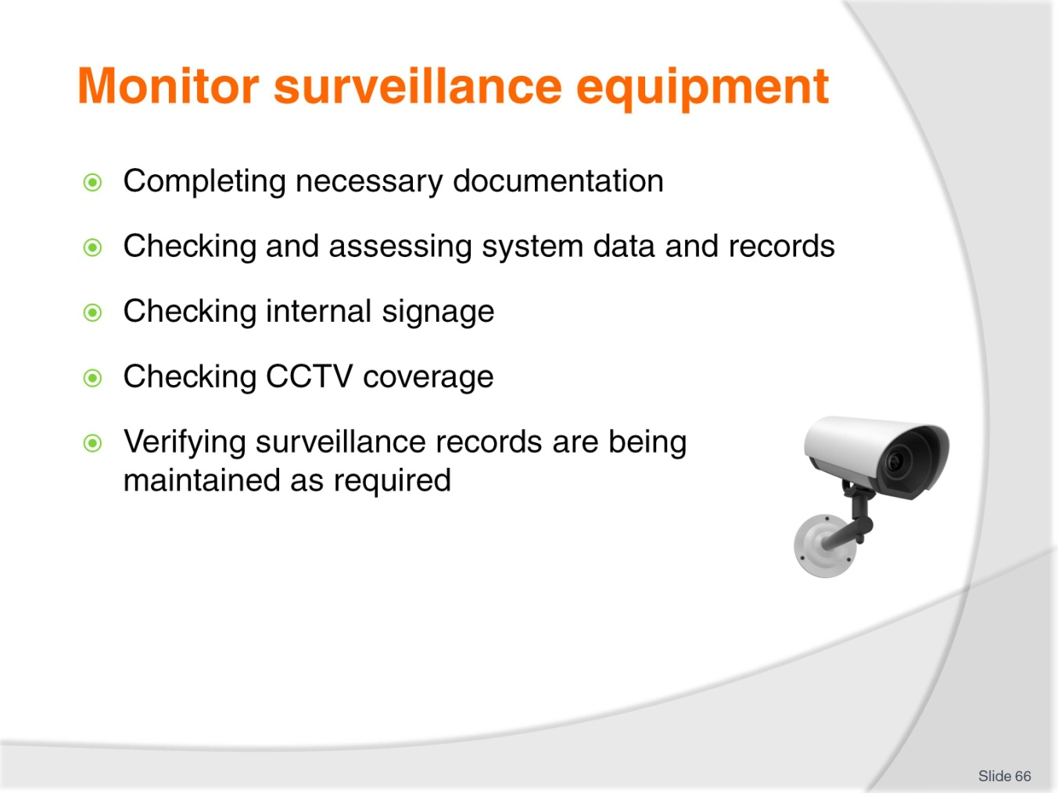
Slide No | Trainer Notes
Trainer continues presenting examples of possible monitoring activities:
- Completing necessary logs, forms and registers – these have to be completed to provide evidence of actions such as:
- All activities identified/described immediately above
- Responses to system alerts and alarms
- Corrective action taken to address identified problems with systems/technology.- a CAR may need to be completed
- It is vital you understand it is never sufficient just to respond to a situation, you also have to record your response as evidence of your action.
- Checking and assessing system data and records – to verify:
- Required information is being captured
- Reliability of system for capturing the data
- Accuracy of data being recorded.
- Checking internal signage – where there is a legislated requirement the venue informs patrons electronic surveillance is being used on the premises, part of the monitoring must be to ensure the required signs are displayed in the required areas and are clearly visible (‘This venue is under contact video surveillance’)
- Checking the coverage by CCTV cameras does not breach the privacy rights of citizens – basically this means ensuring the CCTV cameras do not film public areas which are not part of the venue
 | - Verifying the surveillance records are being maintained for the required period of time – such as proving to yourself (and recording this fact) all surveillance tapes/discs are on file for (usually 14 days) and are dated in such a way to aid easy retrieval of footage as required.

Slide
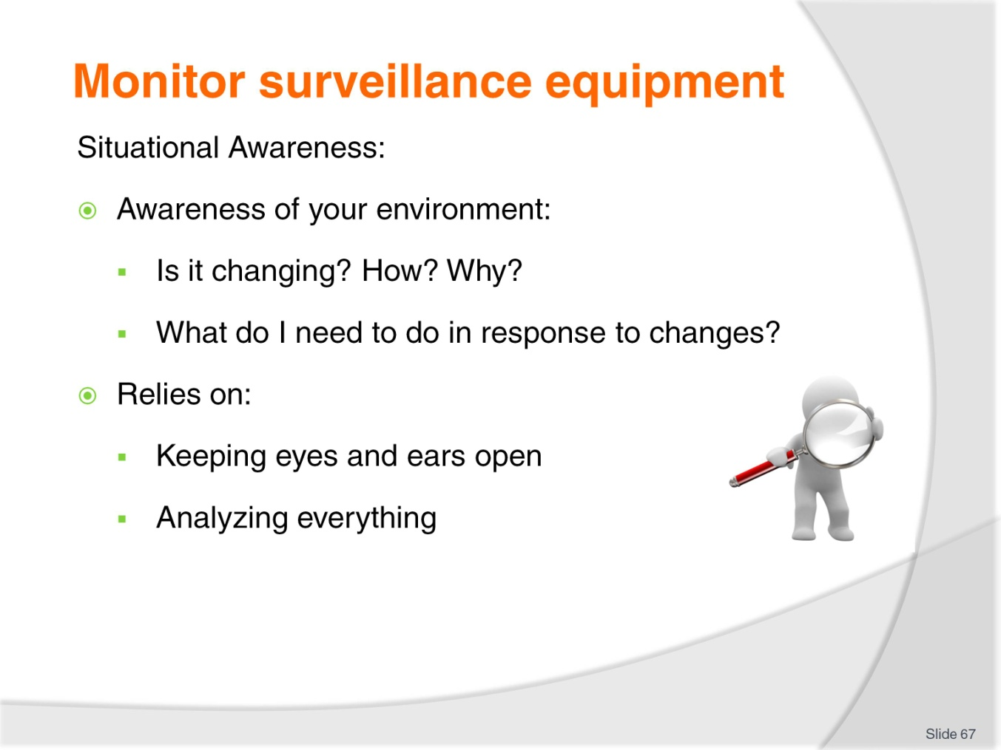
Slide No | Trainer Notes
Trainer explains need for Security staff to maintain ‘Situational Awareness’:
- Situational awareness may be seen as being completely aware of the environment/situation you are in and knowing if it is changing, how it is changing, and why it is changing
- Situational awareness relies heavily on:
- Keeping your eyes and ears open – to keep the inflow of information coming in to you/your senses
- Analysing everything:
- What was that noise?
- Why did the noise happen?
- Where did it come from?
- What does it indicate?
- What action do I need to take in response?

Slide
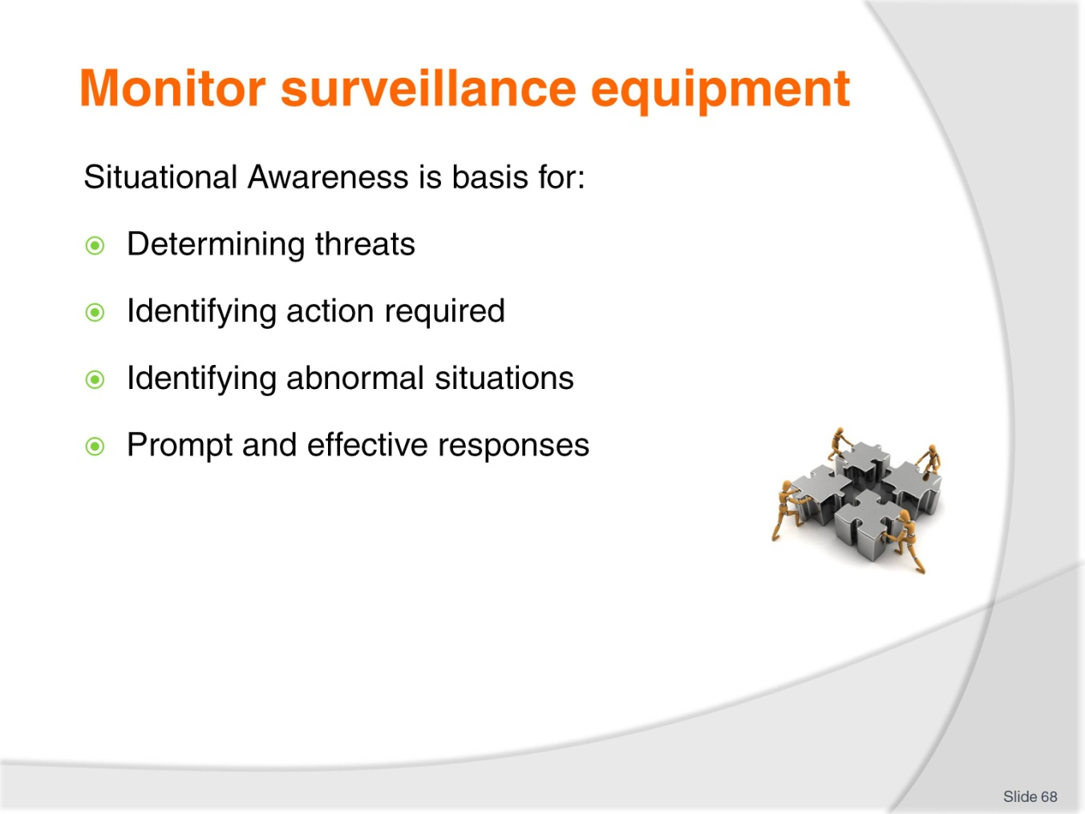
Slide No | Trainer Notes
Trainer points out Situational Awareness is the basis for:
- Determining threat situations
- Identifying action needing to be taken
- Identifying what is ‘normal’ and things are not normal
- Prompt and effective responses.

Slide
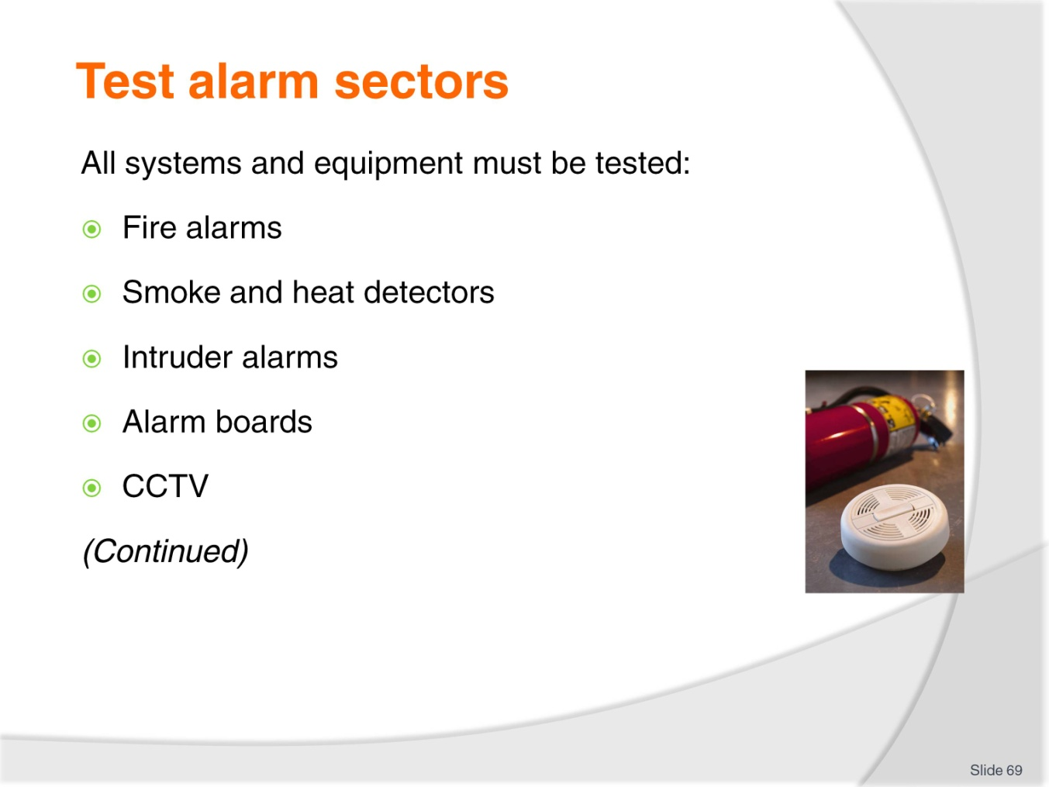
Slide No | Trainer Notes
Trainer introduces testing of alarms highlighting all systems must be checked/tested. Examples of systems/equipment to be tested include:
- Fire alarms
- Smoke and heat detectors
- Intruder alarms – including local alarms on fire doors/exits which are triggered when the door is opened
- Alarm boards and VDUs
- CCTV – including checks on:
- Infrared security cameras (so-called ‘night vision’ cameras)
- Dome (‘eye in the sky’) cameras
- IP/network cameras with remote control (tilt, pan and zoom)
- Any wireless cameras – usually retained only for special security (‘spying’) work.

Slide
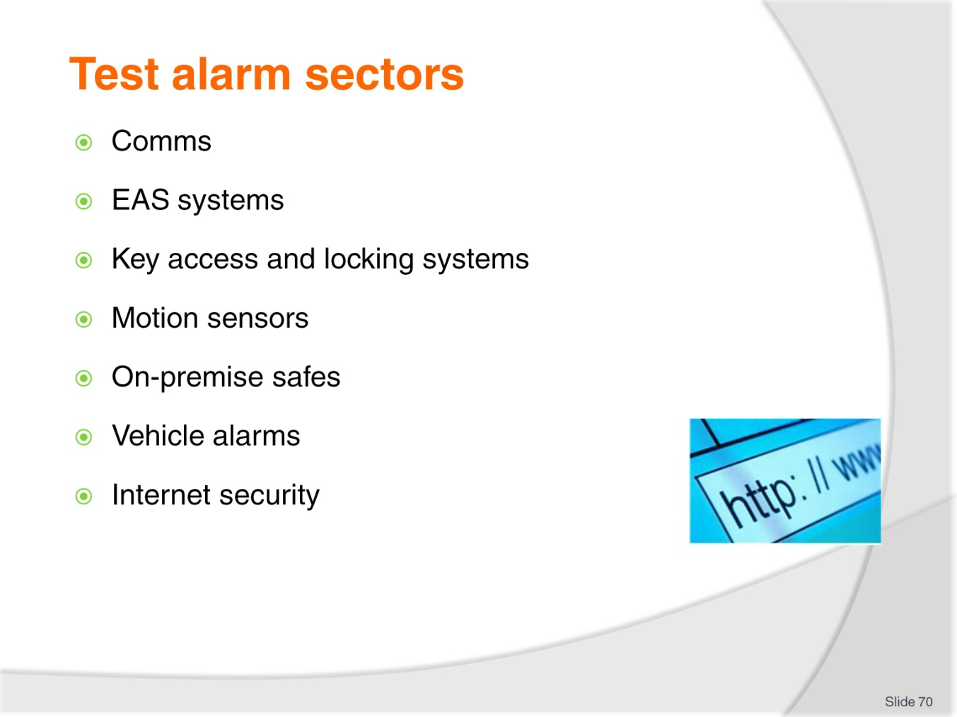
Slide No | Trainer Notes
Trainer continues giving examples of systems/equipment to be tested:
- Comms including PA
- EAS systems
- Key access and locking systems for guest rooms – including card-based RFID systems offering controlled access to (for example) elevators, gymnasium, and other restricted internal areas
- Motion sensors
- On-premise safes – including office and guest room safes
- Vehicle alarms
- Internet security.
Class Activity – Guest Speaker
Trainer arranges for relevant person to attend and:
- Identify systems/equipment which is tested in venues
- Describe protocols and activities for testing
- Identify frequency of testing
- Describe responses to malfunctions.

Slide
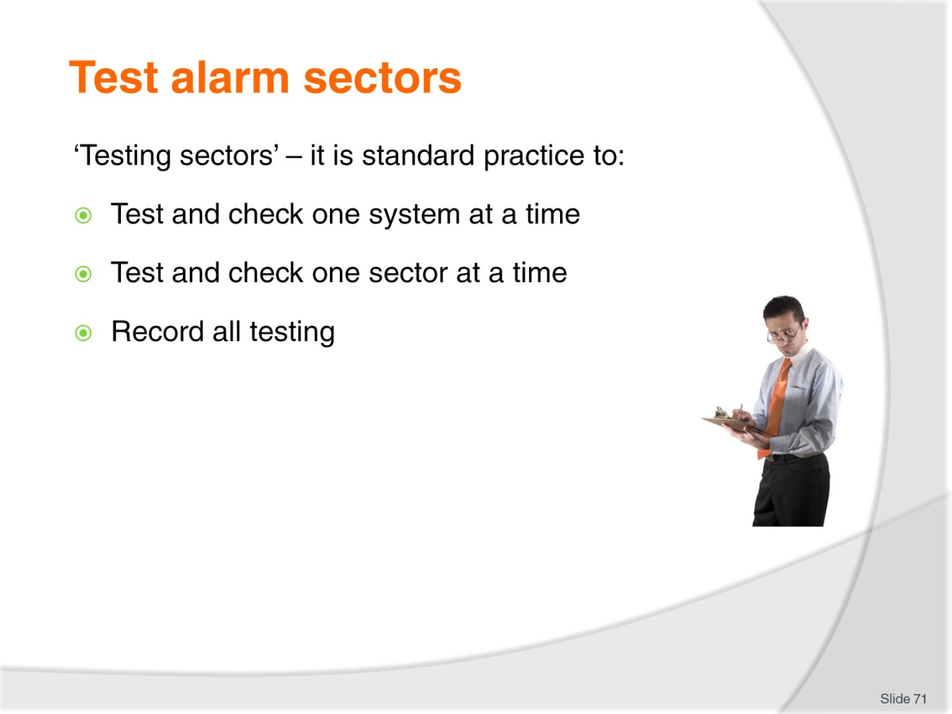
Slide No | Trainer Notes
Trainer addresses concept of ‘testing sectors’ stating:
- Testing ‘sectors’ refers to the practice of testing, checking and verifying the operation of a system in a defined location/space:
- The designation of a sector will be determined by management in conjunction with security consultants and the people who install and commission the systems, may be internal of external and may relate to:
- Certain entries and exits
- Car parks
- A particular room or passageway
- A department
- A group of rooms or facilities – a general area
- A specified type of system.
- Standard practice is to:
- Test/check one system at a time
- Test/check one sector at a time
- Record all testing/checking procedures and the results/outcomes.

Slide
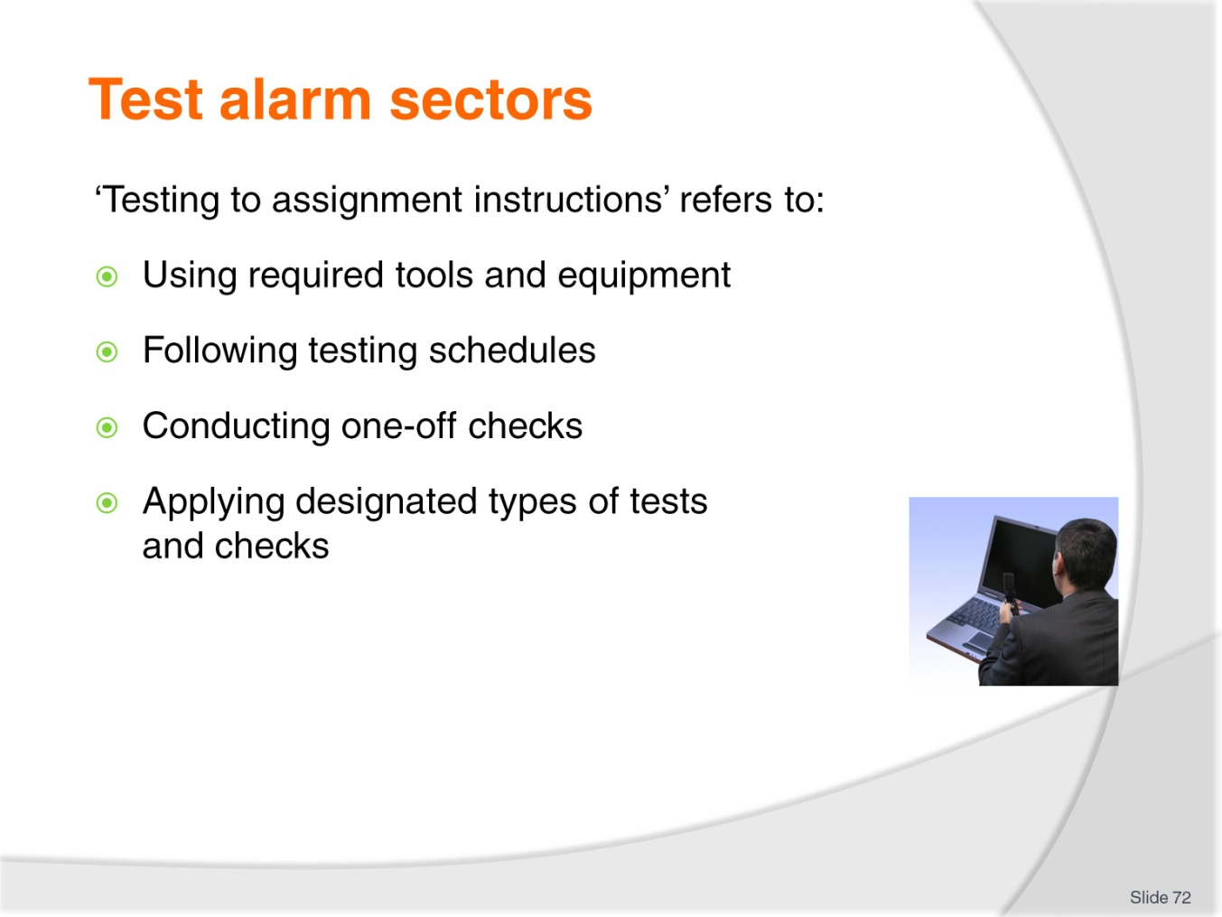
Slide No | Trainer Notes
Trainer explains testing to assignment instructions refers to:
- Using the tools and equipment for undertaking designated maintenance activities/jobs – including having access to and using:
- Service/Repair manuals
- Diagnostic information
- Conducting checks/tests of sectors and systems in accordance with pre-determined schedules and testing regimes – these are the standard testing requirements for systems/technologies conducted on a regular, ongoing basis
- Conducting one-off checks such as:
- Directed by management – perhaps in response to a problem situation or a concern they have about the operation/coverage of the system
- Deemed necessary on the basis of (for example):
- A system malfunction
- A breach of security
- Personal observations/monitoring which indicate a potential issue/cause of concern.
- Applying certain types of checking/testing such as:
- Perimeter vulnerability tests
- Penetration testing
- PCI compliance testing
- Cable testing.
The use of ‘assignment instructions’ demonstrates staff do not have the authority to simply interfere with security systems: you can only take action:
- In response to an alarm – for the purpose of diagnosis/investigation
- As part of standard testing and maintenance
- For approved monitoring activities.

Slide
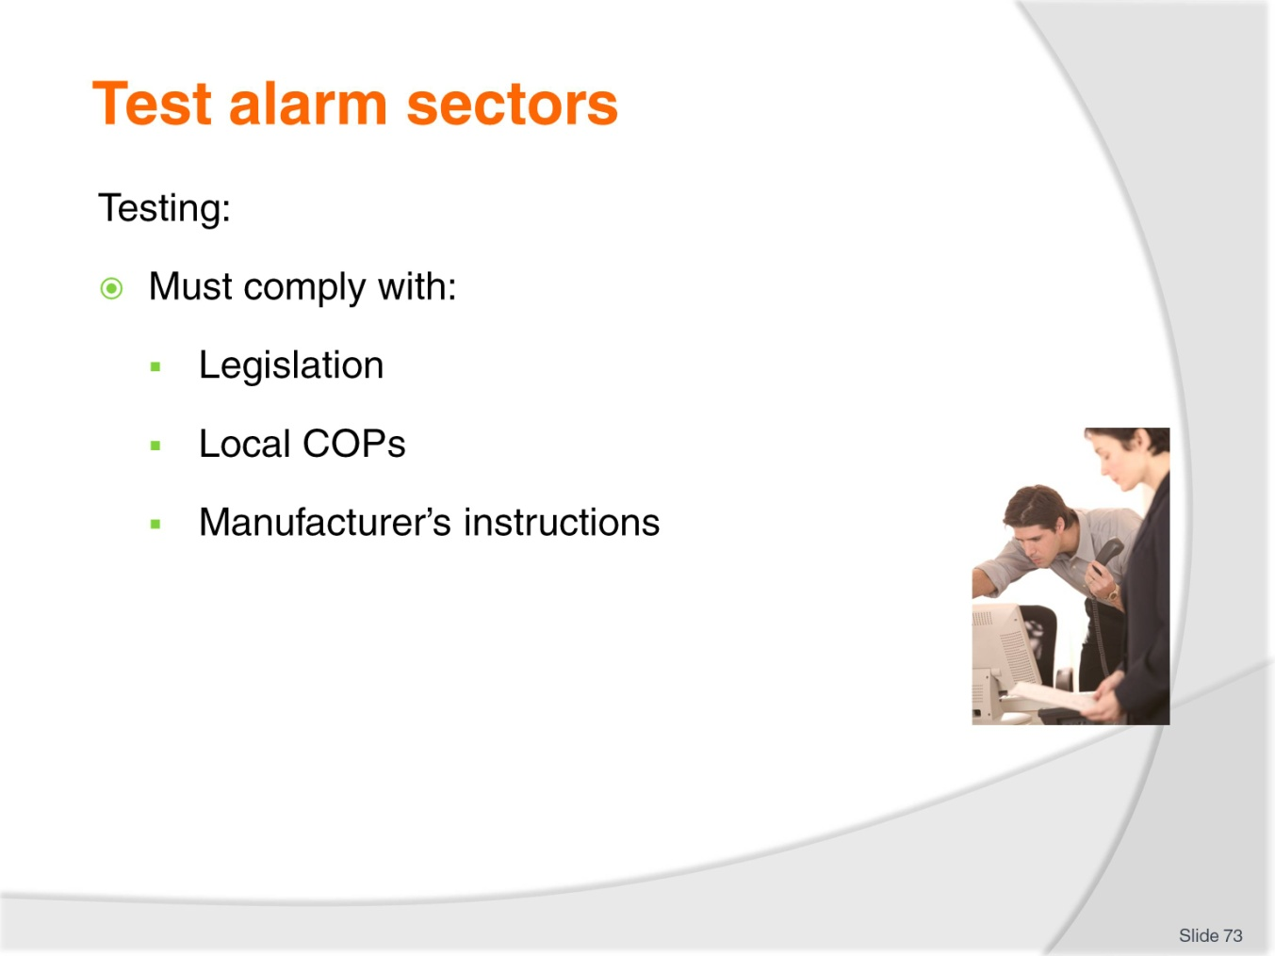
Slide No | Trainer Notes
Trainer states activities involved in testing alarms:
- Must comply with:
- Local legislation
- Local COPs
- Manufacturer’s instructions.
Class Activity – Presentation and Explanation
Trainer obtains, presents and explains local requirements regarding testing of security equipment.

Slide
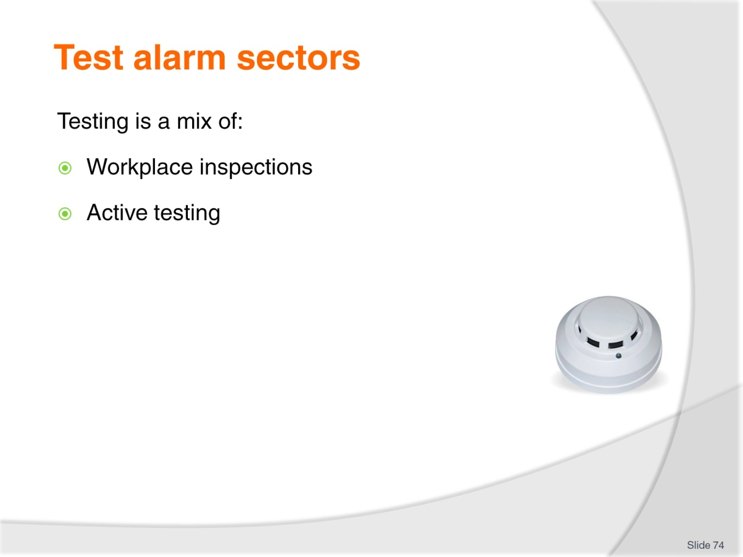
Slide No | Trainer Notes
Trainer explains testing is a mix of:
- Inspections – looking at:
- Fire extinguishers are actually located where they are supposed to be – and have not been moved, stolen or disconnected
- Extinguishers have been services according to their service schedule
- Smoke detectors have not been painted over as part of a refurbishment of the property
- Nozzles of fire hoses are still in place and have not been stolen
- Security mirrors are still correctly positioned/angled – and allow operators to view hidden areas
- Cleanliness of lenses on cameras and domes
- Components showing signs of leaks, looseness, corrosion, damage, interference or anything out of the ordinary.
- Active testing – must address:
- Actual response and sensitivity of smoke and heat detectors – using (for example) commercial aerosol products
- Tilt, pan and zoom facilities of relevant cameras
- Freedom from physical impediment in line-of-sight cameras
- Quality of pictures from CCTV cameras
- Recording quality and capacity of CCTV
- Flow rates of hydrants and hoses
- Scanners using a sample ‘test scan’ package or item
- Lesser used elements and functions of systems – these items are not frequently used and may fall into disrepair: it is important they are tested to ensure operational effectiveness because many of these components (while only used infrequently) are extremely important when they are needed
- Locks – all types, all fixtures and fittings
- All audible alarms – this should be done ‘remotely’ and ‘locally’:
- Remotely refers to initiating an alarm at the control panel and verifying the required indicator is showing
- Locally refers activating the alarm at the point where the initiating device is located (by, for example, opening an alarmed door to verify the alarm sounds) and verifying:
- The alarm has sounded at the door
- The control panel is indicating the alarm has been activated.
- Operation of all shut-off valves – for gas, water and electricity
- All visual alarms – by physically observing they are working as required and not just assuming they are working because an indicator light in the control room says they are
- All levels of alarms – for example alarms may have different sequences (or tones) to indicate various levels of alert.
Class activity – Excursion
Trainer arranges visit to a venue so students can:
- Observe and talk to security staff
- View security facilities and operations
- Observe security system checks, tests and inspections.

Slide
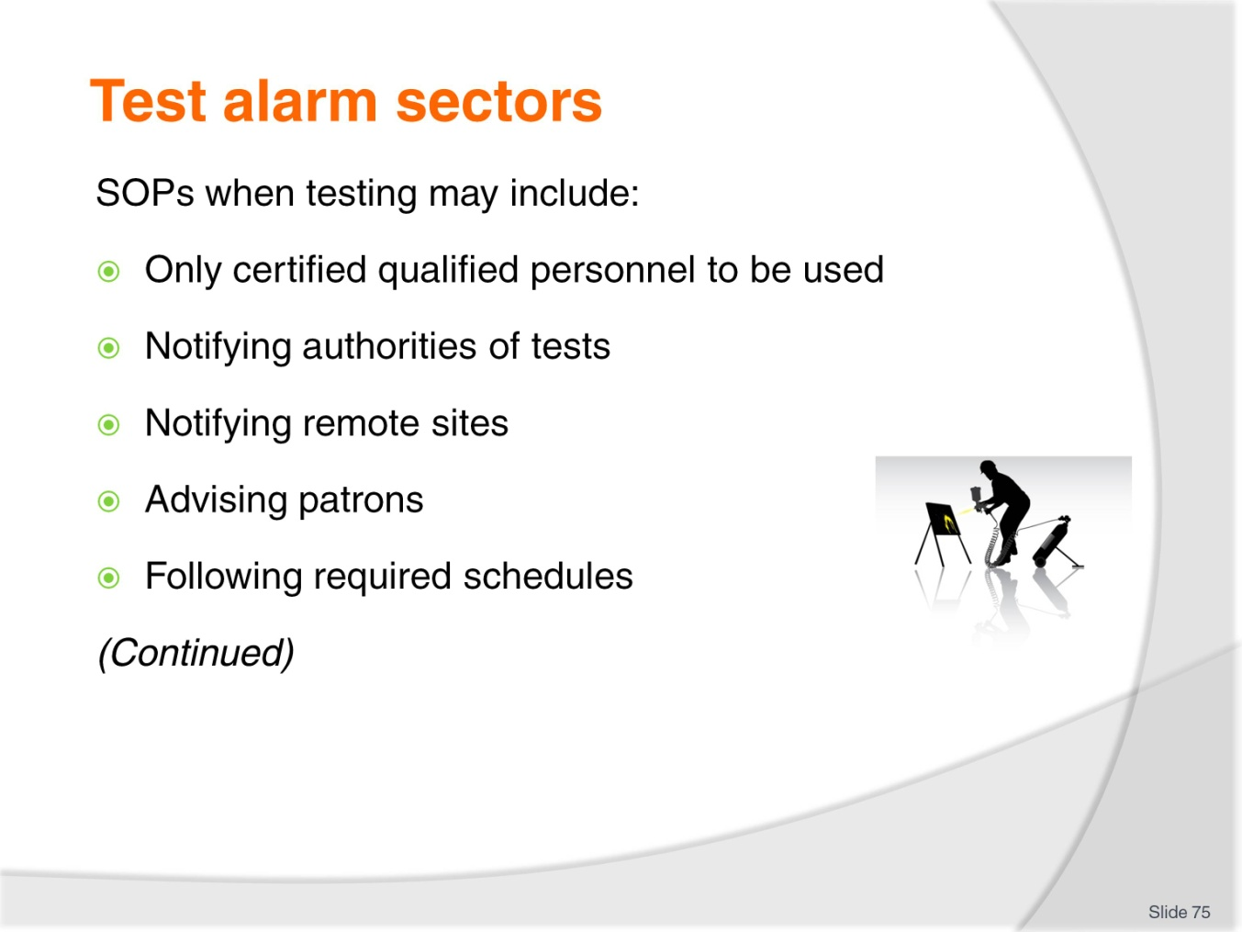
Slide No | Trainer Notes
Trainer states the following are SOP when undertaking testing of systems:
- Certified and accredited testers must be used – where specified by law or manufacturer’s instructions
- Notify the authorities (police and fire) you are conducting a test (or a drill) – to avoid an emergency response when there is no need
- Notify any remote monitoring sites you are conducting a test
- Advise patrons in advance of any test which requires an audible or visual signal – to prevent worry and avoid panic
- Conduct tests in accordance with specifications for each system as required by the manufacturer, supplier and/or installer. In practice this means tests of different types are usually conducted:
- Quarterly
- Half-yearly
- Annually.
Class Activity – De-brief of Excursion
Trainer conducts a de-brief of the excursion listed in the previous slide.

Slide
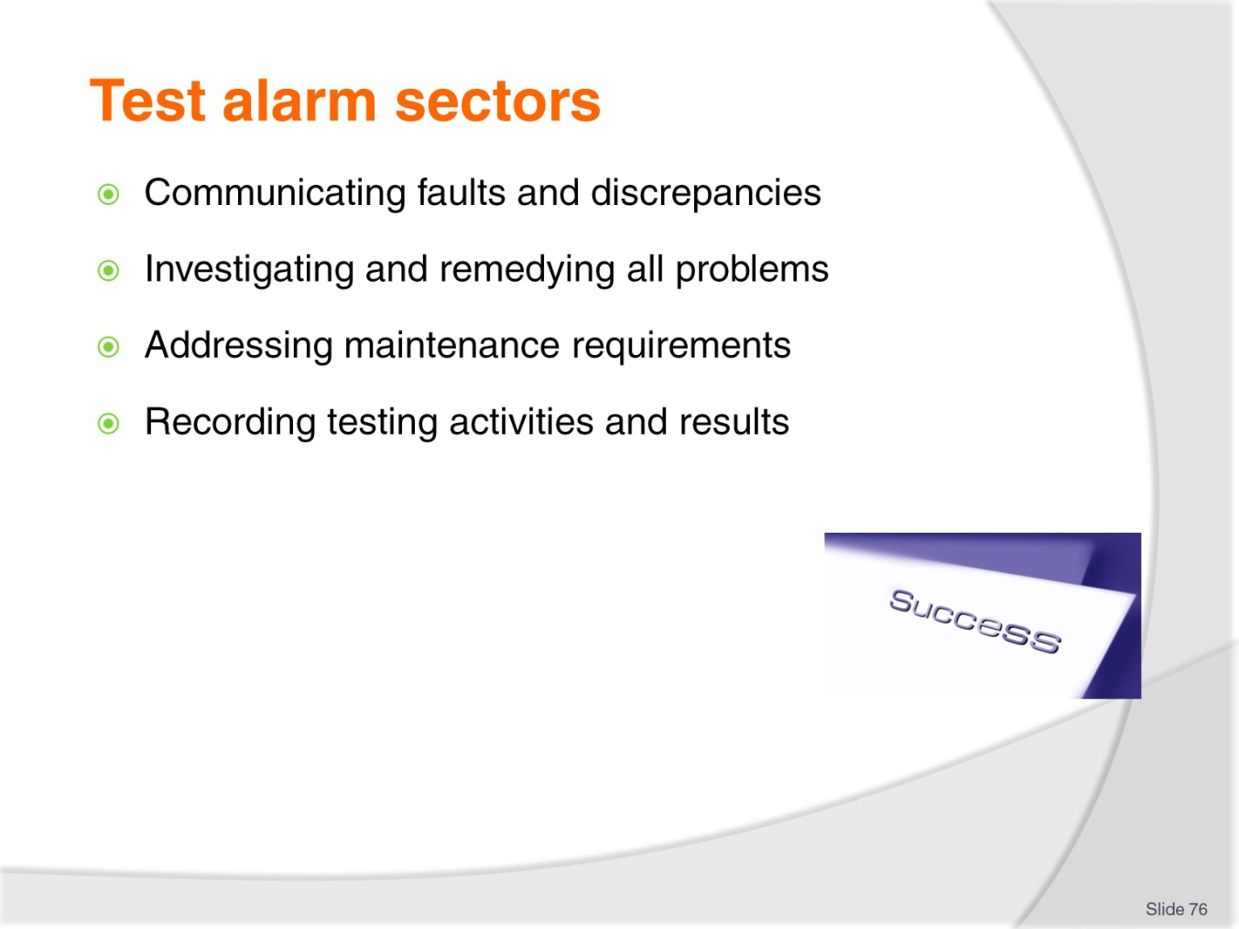
Slide No | Trainer Notes
Trainer continues providing examples of SOPs when testing is conducted:
- Advise and involve external security support companies where faults or discrepancies are identified as a result of the testing procedures
- All problems must be investigated and remedied
- Ensure any maintenance requirements identified as part of the testing program are addressed – by internal service or through using external service providers
- Testing activities MUST be recorded – detailing:
- Date/s and time/s
- Items/systems tested
- Nature of tests conducted
- Results/outcomes of tests – including (as appropriate) hard copy data from the system
- Names of those who conducted tests.

Slide
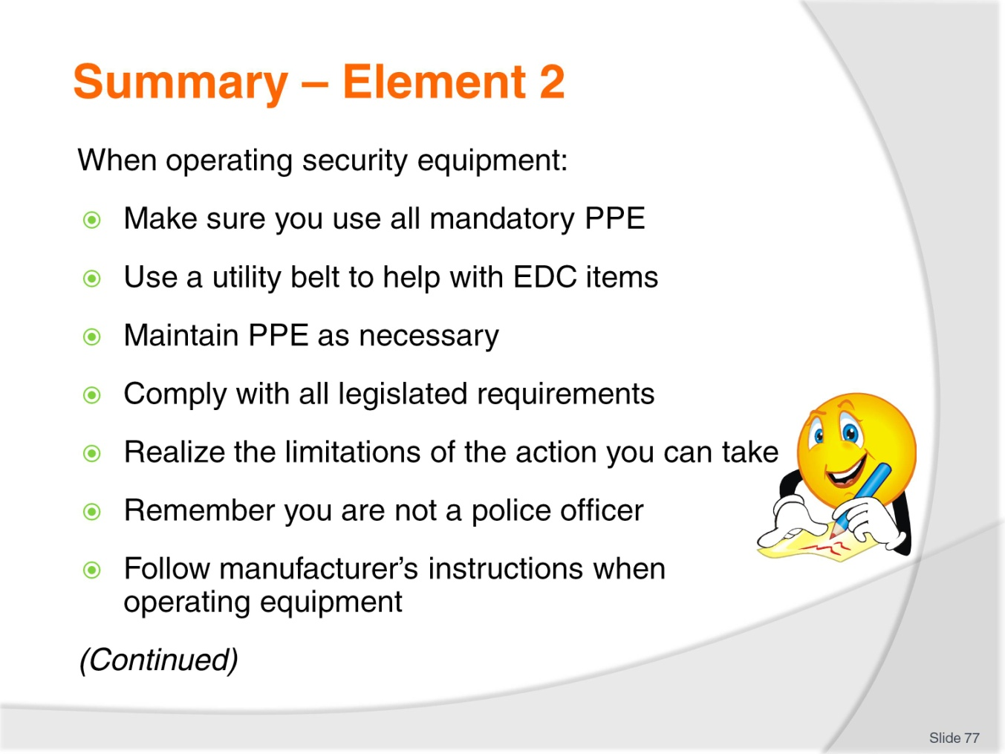
Slide No | Trainer Notes
 | Trainer provides a recap of the Element asking questions to check trainee understanding and responding to questions from trainees, as required.

Slide
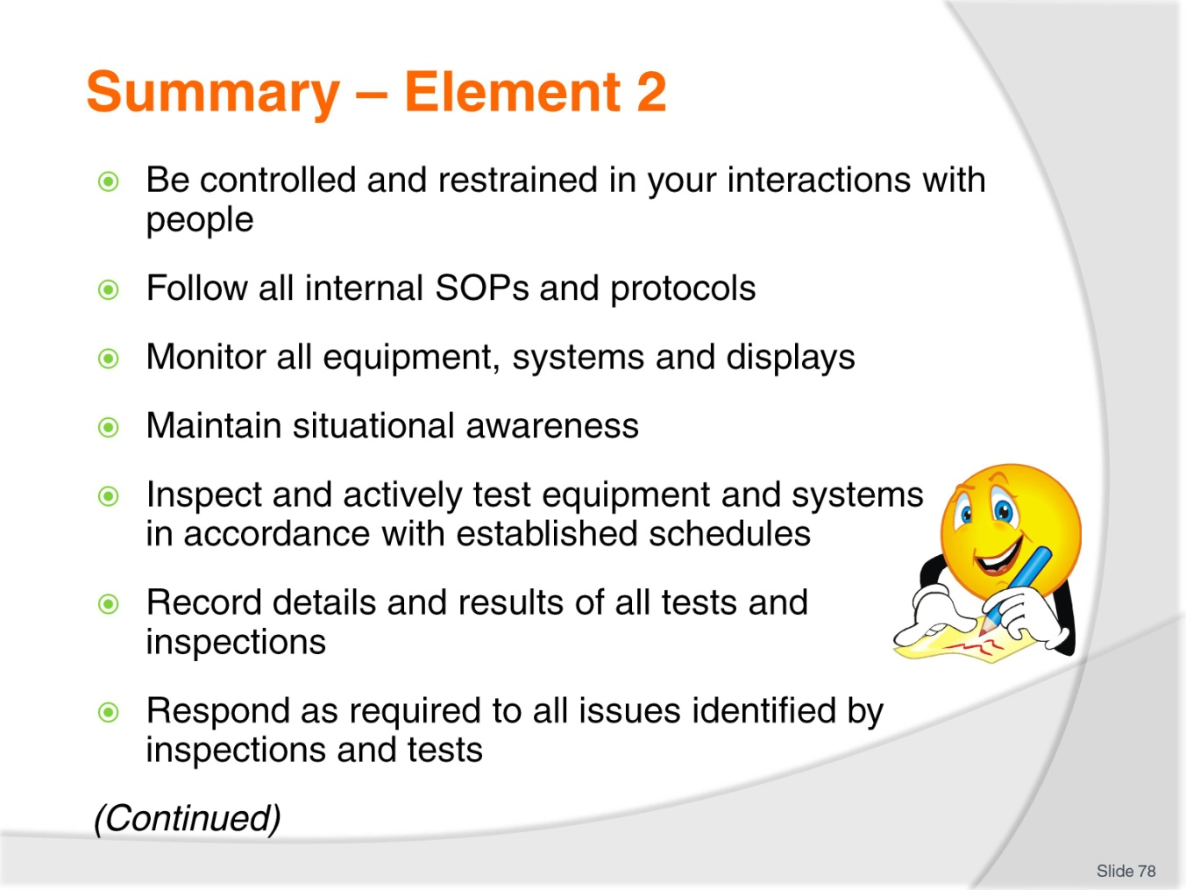
Slide No | Trainer Notes
 | Trainer provides a recap of the Element asking questions to check trainee understanding and responding to questions from trainees, as required.

Slide
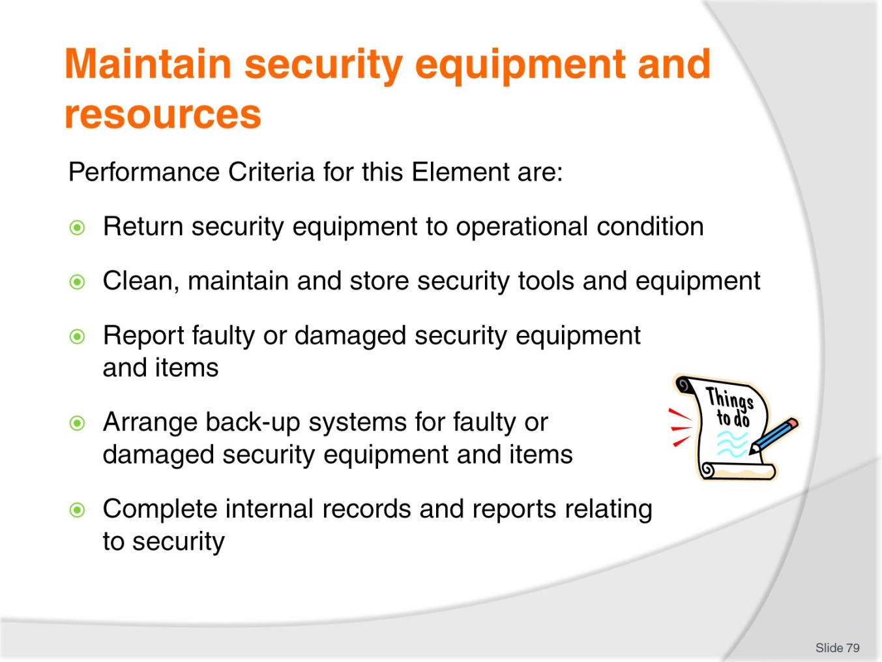
Slide No | Trainer Notes
Trainer identifies for trainees the Performance Criteria for this Element, as listed on the slide.
Class Activity – Discussion
Trainer leads a discussion on maintaining security equipment and resources by asking students questions such as:
- What problems/issues may arise with security equipment and items?
- What do you think is involved in cleaning security equipment?
- What items have to be cleaned?
- Why is cleaning them important?
- What paperwork do you think needs to be competed relating to security?
- Why and when does it need to be completed?

Slide
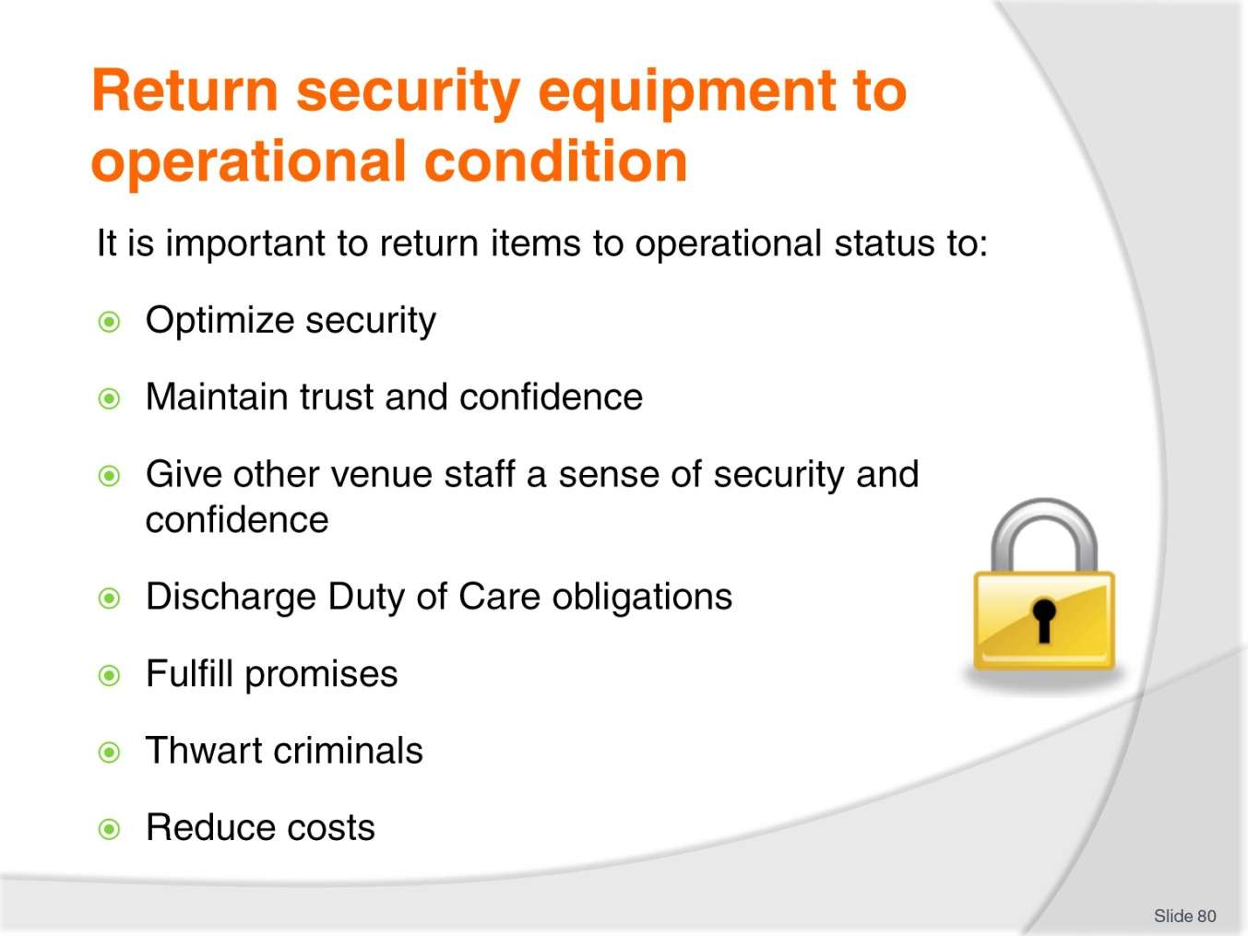
Slide No | Trainer Notes
Trainer advises students given the essential roles performed by security equipment it is crucial to return all items to operational condition when damage or a malfunction is identified highlighting this is important for the following reasons:
- To optimize/maintain security coverage as intended for the venue
- To maintain trust and confidence of guests/patrons
- To give staff a sense of well-being and security
- To discharge Duty of Care obligations
- To deliver on promises made about a safe and secure environment
- Because many criminals include disabling of security equipment as a fundamental part of their plan
- To reduce cost of loss (to patrons and venue) occasioned by events which occur when – or because – security systems/equipment are not operational.

Slide
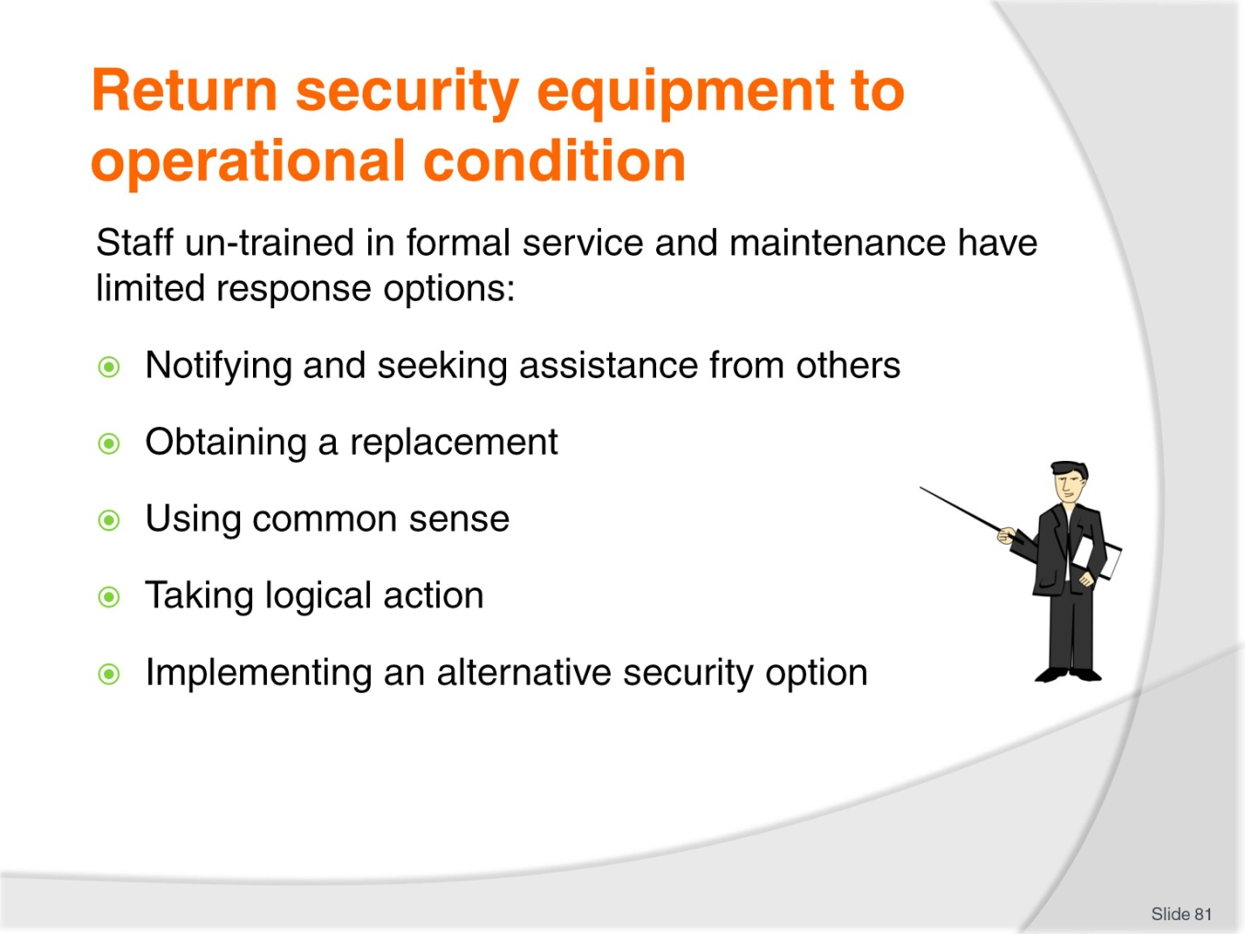
Slide No | Trainer Notes
Trainer advises students that staff who are un-trained in servicing/repairing systems and equipment have limited response options – these include:
- Notifying others to come and assess the situation and make necessary repairs – this may mean contacting Head Office, the manufacturer, your Maintenance department or a designated service provider/security technician or consultant:
- Remember you can only do this within your designated scope of authority so in some cases you will have to report/refer the issue for someone else to action.
- Obtaining a replacement item – and taking the faulty/damaged item away, out-of-service or off-line
- Using common sense combined with any relevant experience and training to (for example):
- Remove whatever is causing the problem, fault or damage, and then testing the item
- Re-set the piece of equipment or system – where this facility exists: non-operational security equipment can sometimes be the result of some internal problem or conflict
- An option to re-setting the item (where no re-set facility exists) may be to turn it off, wait 20 seconds, and then turn it back on again.
- Taking whatever action appears logical at the time and given the circumstances you are faced with
- Implementing an alternative security option – for example:
- If a window is broken (giving rise to the potential for unauthorized entry) you might stay on site (as a guard) until the broken window is shuttered or replaced
- If the belt scanner is not working then you may implement scanning using hand-held wands.

Slide
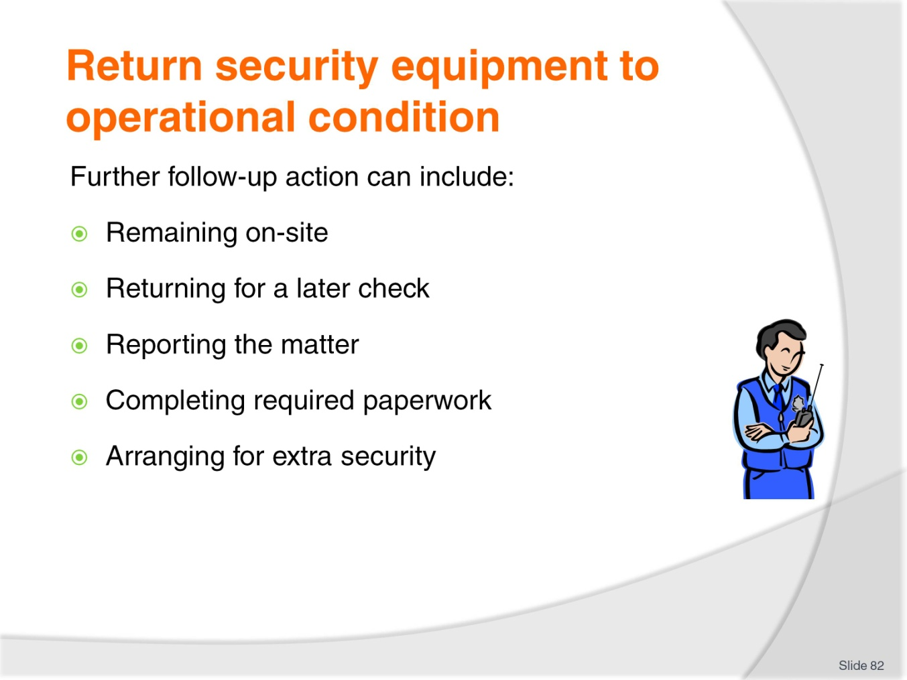
Slide No | Trainer Notes
Trainer states whenever students identify a piece of security equipment which was not operating correctly they will need to follow one or more protocols as established by the workplace – these can include:
- Remaining at the site/location for a period to verify what you have done really has fixed the problem
- Returning at a later time to check the item you fixed and returned to service is still working properly
- Reporting the issue verbally to your supervisor – see later slides
- Completing designated internal form/report flagging the incident and the action you took
- Arranging for extra security staff to patrol/attend the location to provide extra human resources to supplement the failed physical resource/s.

Slide
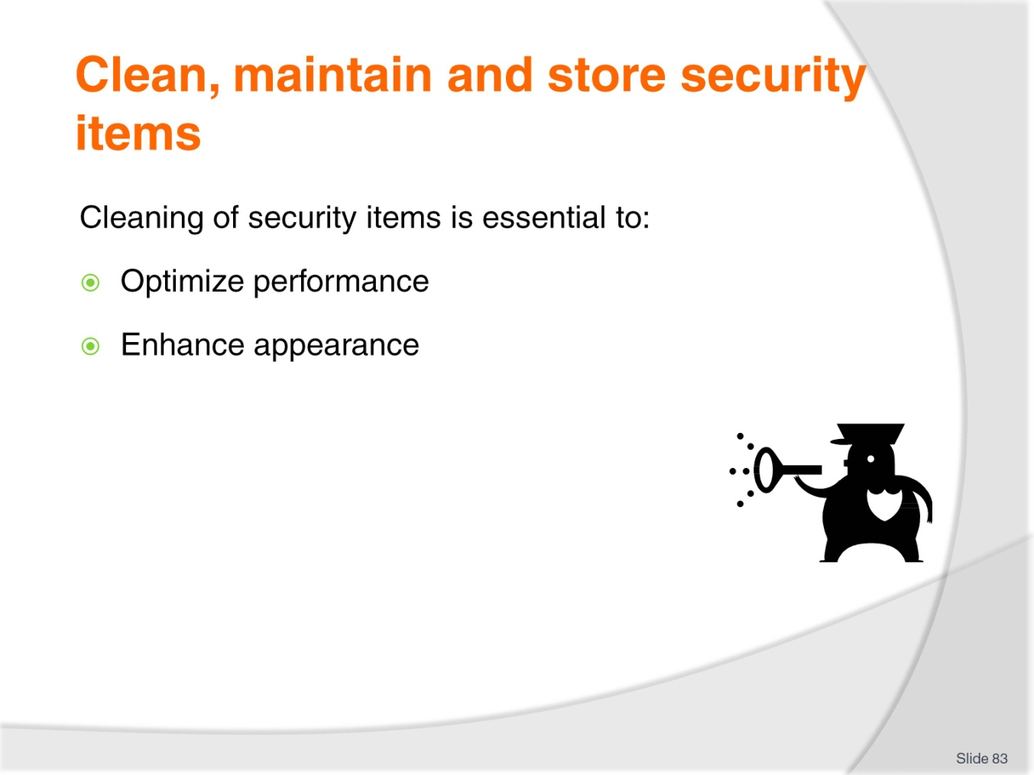
Slide No | Trainer Notes
Trainer stresses it is necessary to clean security equipment/items to:
- Optimize operational performance
- Enhance appearance of items so they look good to customers/guests:
- There is no doubt guests infer things from the appearance/condition of security equipment
- They have much more confidence in the venue and its ability to safeguard them where they see clean and properly maintained security equipment.

Slide
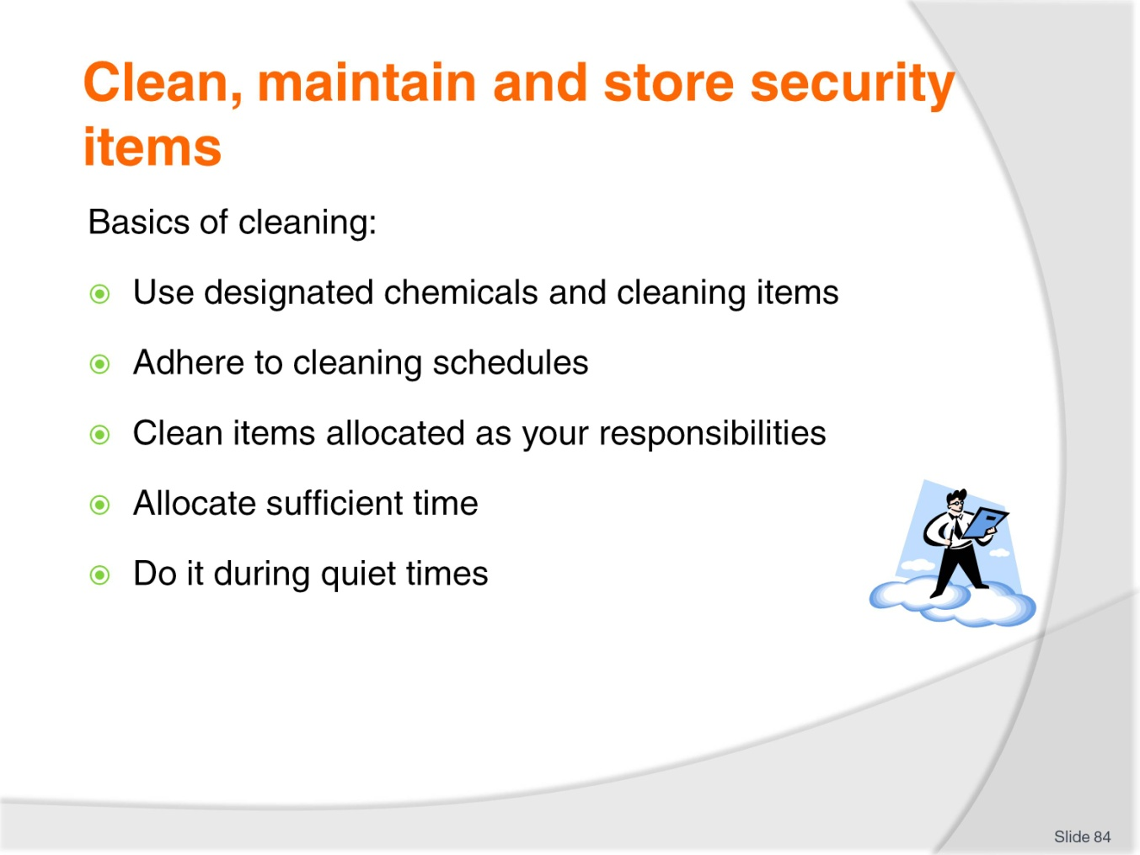
Slide No | Trainer Notes
Trainer advises cleaning basics are:
- Use only designated chemicals for cleaning – certain items demand certain cleaning agents
- Use only designated cleaning products – some items can be cleaned using a cloth and some (for example) require a brush
- Adhere to required cleaning schedule for each item – if a cleaning schedule does not exist, develop one
- Cleaning of items should be allocated to specified individuals/staff members – so everyone knows what they have responsibility for and to ensure no item is omitted from the cleaning regime
- Cleaning is a task which should be given the appropriate time – this means cleaning of security items needs to be time-tables into normal duties and not treated as something which is done ‘if there is time’
- Cleaning of many items should be scheduled/undertaken during quiet times – this can mean it needs to be done during ‘low’ periods and/or at night.
Class Activity – Demonstration and Practical
Trainer:
- Demonstrates how to clean security items/equipment
- Provides opportunity for students to do same.

Slide
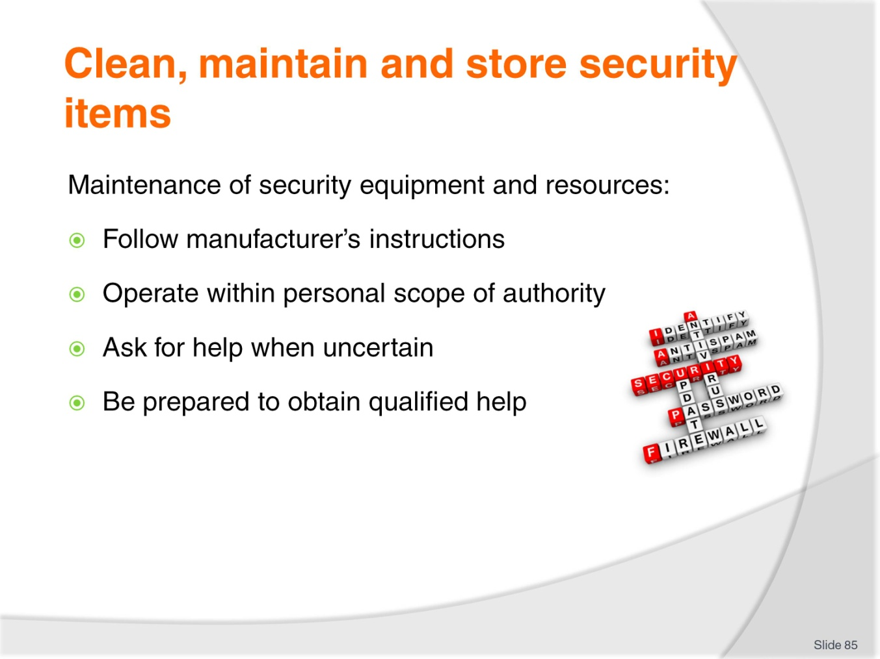
Slide No | Trainer Notes
Trainer discusses maintenance of security equipment and resources highlighting there is a need to always:
- Follow manufacturer’s instructions when undertaking maintenance
- Stay within your designated scope of authority when taking action
- Ask for assistance when unsure about what to do
- Be prepared to obtain qualified help when faced with an uncertain or difficult situation.

Slide
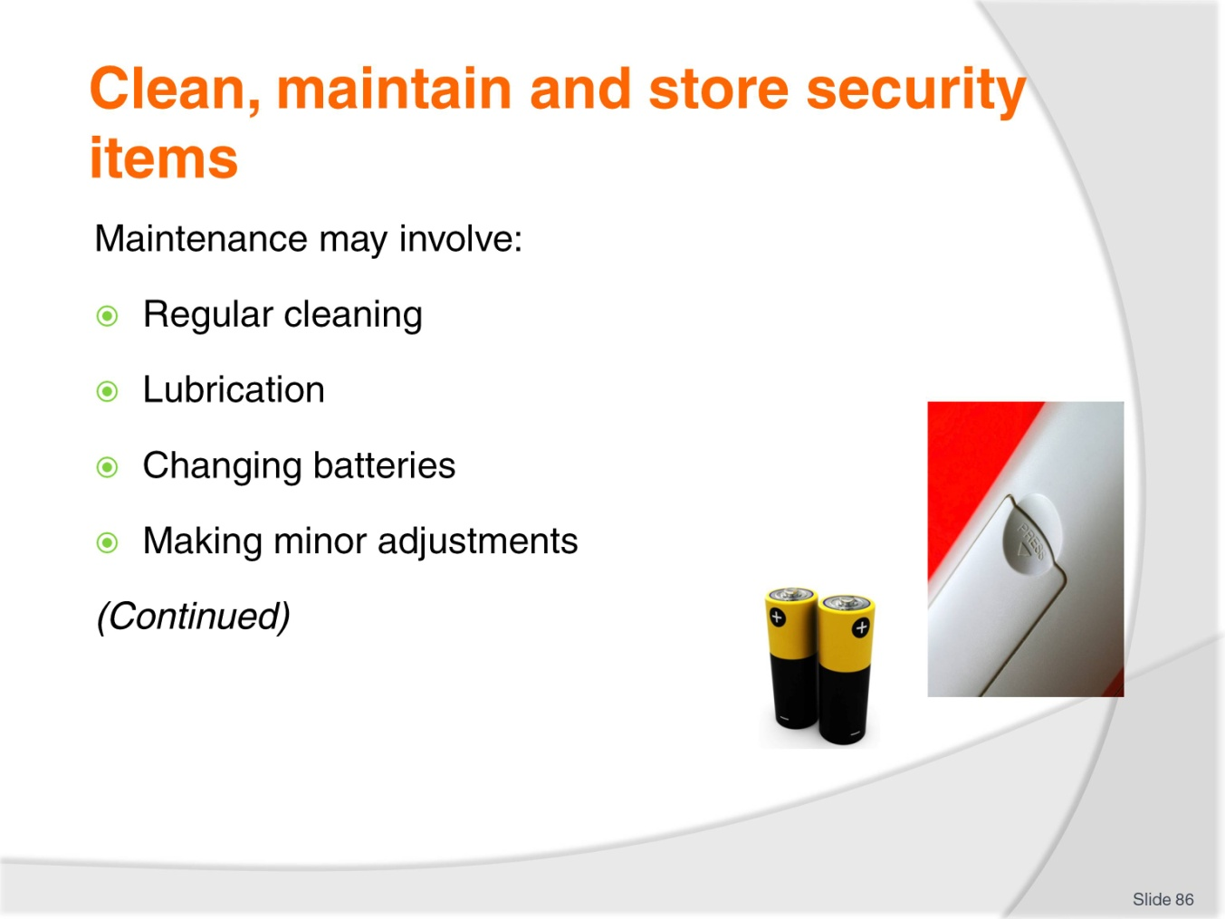
Slide No | Trainer Notes
Trainer states generic maintenance activities can include:
- Regular/scheduled cleaning – it is critical you understand how important clean equipment is to its effective operation
- Lubricating moving parts
- Changing batteries
- Making minor modifications and adjustments.

Slide
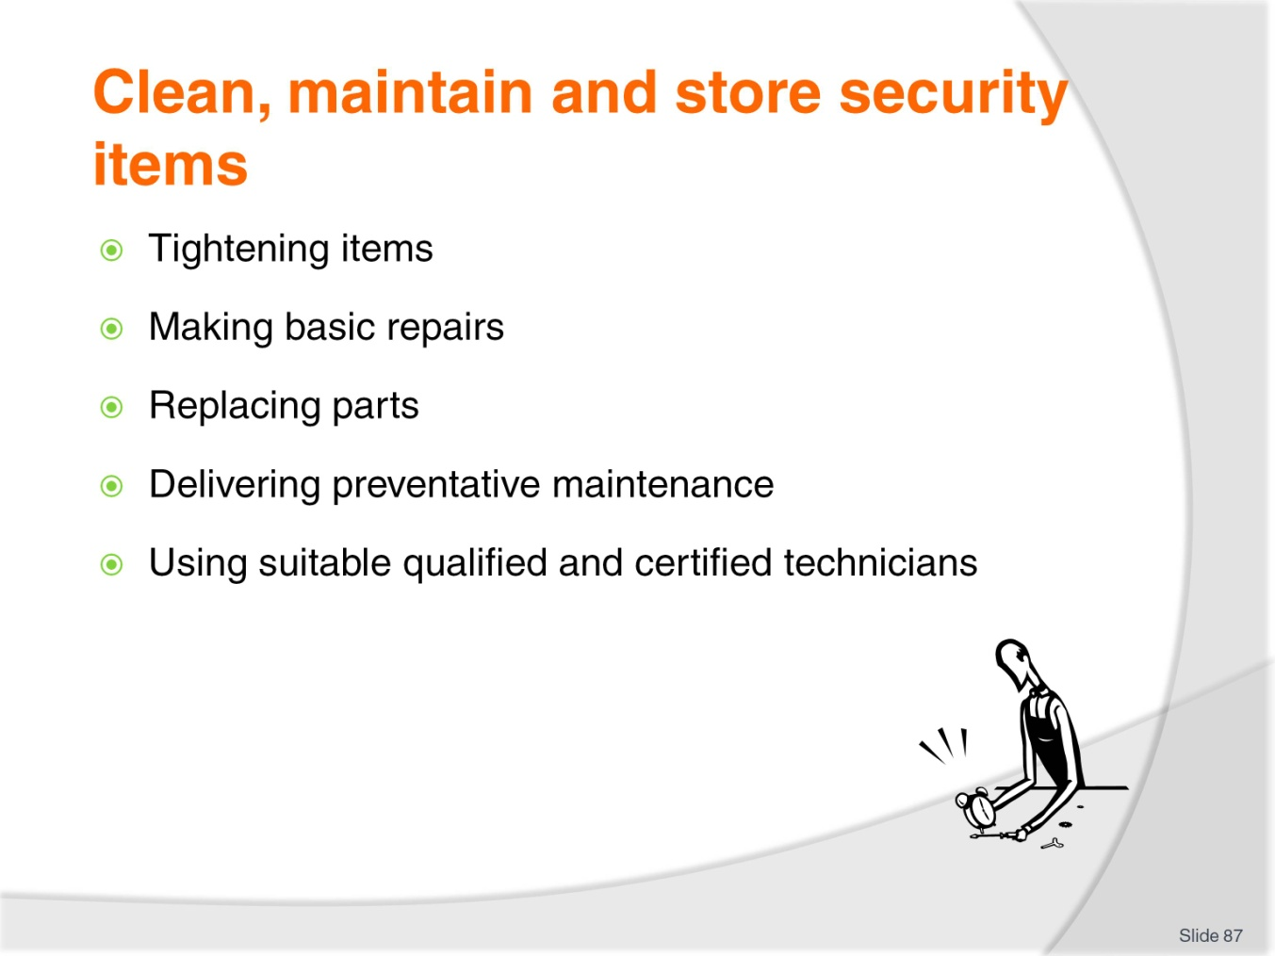
Slide No | Trainer Notes
Trainer continues presenting examples of maintenance activities:
- Tightening screws, nuts and bolts, fixtures and fittings, panels, straps and similar
- Undertaking basic repairs
- Replacing parts commonly subject to wear – such as O-rings, washers, belts, globes, fuses
- Providing service designed to prevent ‘wear and tear’ on the equipment – so it can remain in service and to reduce the potential for, and amount of, down-time
- Completing required documentation to record work performed, time taken and parts used
- Using properly qualified/certified technicians – where necessary.
Class Activity – Demonstration and Practical
Trainer:
- Demonstrates how to maintain security items/equipment
- Provides opportunity for students to do same.

Slide
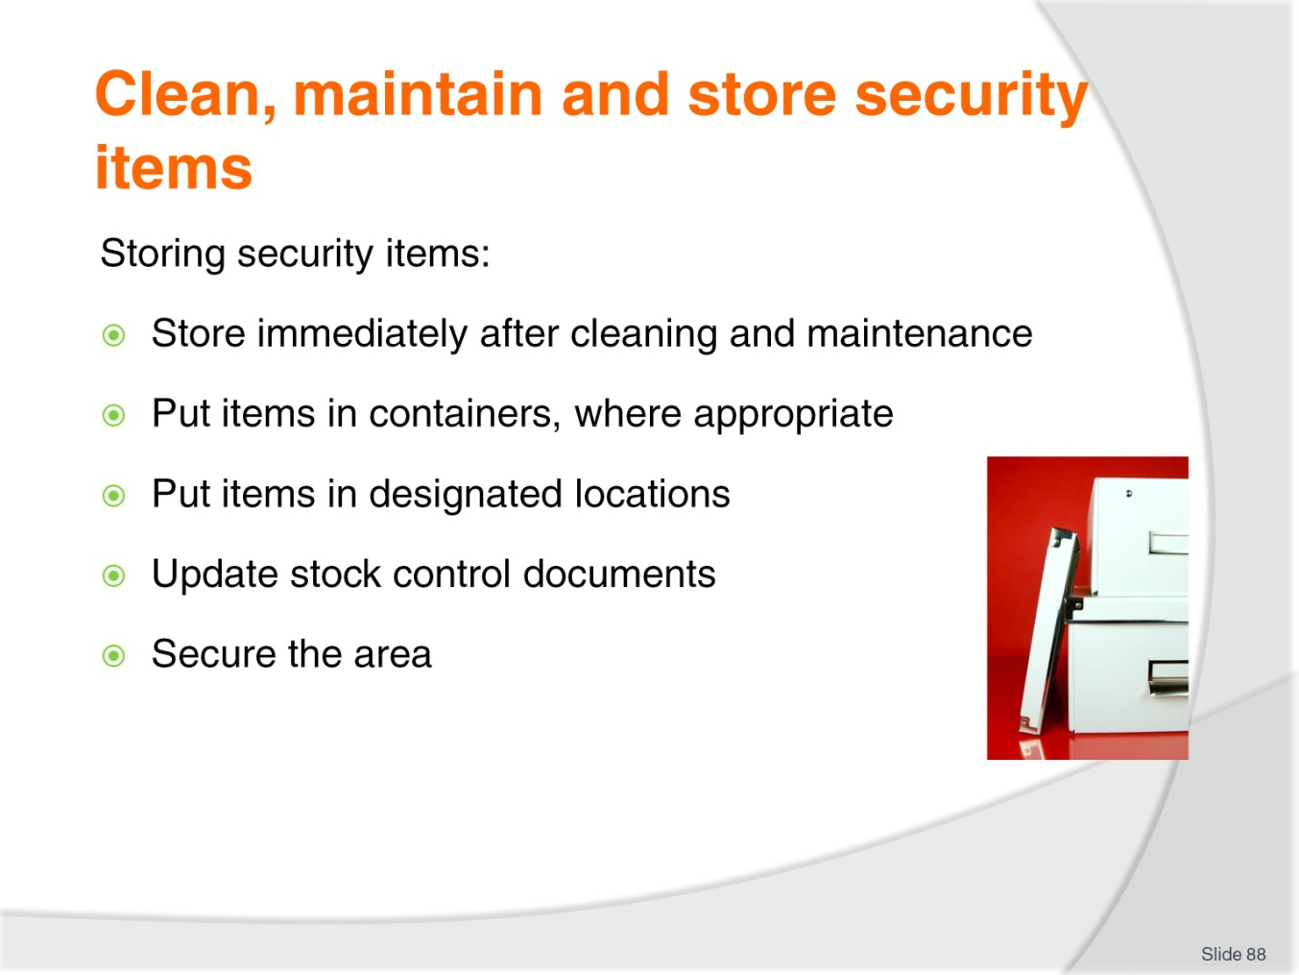
Slide No | Trainer Notes
Trainer explains the fundamentals of storing security tools and equipment are:
- Store items immediately after cleaning and maintenance has been completed
- Return items to their individual containers, where appropriate
- Locate each/every item in its designated location
- Update internal storage documentation
- Secure the storage area.

Slide
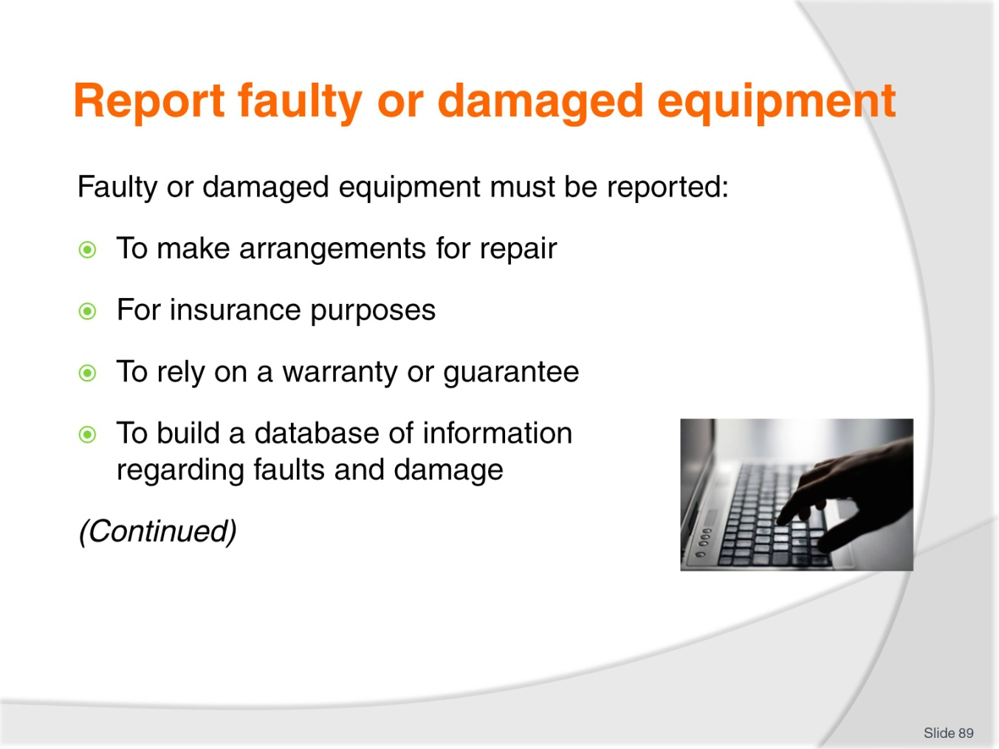
Slide No | Trainer Notes
Trainer states faulty or damaged security equipment and items must be reported for one or more of the following reasons:
- So arrangements can be made to initiate required repairs, service or other action (such as replacement of items, purchase of additional items or purchase of different types of items)
- For insurance purposes – so an insurance claim can be made’
- In order the business can rely on the protection afforded by product warranty or guaranties
- To enable generation of an historic body of evidence about faults and damage to security items – which may be used as the basis for preventing future events.

Slide
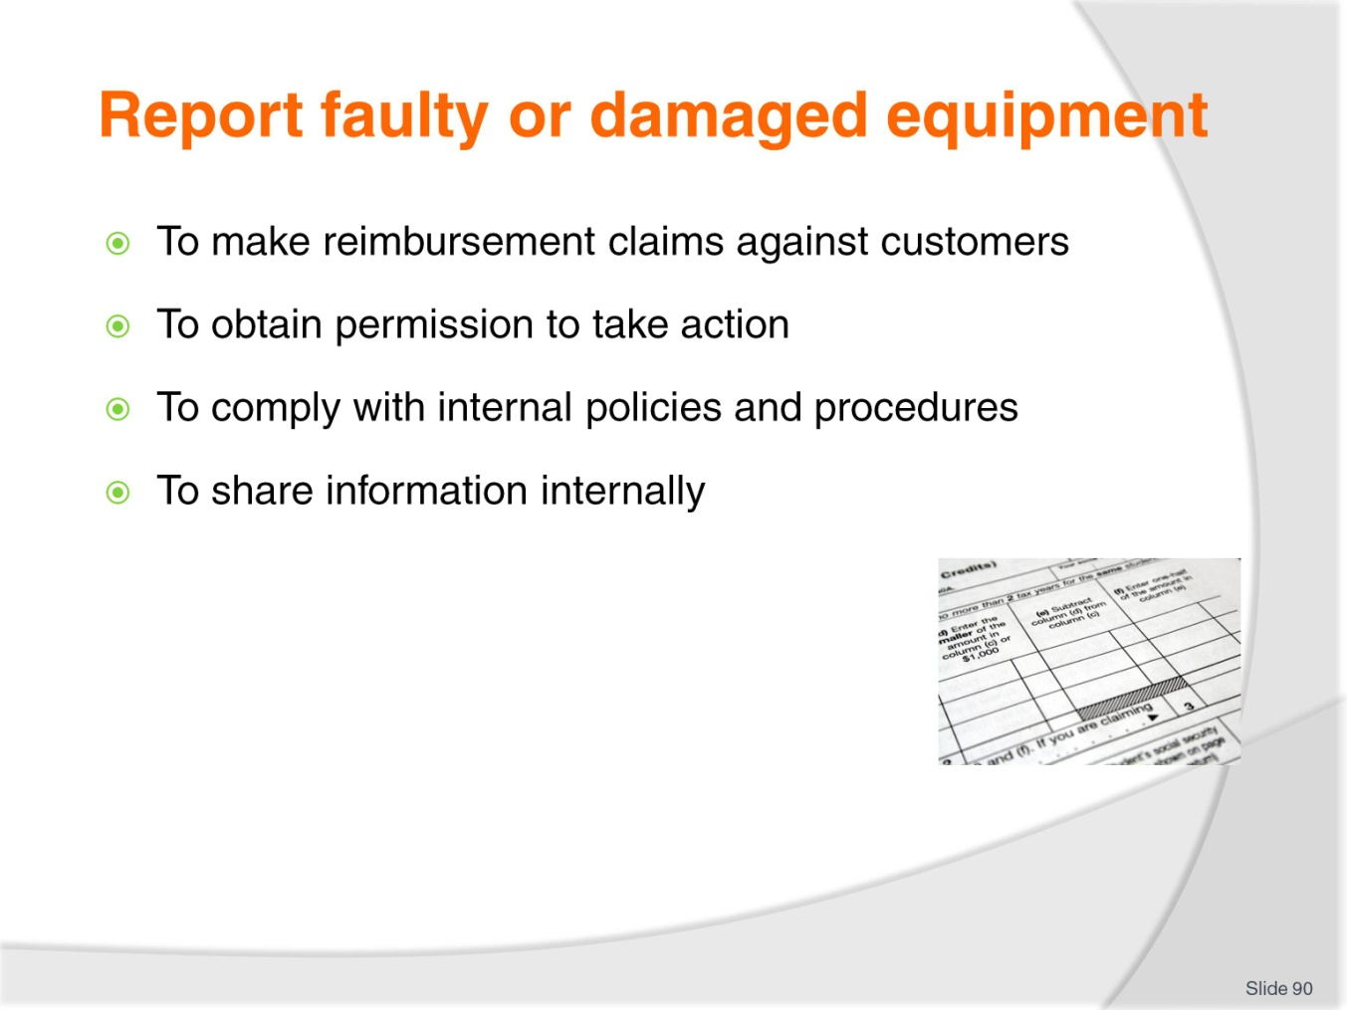
Slide No | Trainer Notes
Trainer continues identifying why damaged/faulty items must be reported:
- In order a claim for reimbursement may be made against a customer/guest who has intentionally damaged an item
- To obtain one-off permission for you to take action in excess of your standard scope of authority to effectively address the identified situation
- In order to comply with internal policies related to reporting of issues
- To share information with other staff so they are aware of the situation, possible cause and item/s involved.

Slide
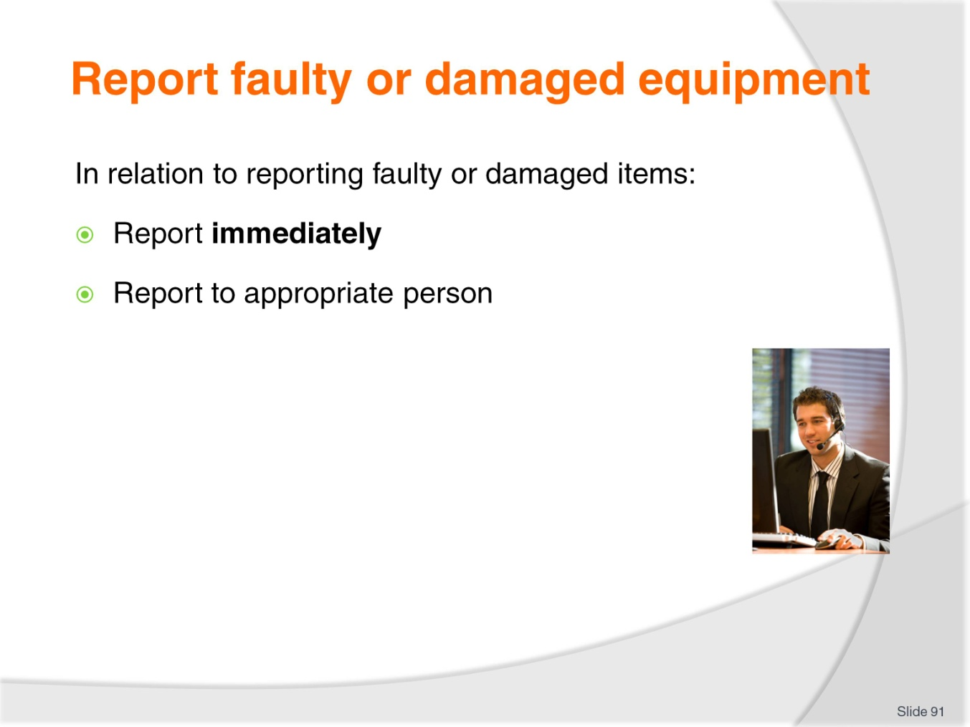
Slide No | Trainer Notes
Trainer provides further details about reporting faulty/damaged equipment:
Immediacy of reporting
It is standard procedure for you to have to report faulty or damaged security immediately so action can be taken to address the situation, and so other staff are aware of the problem and the extent to which normal security has been compromised.
This will mean using your radio to communicate with the ‘appropriate person’.
This is a mandatory requirement.
‘Appropriate person’
The appropriate person to report to will often depend on the time of day the problem is identified.
For example a fault at 2:00AM may require you to report:
- Direct to the external security consultant/provider so they can initiate action to fix the problem
- To the Night Auditor.
In other circumstances/at other times you may be required to report to:
- The control room
- Your supervisor
- Head of Security
- Duty manager
- Head office
- Maintenance department
- The owner.

Slide
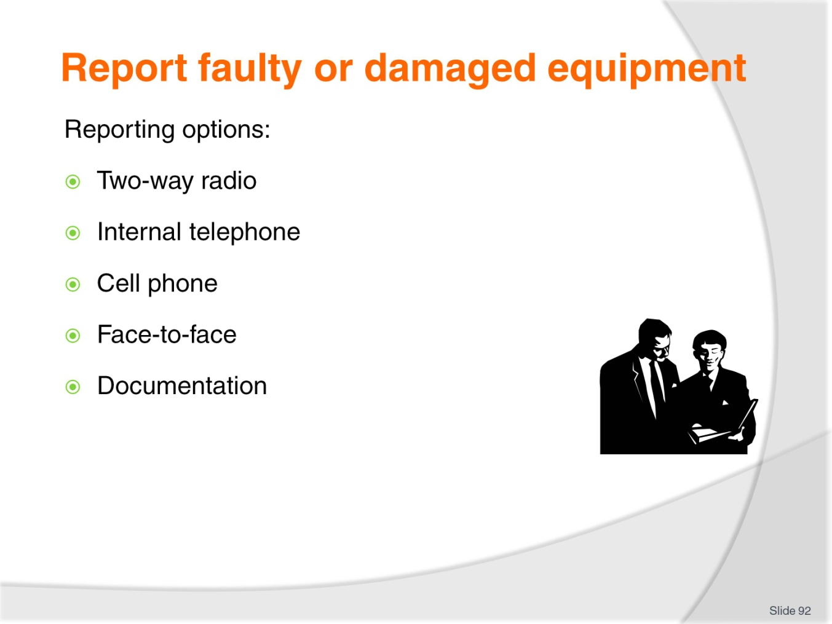
Slide No | Trainer Notes
Trainer states options for reporting damaged or faulty security items are:
- Using two-way radio
- Using internal telephone system
- Using cell phone
- Making a face-to-face report – which can occur:
- On-site when the appropriate person has responded to a radio or phone call and attended the location
- On your return to the control room after the situation has been resolved
- At end-of-shift as part of the standard de-briefing
- Completing documentation after the event to record full details – such as:
- Incident Report
- Maintenance Request.

Slide
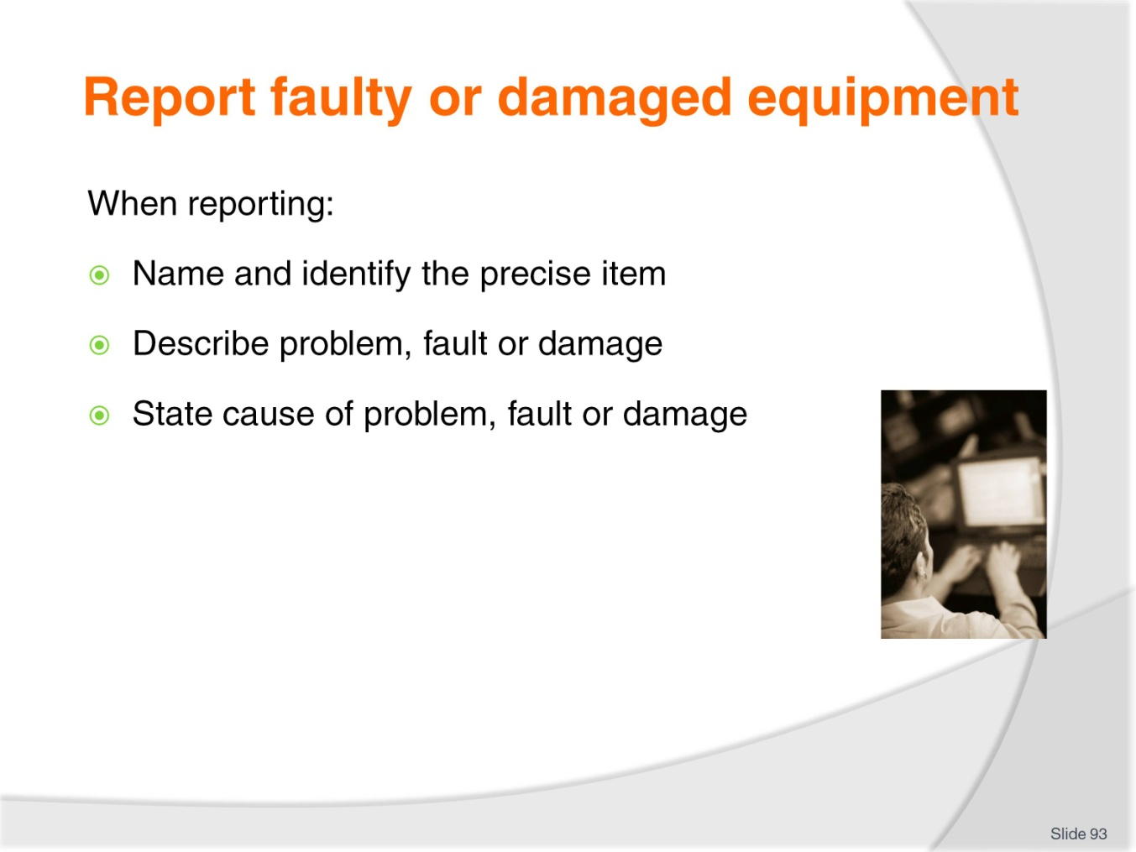
Slide No | Trainer Notes
Trainer explains the details of the report will, obviously, reflect the individual fault or damage situation but the following generic requirements will always apply:
- Name/type of item
- Identification of product/serial number
- Description of identified problem
- Known cause/s – if any, including names of anyone involved in causing the fault/damage.
Class Activity – Demonstration and Practical
Trainer:
- Demonstrates verbal reporting of damaged/faulty security equipment to (for example) Supervisor
- Provides opportunity for students to do same.

Slide
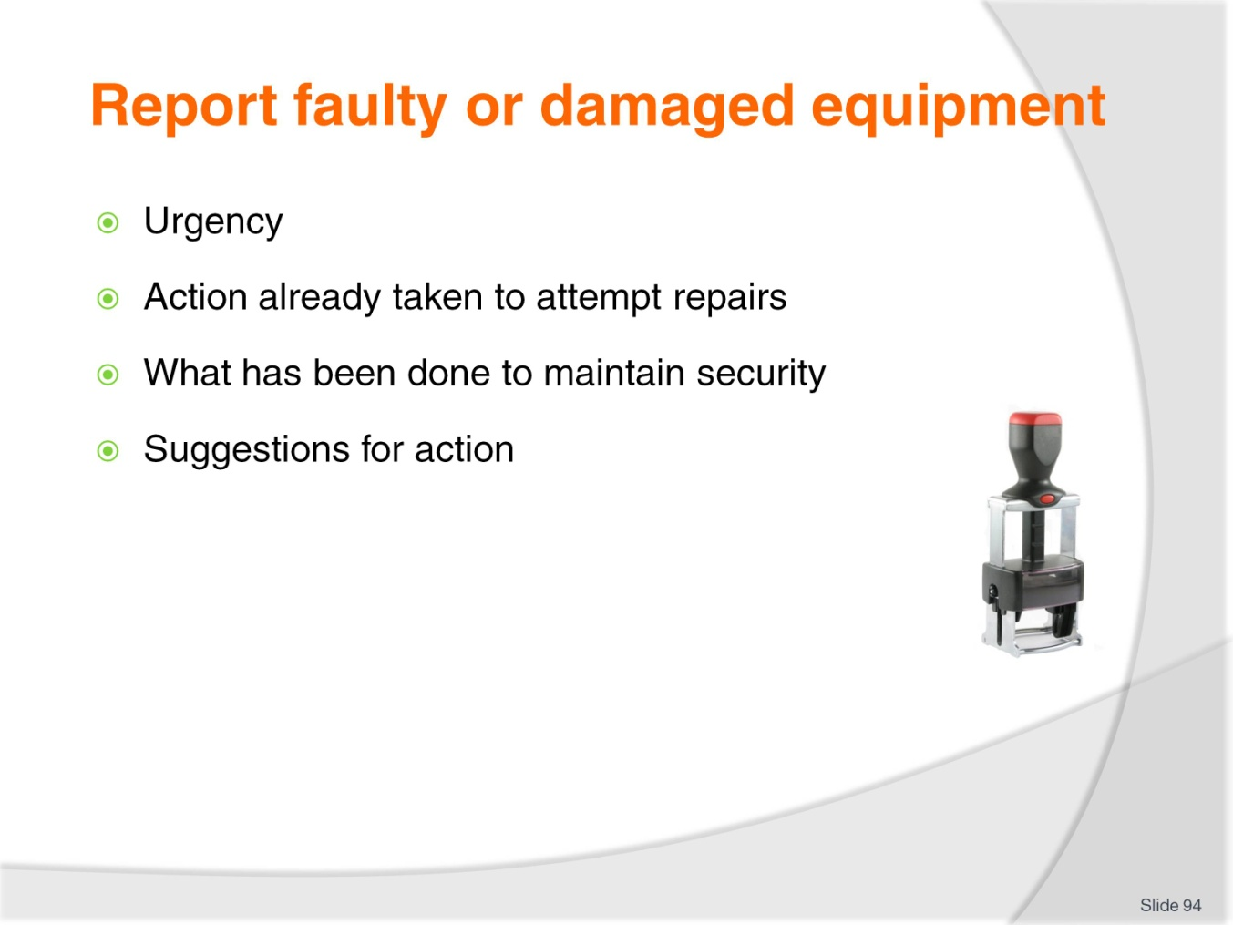
Slide No | Trainer Notes
Trainer continues identifying details/information to be conveyed/communicating when reporting faulty/damaged items:
- Urgency involved in returning item to full operational status
- Details of any action taken by you on-the-spot to try to fix the problem/fault/damage
- Explanation of action taken to maintain security at the site
- Suggestions for action to take – this is often extremely beneficial as you can be expected to have a detailed knowledge of the venue, the situations, possible threats and practical options for addressing the problem.
Class Activity – Demonstration and Practical
Trainer:
- Demonstrates reporting damaged/faulty security equipment using documentation
- Provides opportunity for students to do same.

Slide
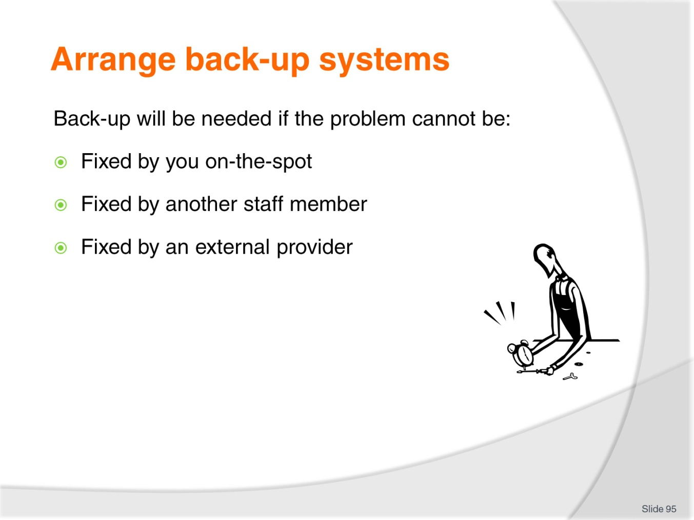
Slide No | Trainer Notes
Trainer explains students will need to arrange back-up items or systems where damaged or faulty systems cannot be fixed:
- By them on-the-spot – using their training, experience, common sense
- By others in the workplace – such as qualified technicians or maintenance staff
- By external providers – who have attended and inspected/diagnosed the problem.

Slide
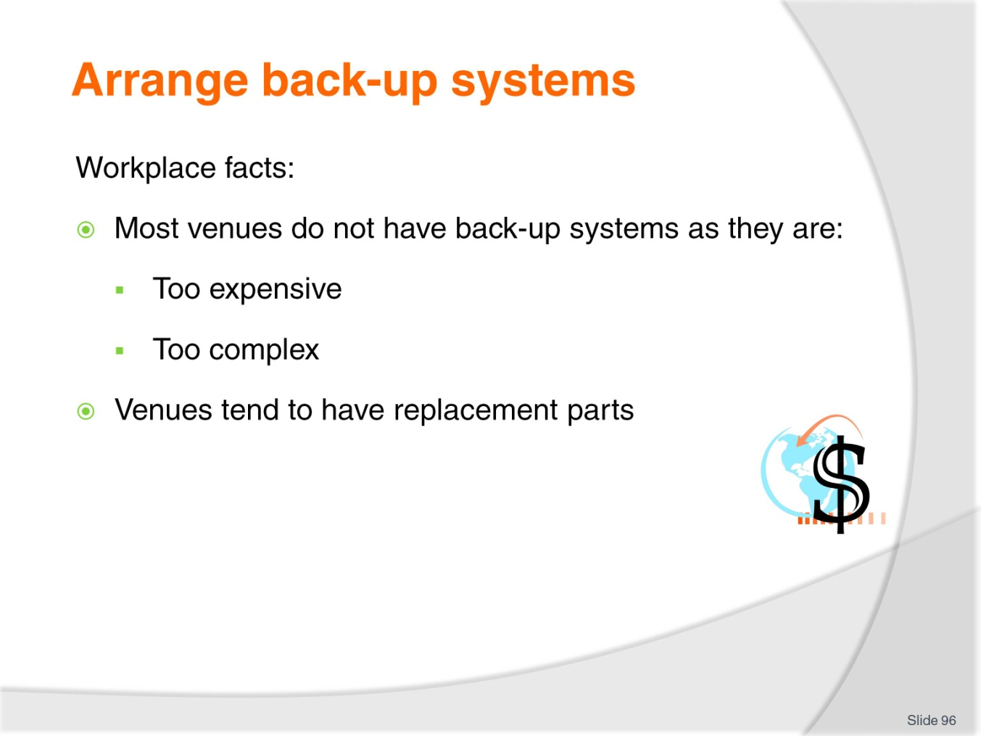
Slide No | Trainer Notes
Trainer discusses the reality of workplaces in relation to back-up systems stating in most cases venues do not have back-up ‘security systems’ because:
- They are too expensive to duplicate
- They are too complex – in terms of how and where they are installed
- Instead venues will probably have replacement ‘components’ (such as spare/replacement cameras, spare detectors, spare VDUs or an assortment of general ‘spare parts’).

Slide
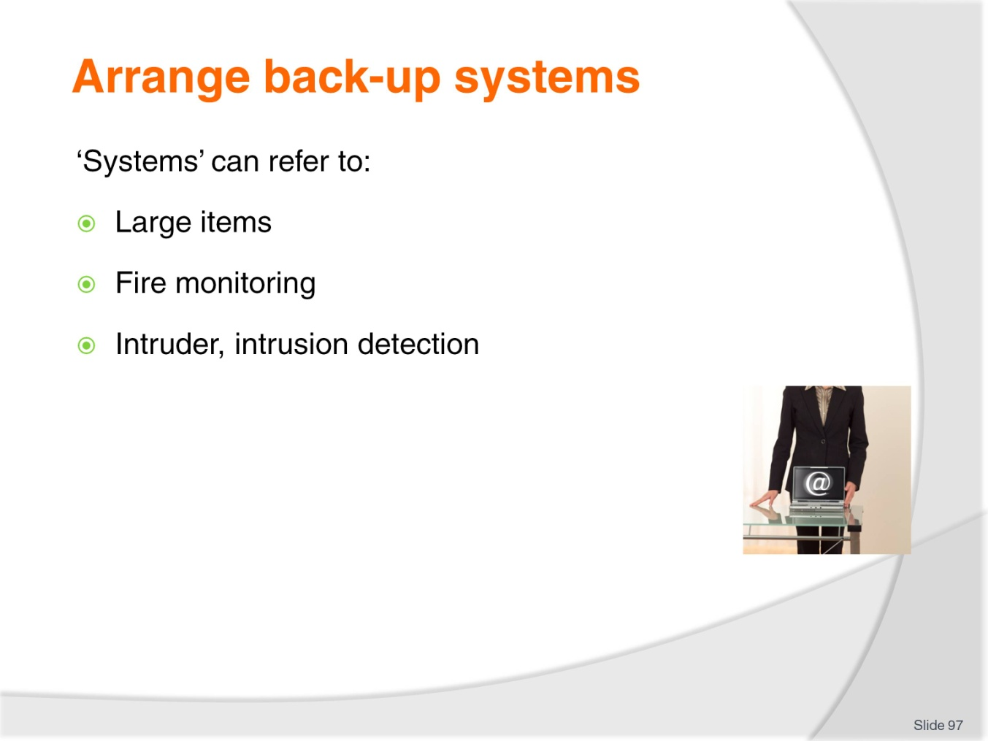
Slide No | Trainer Notes
Trainer states in this context ‘security systems’ refers to:
- Large items of security equipment such as:
- Walk-though scanners
- Conveyor belt baggage scanners/X-ray machines
- Fire monitoring systems
- Intruder/intrusion detection systems.

Slide
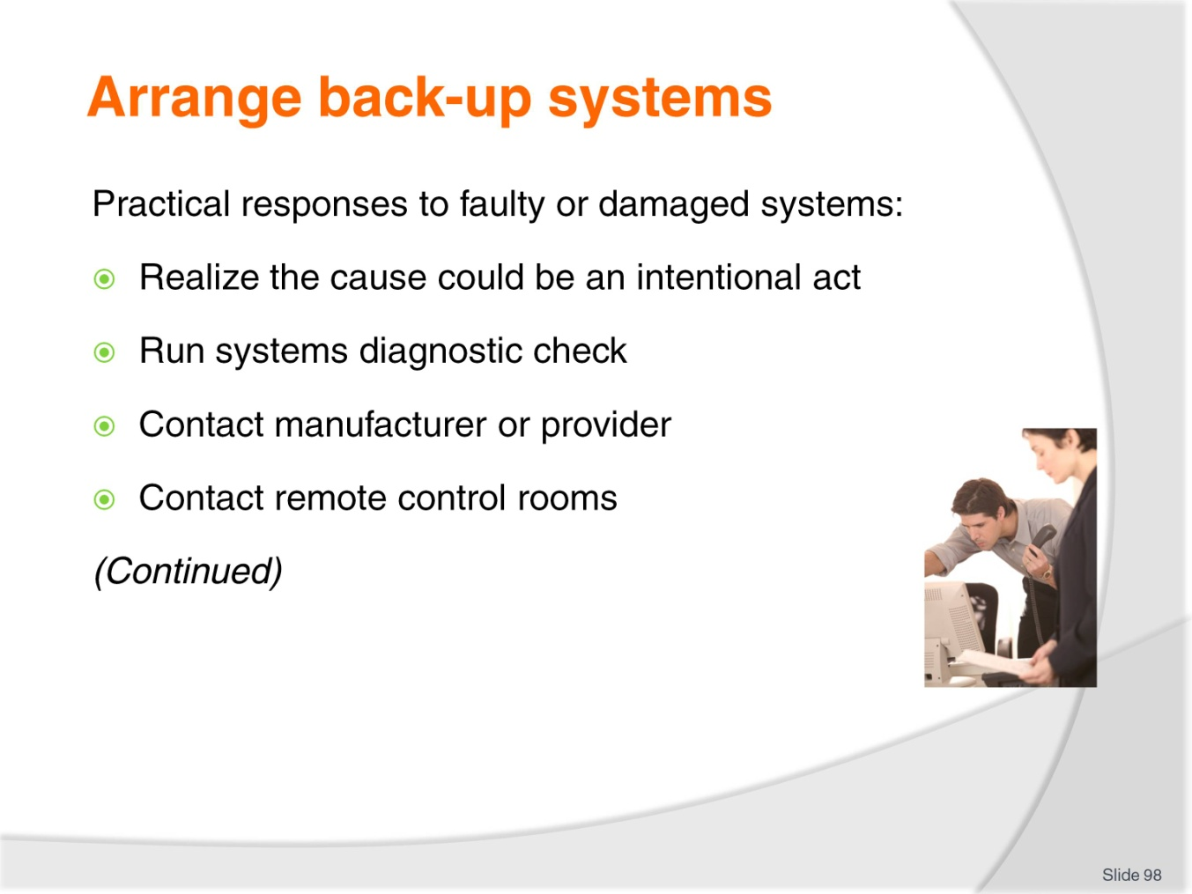
Slide No | Trainer Notes
Trainer advises given the usual lack of a full back-up system on site, when ‘the system’ fails students will need to:
- Be alert to the possibility the system failure was the result of an intentional act caused by a would-be offender – a standard response to system failure is to enhance on-the-ground, eyes-on security
- Run immediate system diagnostic checks – many systems have the capacity to self-diagnose a problem and report on what can be done to fix the problem
- Contact the manufacturer/provider:
- Some systems and equipment can be remotely interrogated to identify faults and problems and some (relatively few) can even be repaired from this remote location)
- They may be able to provide over-the-phone advice about what to do to (try to) fix the problem
- To initiate a service call to address the situation.
- Contact remote control rooms which may be linked to/monitoring the systems – in order to:
- Determine if they have the same indicators of malfunction you are experiencing
- Identify if they can suggest remedial action which may be taken to retrieve the situation.

Slide
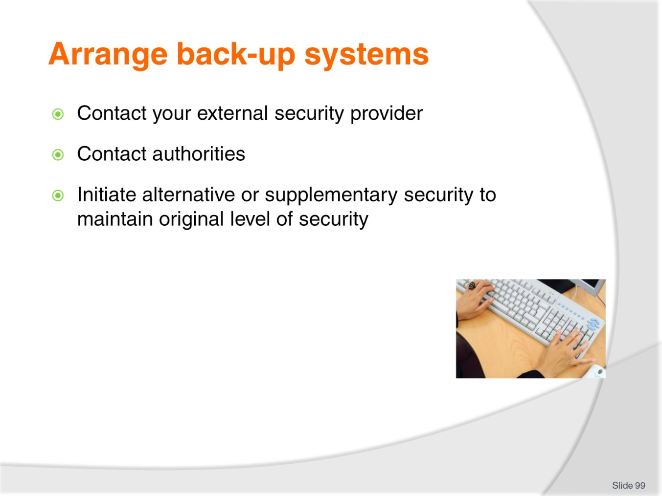
Slide No | Trainer Notes
Trainer continues identifying possible practical responses when security systems/equipment are faulty or damaged:
- Contact the external security company used by your venue – this can be a formal SOP where systems fail so as to:
- Advise them of the situation
- Call in extra security officers to provide additional security coverage
- Contact the authorities – this can mean:
- Notifying the police where intruder systems have gone down
- Advising the fire authorities win situations where the fire monitoring system has failed
- Initiate an alternate security strategy to deal with the situation – most venues will have a set of contingency plans developed to deal with situations where major security systems fail. Generic options include:
- Increased foot patrols
- Higher levels of awareness.
- Increased checks and inspections.

Slide
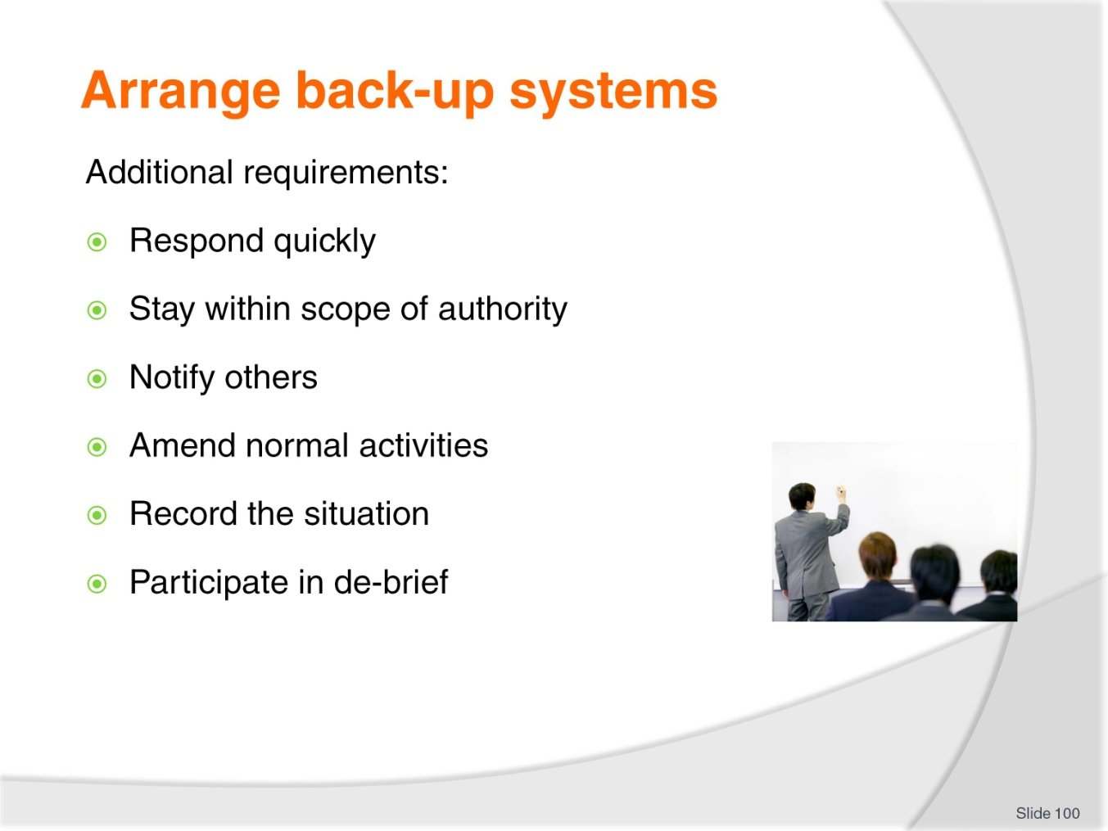
Slide No | Trainer Notes
Trainer provides additional information and advice in regard to this topic stating in these circumstances students should:
- Respond quickly
- Stay within designated scope of authority … but you will be expected to exercise common sense and initiative: this is a fine balancing act but one management will expect you to discharge
- Notify others – communication with internal and external personnel is critical
- Be ready to limit normal activities – as required in order to respond effectively. This may include:
- Closing some entry and exit points – or making sure there is only one ingress/egress point
- Prohibiting vehicle access to nominated areas
- Restricting access to high-risk areas.
- Record the situation – take notes of what happened and your actions; note times and who was involved; use cameras to record physical evidence
- Actively participate in the de-brief which normally follows such situations – to provide information which may be able to be used to:
- Prevent a recurrence
- Enhance future responses to similar situations.

Slide
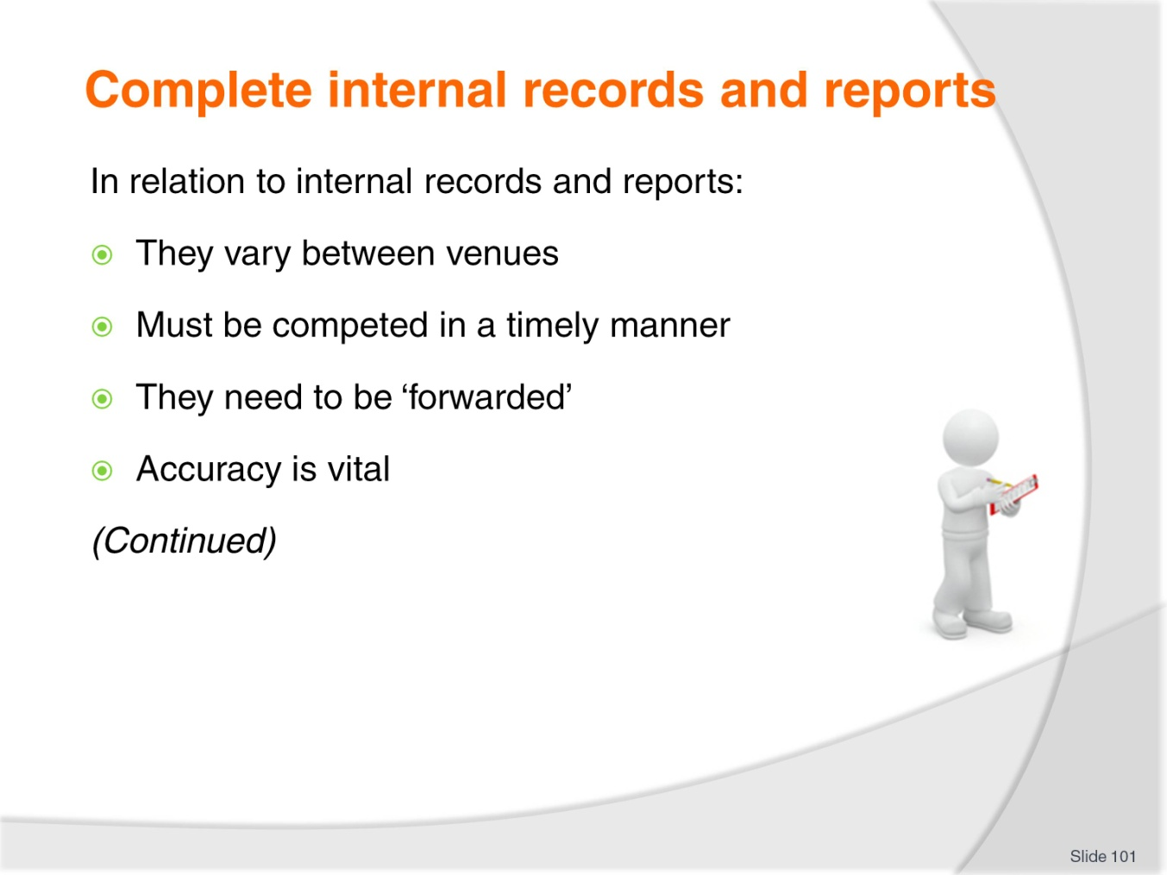
Slide No | Trainer Notes
Trainer provides background information on internal records and reports:
- These vary between venues – what is required in one venue is not required in another; what does not have to be reported/recorded in one premises does have to be reported/recorded elsewhere
- It is important to complete the documents in a timely manner – in practice this means filling in reports and records ‘immediately’ after an incident, event or nominated activity
- Completed documentation needs to be ‘forwarded’ – there is always a need to file a form or hand it in to a designated person/department
- Accuracy is vital – it is essential you take the time to make sure all the details (information as well as statistical data) is correct in every aspect.

Slide
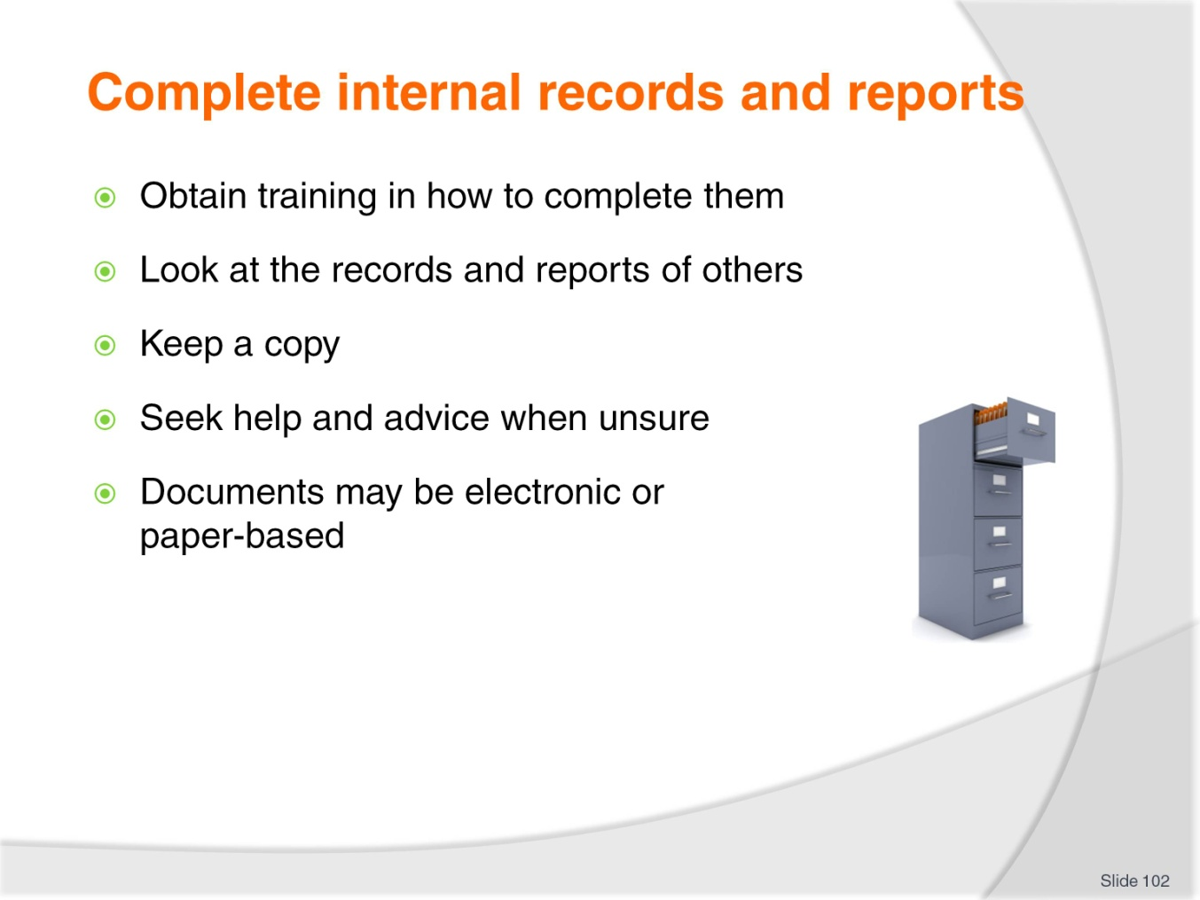
Slide No | Trainer Notes
Trainer continues providing background information on internal records and reports:
- Obtain necessary in-house training – all venues will provide advice and instruction on:
- Which documents to use when a report/record is required
- How to complete the required
- When to complete them
- What to do with them when they are completed.
- Make an effort to look at records/reports others have completed – to get a ‘feel’ for how they complete them, the language and phrases used, and the detail included
- Keep a copy of any records/reports you complete – for your own records/purposes ‘after the event’
- Seek advice – when uncertain about:
- Whether a record/report is required
- Details/information required
- Documents may be electronic or paper-based.

Slide
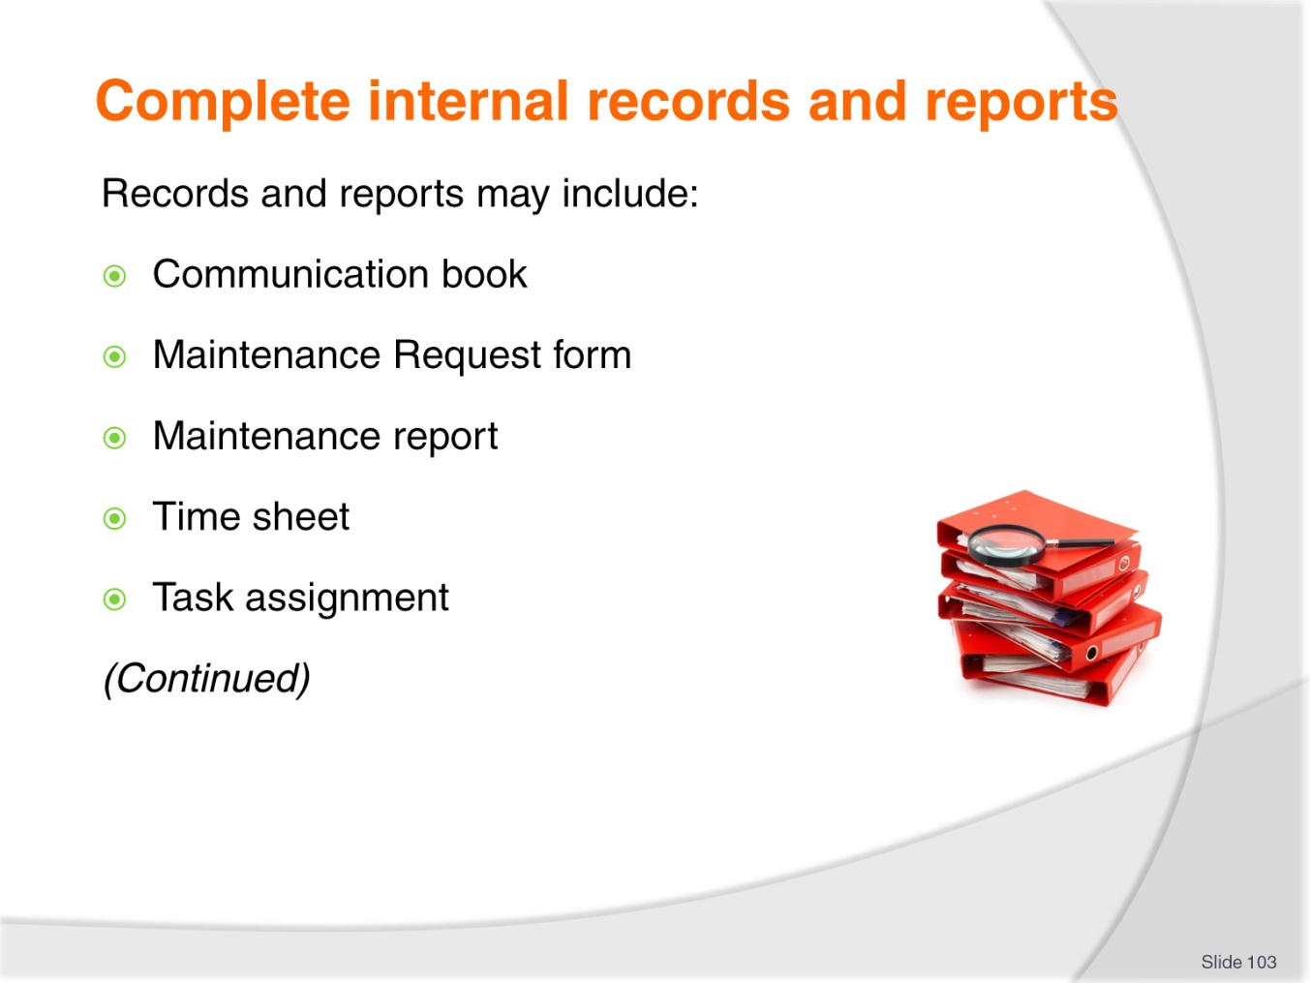
Slide No | Trainer Notes
Trainer identifies records and reports which may need to be completed:
- Communications book – used by venues to facilitate communication between staff who work different shifts/days
- Maintenance Request forms – also known in some venues as Maintenance Requisitions
- Maintenance reports – detailing repairs, service and maintenance on items specifying what was done, when it was done and who did it. This form is required when maintenance is undertaken by internal staff or an external provider
- Time sheets – detailing hours worked for a shift: a time clock may replace the need to complete a paper-based time sheet
- Task assignments – at the end of the allocated assignment.
Class Activity – Presentation and Explanation/Demonstration
Trainer presents sample records/reports as listed on the slide and:
- Explains what they are used for
- Demonstrates what is involved in competing each.

Slide
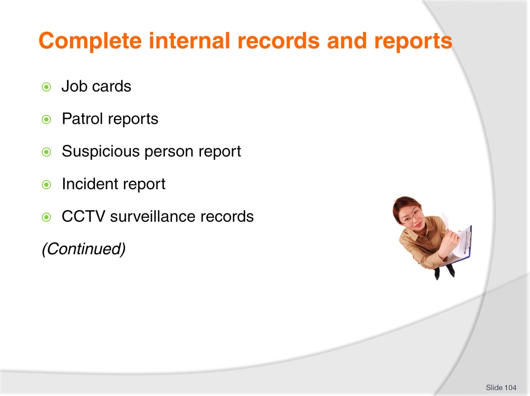
Slide No | Trainer Notes
Trainer continues identifying records and reports which may need to be completed:
- Job cards/sheets – when allocated work (inspections, repairs, replacements) have been finalised this record will detail:
- Who did the job
- Time taken
- Materials used
- Parts and components replaced
- These details enable costing of work done.
- Patrol reports – at the end of vehicle and foot patrols completed at the end of the patrol or end-of-shift to record times and routes as well as operational details
- Suspicious person report – completed at the end of the patrol, end-of-shift or after having responded to a call from venue staff to investigate
- Incident report – to record details relating to an incident which has occurred in the venue
- CCTV surveillance records – to identify discs/tapes stored/maintained for different dates, times and locations/cameras.
Class Activity – Presentation and Explanation/Demonstration
Trainer presents sample records/reports as listed on the slide and:
- Explains what they are used for
- Demonstrates what is involved in competing each.
Slide
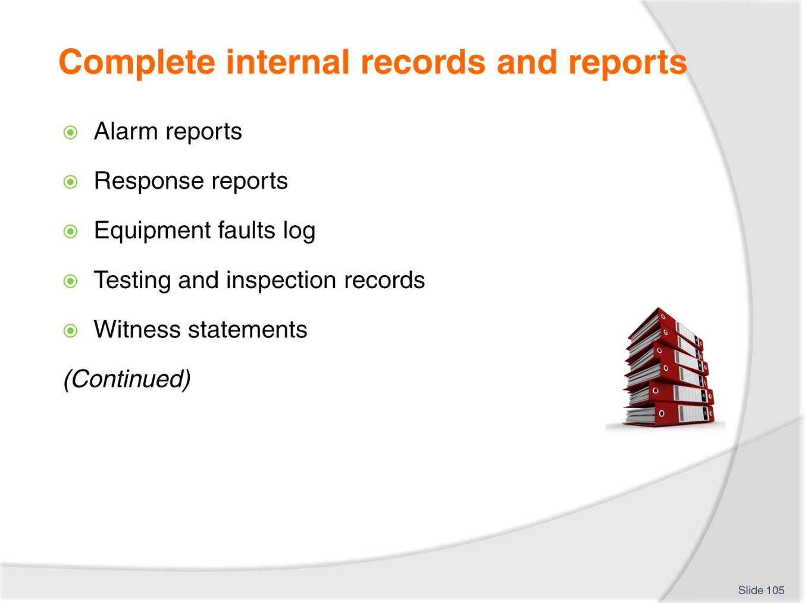
Slide No | Trainer Notes
Trainer continues identifying records and reports which may need to be completed:
- Alarm reports – identifying activated alarms, locations, times and causes including false alarms
- Response reports – detailing action taken in response to alarms and calls for assistance
- Equipment faults log – this is used to report operational faults in systems and equipment and to record action taken to record diagnoses
- Testing and inspection records – which:
- Provide evidence of inspections/tests having been undertaken
- Highlight areas where problems/issues have been identified for further action/follow-up.
- Witness statements – taken when members of the public are prepare to make statements regarding what they observed when an event, incident or offence took place:
- Members of the public, customers or guest are under no obligation to make witness statements.
Class Activity – Presentation and Explanation/Demonstration
Trainer presents sample records/reports as listed on the slide and:
- Explains what they are used for
- Demonstrates what is involved in competing each.
Slide
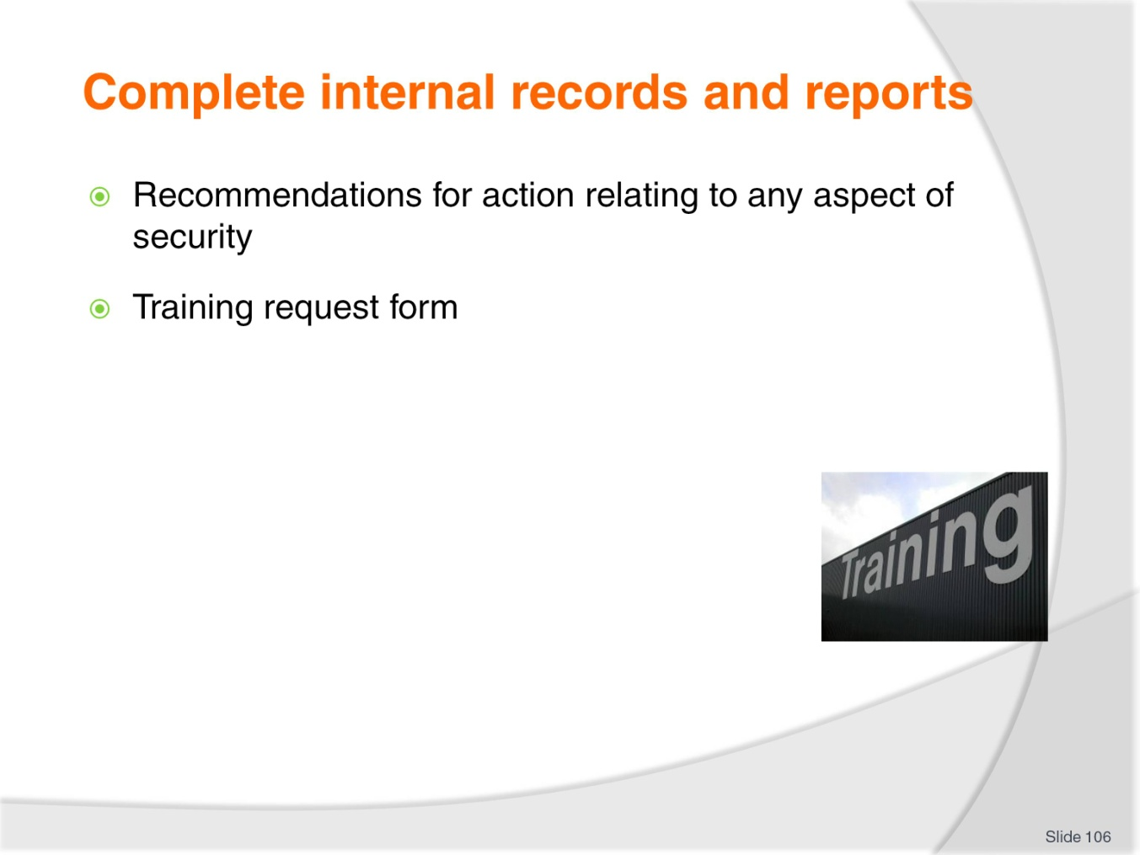
Slide No | Trainer Notes
Trainer continues identifying records and reports which may need to be completed:
- Recommendations for action – this is a form allowing staff to formally convey suggestions and ideas for issues such as:
- Changes to SOPs
- Introduction of new SOPs
- Replacement of items
- Disposal of faulty or damaged equipment
- Purchase of new/different items and equipment.
- Request for training – identifying the training required (such as ‘initial training’, ‘top-up training’ or ‘refresher training’) and the items (equipment and/or systems) involved. This training request may also identify ancillary areas in which training is required – these areas may include:
- First aid
- Maintenance and service.
Class Activity – Presentation and Explanation/Demonstration
Trainer presents sample records/reports as listed on the slide and:
- Explains what they are used for
- Demonstrates what is involved in competing each.

Slide
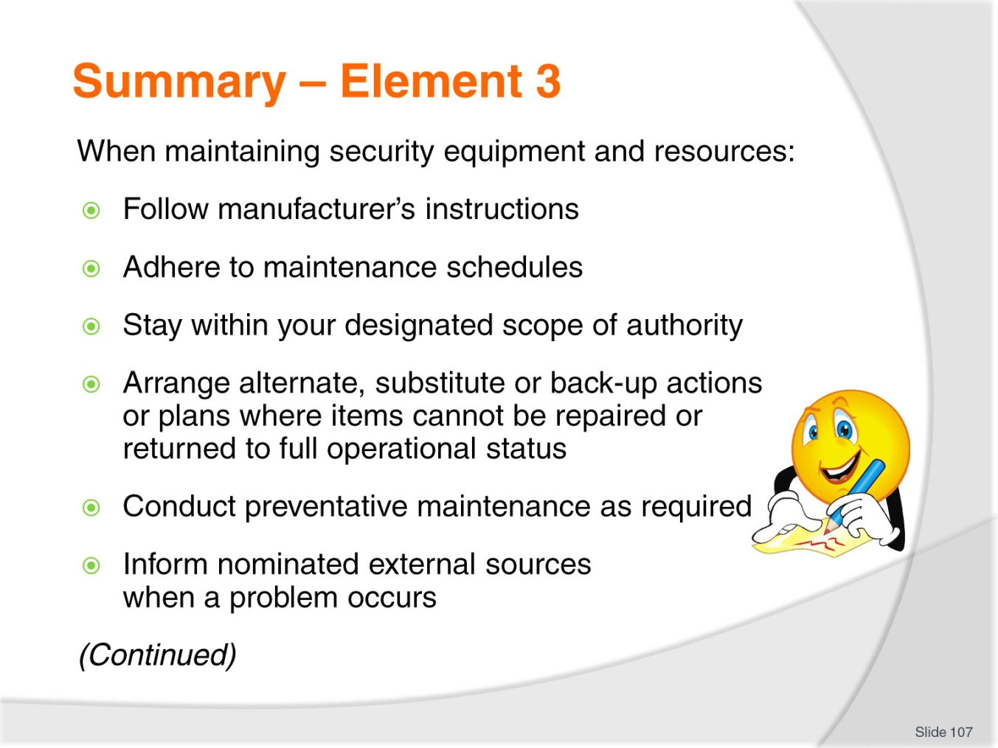
Slide No | Trainer Notes
 | Trainer provides a recap of the Element asking questions to check trainee understanding and responding to questions from trainees, as required.

Slide
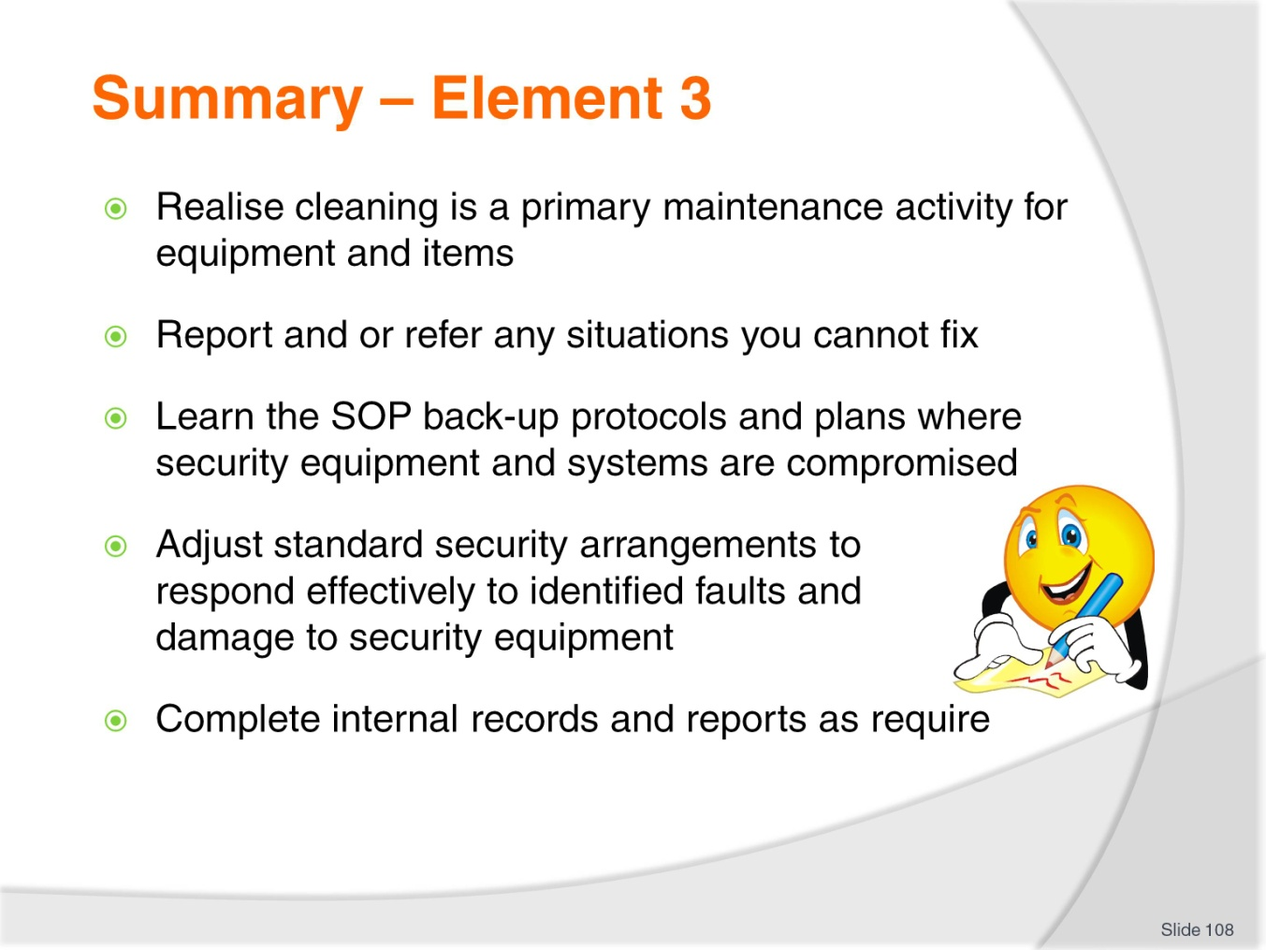
Slide No | Trainer Notes
Trainer thanks trainees for their attention and encourages them to apply course content as required in their workplace activities.
provides a recap of the Element asking questions to check trainee understanding and responding to questions from trainees, as required.

Recommended training equipment
- Range of security equipment:
- Electronic screening equipment
- Video cameras
- Closed circuit TV systems (cameras and monitors)
- Alarms and sensors
- Personal duress alarms
- Static alarms
- Security systems
- Personal protective equipment and clothing:
- Body armour
- Protective shields
- Masks
- Safety boots
- Head protection
- Safety glasses
- Knee pads
- Gloves
- Baton
- Asp
- Torches/flashlights
- Communication equipment/items:
- Two-way radios
- Landline phone
- Cell phone
- Megaphone
- Public address system
- Documentation – such as:
- Incident reports
- Alarm reports
- Maintenance reports
- Security SOPs
- Assignment briefs
- Cleaning and maintenance instructions for equipment
- Operating instructions for systems and equipment
- Sample work tasks
- Maintenance schedules
- Log books
- Sample emergency and evacuation procedures
- Relevant legislation, codes (of conduct; of ethics) and local guidelines – relating to:
- Security
- Duty of care
- Occupational health and safety
- Access and equity
- Fire extinguishers
- First aid kits
- Records/reports including:
- Communications book
- Maintenance Request forms
- Maintenance reports
- Time sheets
- Task assignments
- Job cards/sheets
- Patrol reports
- Suspicious person report
- Incident report
- CCTV surveillance records
- Alarm reports
- Response reports
- Equipment faults log
- Testing and inspection records
- Witness statements
- Recommendations for action
- Request for training.

Instructions for Trainers for using
PowerPoint – Presenter View
Connect your laptop or computer to your projector equipment as per manufacturers’ instructions.
In PowerPoint, on the Slide Show menu, click Set Up Show.
Under Multiple monitors, select the Show Presenter View check box.
In the Display slide show on list, click the monitor you want the slide show presentation to appear on.
Source: http://office.microsoft.com
Note:
In Presenter View:
You see your notes and have full control of the presentation
Your trainees only see the slide projected on to the screen
More Information
You can obtain more information on how to use PowerPoint from the Microsoft Online Help Centre, available at: http://office.microsoft.com/training/training.aspx?AssetID=RC011298761033
Note Regarding Currency of URLs
Please note that where references have been made to URLs in these training resources trainers will need to verify that the resource or document referred to is still current on the internet. Trainers should endeavour, where possible, to source similar alternative examples of material where it is found that either the website or the document in question is no longer available online.

Appendix – ASEAN acronyms
AADCP | ASEAN – Australia Development Cooperation Program.
ACCSTP | ASEAN Common Competency Standards for Tourism Professionals.
AEC | ASEAN Economic Community.
AMS | ASEAN Member States.
ASEAN | Association of Southeast Asian Nations.
ASEC | ASEAN Secretariat.
ATM | ASEAN Tourism Ministers.
ATPMC | ASEAN Tourism Professionals Monitoring Committee.
ATPRS | ASEAN Tourism Professional Registration System.
ATFTMD | ASEAN Task Force on Tourism Manpower Development.
CATC | Common ASEAN Tourism Curriculum.
MRA | Mutual Recognition Arrangement.
MTCO | Mekong Tourism Coordinating office.
NTO | National Tourism Organisation.
NTPB | National Tourism Professional Board.
RQFSRS | Regional Qualifications Framework and Skills Recognition System.
TPCB | Tourism Professional Certification Board.







